

Training for Georgia
Performance Standards
Day 7: Feedback, Commentary, & Evaluation
Also includes:
Manipulative and Calculator Training

Facilitator’s Guide
Mathematics Grade 6

Acknowledgements
This training program was developed by the Georgia Department of Education as part of a series of professional development opportunities to help teachers increase student achievement through the use of the Georgia Performance Standards.

For more information on this or other GPS training, contact Marcia Mayo at (404) 463-1933 or mmayo@doe.k12.ga.us.

Use of This Guide
The module materials, including a Content Facilitator’s Guide, Participant’s Guide, PowerPoint Presentation, and supplementary materials, are available to designated trainers throughout the state of Georgia who have successfully completed a Train-the-Trainer course offered through the Georgia Department of Education.

Table of Contents
Acknowledgements …2
Use of This Guide 2
Table of Contents 3
Overview 4
Recommended Resources: Feedback, Commentary, & Evaluation 8
Agenda 14
Introduction 15
Infomercial for the GPS IT Portal 16
What is Exemplary Feedback? 16
Key Elements in a Model Learning Process 19
Assessment Terminology 23
Characteristics of Exemplary Feedback and Commentary 24
Criteria for Excellent Feedback 25
Manipulating Manipulatives with Feedback and Commentary 27
Providing Teacher Commentary 28
Oral Teacher Commentary 29
Maximum/Minimum Measurements 33
Written Teacher Commentary 34
Written Teacher Commentary, An Example 35
Guided Practice 38
Procedures for Students 45
Fraction Puzzles 49
Practicing Student Commentary 52
Protocol for Collaborative Writing of Teacher Commentary 54
Where Do We Go From Here 56
Feedback on the GPS 57
The Survey 58
Suggested Reading: “Working Inside the Black Box” 59

Overview

Module Rationale | This training extends and builds upon Days 1 through 6 of training.  Student work samples and teacher commentary, along with content standards and their elements, and tasks comprise the four parts of the Georgia Performance Standards. Day 7 focuses on the importance of teacher commentary, particularly feedback and guidance, as a means of helping students develop the metacognitive, self-evaluative skills necessary for real learning. Day 7 will also address the use of manipulatives and calculators within the mathematics classroom with special emphasis on those that were shipped to our Georgia schools.
Module Description | This module includes an instructor-led one-day session composed of large and small group activities, as well as practice in examining student work and in providing commentary.
Module Goal | Demonstrate a deep understanding of the new Georgia Performance Standards and the standards-based education approach, through thoughtful determination of learning goals for specific units of instruction, development of a balanced assessment plan that includes formative and summative assessments, and the design of instruction that will provide students with the knowledge, skills, and understandings necessary to achieve the learning goals. This goal shall be measured by student performance on progress monitoring and on standardized criterion-referenced tests.  Note that the goal will not be reached by any single day of training. It will take preparation and follow up to master this goal.

Day 7 Objectives | By the end of Day 7 of training, participants will be able to:  - Explain the importance of feedback in the standards-based education process.  - Apply a common vocabulary to demonstrate understanding of assessment and evaluation processes.  - Describe the characteristics of exemplary feedback.  - Provide effective teacher commentary for student work.  - Establish procedures to develop students’ metacognitive, self-evaluative skills.  - Establish protocols for examining student work collaboratively.  - Become familiar and comfortable with the use of the manipulatives and calculators that were shipped to Georgia schools.  - Gather information and prepare for Day 8.

Module Sequence | Prior Preparation—Participants  - Each participant should bring 4 copies of a student work sample and 1 copy of the assignment that generated the work sample to the Day 7 workshop; include the standard(s) being assessed via this student work sample as well as 1 copy of each of the two permission forms.  Introduction  - Infomercial for the GPS IT Portal  - Grab Bag Activity (Centimeter Cubes and Calculators)  - Review of Goals of Assessment  - What is Exemplary Feedback? Activity  - Key Elements in a Model Learning Process  - Coming to Terms with Assessment  - Characteristics of Exemplary Feedback  Manipulating Manipulatives with Feedback and Commentary  - Maximum/Minimum Measurements (Centimeter Cubes and Calculators)  - Review of Student Work  - Providing Teacher Commentary  - Oral Commentary  - Written Commentary  - Fraction Puzzles (Pattern Blocks and Calculators)  - Group Practice with Commentary  Where Do We Go from Here  - Feedback on the GPS  - What It’s All About
Module Materials for Day 7 | Content Facilitator’s Kit contents:  - Content Facilitator’s Guide (one for each leader)  - Participant’s Guide (one per participant and one per leader)  - Complete set of slide transparencies (PowerPoint)
Other materials needed:
- Flipchart paper and markers
- Masking tape to post flipcharts
- Posters of student work sample for guided practice
- Centimeter Cubes
- Pattern Blocks
- TI-83 Plus Calculators
- Calculator View Screen
- Write on transparencies and pens for the overhead projector
Equipment:
- Overhead projector, computer and LCD projector

Recommended Resources: Feedback, Commentary, & Evaluation
Note: A more general list of resources for standards-based education is contained in the materials for Day 1 of training.

Allen, D., and T. Blythe. (2004). The Facilitator’s Book of Questions: Tools for Looking Together at Student and Teacher Work. New York: Columbia UP.
This resource answers questions and provides information about using protocols for examining student and teacher work.

Andrade, H. (2000, Feb.). Using Rubrics to Promote Thinking and Learning. Educational Leadership, 56 (5), 13-19.
An excellent resource on using rubrics to support student learning, this article outlines the importance of rubrics by providing insight into their purpose, various uses, and effective designs. The author stresses that rubrics can help educators assess student work quickly and efficiently and help support student grades. When properly designed and used correctly, rubrics can support both learning and the assessment process.

Assessment to Promote Learning. (2005, Nov.). Educational Leadership, 63 (3).

The entire November 2005 issue of Educational Leadership focuses on assessment for learning. Articles by Jay McTighe and Ken O’Connor, Siobhan Leahy et al., Marilyn Burns, Jan Chappuis, and Tony Winger directly relate to the topics in the Day 7 training.

Black, P., and D. Wiliam. (1998, Oct.). Inside the Black Box: Raising Standards Through Classroom Assessment. Phi Delta Kappan. http://www.pdkintl.org/kappan/kbla9810.htm.

In this, one of the most often quoted articles on classroom assessment, Black and Wiliam make the case for formative assessment practices in the classroom.

Black, P., et al. (2004, Sept.). Working Inside the Black Box: Assessment for Learning in the Classroom. Phi Delta Kappan, 9-21.

Paul Black, Dylan Wiliam, and others, revisit the ideas they initiated in their widely read article, “Inside the Black Box,” in order to show how teachers and students have applied improved formative assessment strategies and raised student achievement.

Davies, A. (2000). Making Classroom Assessment Work. Merville, B C: Connections.

This provides a thoughtful framework for ways teachers and administrators can reconsider how assessment is working in classrooms in order to connect research to what teachers can do in their classrooms.

Gregory, K., C. Cameron, and A. Davies. (1997). Knowing What Counts. Merville, B C: Connections.

This series of seven books for use in middle grades and high school classrooms outlines practical ways for teachers to involve students in their own assessment. Additional information about Anne Davies’ work in assessment can be found at: www.connect2learning.com.

Guskey, T. (2004, Dec.). The Communication Challenge of Standards-Based Reporting. Phi Delta Kappan, 326-329.

Guskey offers suggestions for developing standards-based report cards that describe students’ levels of academic performance in meaningful ways to students, parents, and other stakeholders.

Hattie, J. (1999, 2 Aug.). “Influences on Student Learning,” Inaugural Lecture: Professor of Education, University of Auckland, 29 pp.

In this address, Hattie presents conclusions derived from his review of thousands of studies on learning and instruction. His conclusions strongly support the effective use of feedback in any model learning process.

http://intranet.cps.k12.il.us/Assessments/Ideas_and_Rubrics/ideas_and_rubrics.html

This excellent site by the Chicago Public Schools provides information about rubrics for performance assessments, performance assessment tasks, and assessment resources, as well as a rubric bank.

http://pareonline.net

Practical Assessment, Research and Evaluation (PARE) is an on-line journal supported, in part, by the Department of Measurement, Statistics, and Evaluation at the University of Maryland. Its purpose is to provide education professionals access to refereed articles that can have a positive impact on assessment, research, evaluation, and teaching practice.

http://www.rmcdenver.com/useguide/assessme/online.htm

This site provides links to a variety of websites dealing with creating assessments, assessment strategies and definitions, rubrics, etc.

Kohn, A. (1994, Oct.). Grading: The Issue Is Not How but Why. Educational Leadership. http://www.alfiekohn.org/teaching/grading.htm.

In this article, Alfie Kohn asks whether traditional grading is really necessary or useful and makes a strong case for supportive assessment in place of traditional grades.

Langer, G. M., and A. B. Colton. (2005, Feb.). Looking at Student Work. Educational Leadership, 62 (5), 22-26.

In this article, Langer and Colton make the case for collaborative analysis of student learning.

Little, J., et al. (2004, Nov.). Looking at Student Work for Teacher Learning, Teacher Community, and School Reform. Phi Delta Kappan, 185-192.

Little, et al., describe several examples of teachers working together to examine student work; and from these examples, they determine common elements of successful practice. In addition, they discuss three dilemmas and ways to deal with them.

Lockwood, R., and J. McLean. (1996). Why We Assess Students—And How. Thousand Oaks, CA: Corwin.

This book is a powerful, easy-to-read resource that describes types of assessments, the strengths and weaknesses of each type, uses of kinds of assessment data, and the cautions to be observed while interpreting assessment results. The book includes discussions on criterion-referenced testing and alternative or authentic testing methodologies. The last chapter demonstrates how to develop an ideal assessment program.

Marzano, R. (2000). Transforming Classroom Grading. Alexandria, VA: ASCD.
Grading has the potential for being a valuable learning tool to help both students and teachers clearly see how they can improve; however, this potential is seldom realized. In this book, Marzano presents viable alternatives to traditional assessment that are grounded in research yet practical at the same time.

Marzano, R., D. Pickering, and J. McTighe. (1993). Assessing Student Outcomes: Performance Assessment Using the Dimensions of Learning Model. Alexandria, VA: ASCD.
Marzano et al., make the case that performance tasks should be developed to help students achieve deep learning and promote active construction of knowledge. This book contains numerous examples of performance tasks, as well as several chapters on the construction of rubrics both to score performance and to provide useful feedback to students.

McTighe, J. (1996, Dec.; 1997, Jan.). What Happens Between Assessments? Educational Leadership, 54 (4), 6-12.

McTighe illustrates the effective use of performance assessments, including the use of necessary and appropriate feedback.

Miller, D. (2005, Oct.). The Joy of Conferring: One-on-One with Young Readers. Portland, ME: Stenhouse.

This 75-minute DVD includes clips of actual reading conferences with young children, as well as information about how to establish a successful independent reading program in an early elementary classroom. A viewing guide accompanies the DVD.

O’ Connor, K. (2002). How to Grade for Learning, 2nd ed. Arlington, IL: Skylight. <www.skylightedu.com>.

This book offers eight practical guidelines that encourage effective learning, support student success, and make grades meaningful. Each guideline defines the purpose, provides an example, discusses and analyzes key issues, and summarizes the bottom line. Additional topics include overviews of various grading programs, calculation strategies, the use of report cards and other reporting forms, and insights on future trends in student assessment.

Reeves, D. (1997). Making Standards Work: How to Implement Standards-Based Assessments in the Classroom, School and District. Denver: Advanced Learning.

An examination of the undeniable evidence of the importance of using performance assessment as part of an educator’s daily life, this book leads the reader through the steps of creating and using performance assessments to determine students’ achievement throughout the school year. The author advocates using performance assessments that contain real-world scenarios, multiple tasks, and clear, consistent scoring guides.

Sage Advice: The Wisdom of Crowds. (2005, Apr.). Edutopia. http://www.edutopia.org/ magazine/sagetemp.php?id=Art_1370&issue=apr_05#.

In this column, teachers acknowledge that report cards rarely provide a complete picture of a student’s performance. These teachers then suggest a number of different ways of conveying a more complete picture of how students are doing.

Stiggins, R. (2004, Sept.) New Assessment Beliefs for a New School Mission. Phi Delta Kappan, 22-27.

In this article Stiggins debunks common myths and misconceptions regarding assessment and makes a case for assessment for learning.

Stiggins, R. (2001). Student-Involved Classroom Assessment, 3rd ed. Upper Saddle River, NJ: Prentice-Hall.

An important resource for leaders who want to help teachers create quality classroom assessments, this third edition of Stiggins’ acclaimed textbook shows how classroom assessment can be used to build student confidence and to increase student performance; presents ways to use different assessment methods to reach achievement goals; and builds on Stiggins’ practical guidelines for developing quality classroom assessment practices.

Stiggins, R. (2002, June). Assessment Crisis: The Absence of Assessment FOR Learning. Phi Delta Kappan, 83(10), 758-765.
Written by Rick Stiggins, president of Assessment Training Institute, Inc. in Portland, Oregon, and often considered the country’s most renowned researcher and speaker on assessment, this article sums up the research on classroom assessment with a connection to school improvement.

Stiggins, R. (2005). Student-Involved Assessment FOR Learning, 4th ed. Upper Saddle River, NJ: Prentice-Hall.

In the fourth edition of his book Stiggins continues to present teachers and school leaders with valuable and usable information on assessment for learning.

www.ieq.org/Portal/Stud_assess.html

The student assessment section of the IEQ Teacher Resource Portal provides education program planners and teacher development specialists with access to web-based resources such as case studies, descriptions of alternative approaches to primary school assessment, sample test instruments, and classroom strategies that can be used to link assessment and instructional practice.

www.nwrel.org/assessment

This excellent site provides a wealth of materials, including Toolkit98, which contains tutorials “designed to assist classroom teachers to become better assessors of student learning. The primary users of Toolkit98 are intended to be those who have the responsibility to coordinate and facilitate professional development in assessment for teachers.”

Agenda
This is a one-day course, with approximately 6 hours of instructional time.

Introduction
- Infomercial for the GPS IT Portal
- Grab Bag Activity (Centimeter Cubes and Calculators)
- Review of Goals of Assessment
- What is Exemplary Feedback? Activity
- Key Elements in a Model Learning Process
- Coming to Terms with Assessment
- Characteristics of Exemplary Feedback

Manipulating Manipulatives with Feedback and Commentary
- Maximum/Minimum Measurements (Centimeter Cubes and Calculators)
- Review of Student Work
- Providing Teacher Commentary
- Oral Commentary
- Written Commentary
- Fraction Puzzles (Pattern Blocks and Calculators)
- Procedures for Students
- Group Practice with Commentary


Where Do We Go from Here
- Feedback on the GPS
- What It’s All About

Introduction
Overview | During the introduction, participants will share characteristics of good feedback they have experienced, determine the importance of feedback in a model learning process, come to terms with the vocabulary of assessment, provide feedback about their conceptual understanding of commentary, and then compare the characteristics of good feedback they derived from experience to the characteristics specified by Grant Wiggins. They will also work with manipulatives and graphing calculators.
Objectives | - Explain the importance of feedback in the standards-based education process.  - Apply a common vocabulary to demonstrate understanding of assessment and evaluation processes.  - Describe the characteristics of exemplary feedback.  - Become familiar and comfortable with the Centimeter Cubes and Calculators that were sent to the schools.
Activities | - Infomercial for the GPS IT Portal  - Grab Bag Activity (Centimeter Cubes and Calculators)  - Review of Goals of Assessment  - What is Exemplary Feedback? Activity  - Overview of Key Elements in a Model Learning Process  - Coming to Terms with Assessment  - Characteristics of Exemplary Feedback
Materials | - Overhead projector, computer and LCD projector  - PowerPoint presentation  - Participant's Guide  - Flipchart paper and markers  - Masking tape to post flipcharts  - Centimeter Cubes  - TI-83 Plus Calculators  - Write-on transparencies and pens for the overhead projector

Slide | Infomercial for the GPS IT Portal  - Show slide.  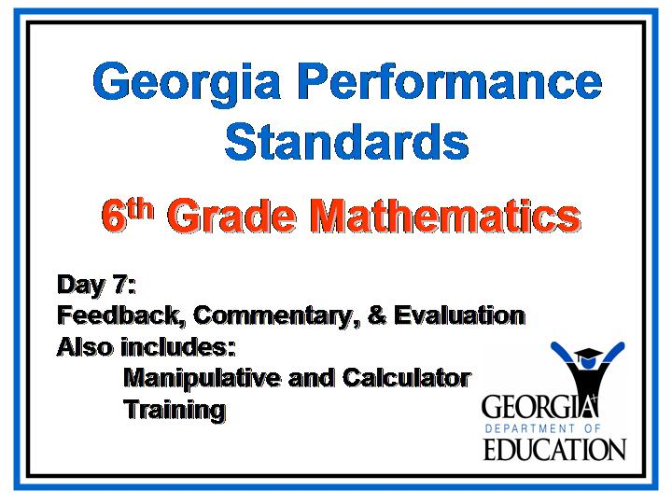  - Welcome participants to Day 7 of GPS training.
Slide | - Show slide.  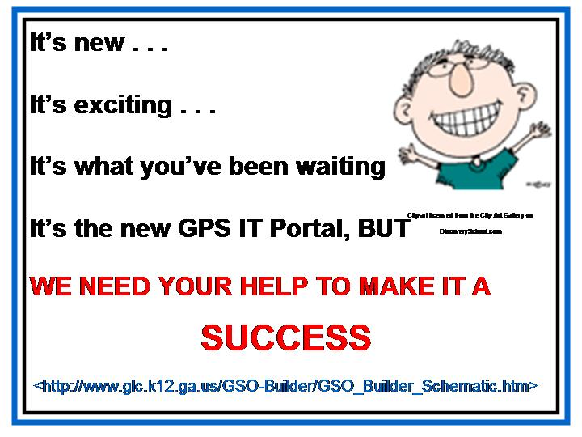
- Present: The Georgia Department of Education is pleased to announce the development of a new web portal. This new portal allows teachers to build and share units of instruction designed using GPS and the standards-based education model. To see the template design for this portal, visit http://www.glc.k12.ga.us/GSO-Builder/GSO_Builder_Schematic.htm.

[Trainer’s Note: All the information on slide 3 will appear automatically EXCEPT for the URL for the website. Click to make that appear at appropriate time.]

 | - Say: This web portal can only succeed if teachers build and share instructional units. If you have a unit you would like to submit OR if you would like to be considered for one of the reviewer positions, please contact Karen Muska in Instructional Technology and Media at the DOE. You can reach her via email at <kmuska@doe.k12.ga.us>.

Slide  Materials: Overhead projector,  a blank transparency, and an overhead pen.  For each pair of students: small opaque bags containing 36 Centimeter Cubes: 6 yellow, 18 red, 4 green, and 8 blue.  Graphing calculators will also be used during this activity.  PG- 48 | Show slide:  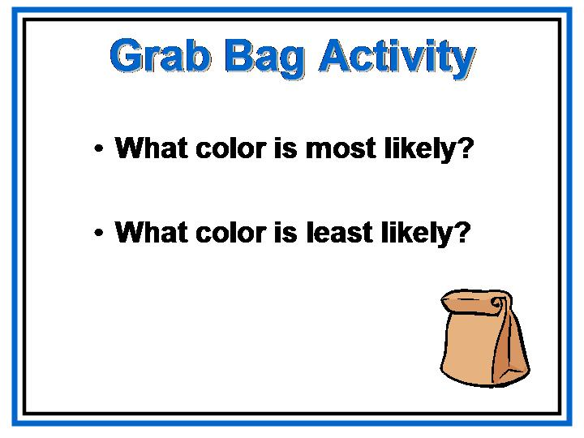  Grab Bag Activity  - Say: On your tables are small bags with 36 Centimeter Cubes in four different colors.  - Using one of the bags, invite a participant to draw one of the cubes.  - As a cube is drawn, a volunteer should record the color on the overhead using a frequency table.  - Continue for a total of 10 trials.  - Ask questions based on what they have seen so far after each drawing. Suggested questions include: What do we know about the blocks in this bag? What color is most likely to be drawn? What color is least likely?  - After 10 trials, the participants should estimate the probability of picking each color in the bag based on the experimental results.  - Dump the blocks onto the overhead and have the participants calculate the theoretical probabilities based on the number of each color out of the total.  - Have the participants compare the estimated probabilities to what should have happened.  - Ask: Were the results reasonable? If not, why?
Explore
1. Have pairs of participants repeat this experiment for 50 trials.
2. They should then create a table to organize tallies and probabilities
(as fractions), and compare their estimated probability results after
50 trials to the 10-trial figures.
Reflect and Connect
1. Ask: Which sample size gave results that were closer to the
theoretical probability: 10 trials or 50 trials? Why is
sample size important?
Allow time for discussion.
2. Ask: How did you calculate the theoretical probability of
pulling a red cube from the bag in this experiment? Explain.
Allow time for discussion.
3. Ask: Why do you think probabilities obtained from
experimental results are called estimated probabilities?
Allow time for discussion.
4. Ask: What would happen to the estimated probabilities if
all pairs combined their results? Predict the outcome. Use the
calculators to help actually combine the results and compare.
Use the calculator to try a much larger sample to compare the
results.
5. Say: Imagine how powerful this could be when the
students actually design their own probability experiments
to compare experimental probability with theoretical
probability!
Slide is linked to a video clip. | At this time, use of the calculators may help students to understand  M6D2. Students will use experimental and simple theoretical probability and understand the nature of sampling. They will also make predictions from investigations.  c. Discover that experimental probability approaches theoretical probability when the number of trials is large.  A video clip is available of sixth grade students participating in this activity.
PG - 6  Slide  Chart paper and markers.  PG -7  FG -19 | What is Exemplary Feedback?  1. Present: Feedback is an integral part of any efficient learning  process, but we don’t often stop to ask ourselves just what  constitutes effective feedback.  2. Present: Now, in your table groups, generalize or inductively  determine some criteria for effective feedback. What are  the common characteristics of effective feedback? [Allow  time for participants to come up with some common characteristics  in their table groups.]  3. Ask: What are the common criteria of the effective feedback  that you’ve determined. [As participants share their responses,  list those responses on chart paper.]  4. Present: You can find a list of these key elements in a  model learning process in your Participant’s Guide.

Key Elements in a Model Learning Process

- Initial engaging experience/pre-assessment

- Performance goals provided

- Initial teaching, modeling

- Feedback and guidance

- Opportunities to self-assess and self-adjust

- Repeated feedback and guidance, with opportunities to adjust, as needed

from “Less Teaching, More Assessing: Learning via Feedback,” ASCD Conference on Teaching & Learning, San Francisco, October 2005. Used with permission of Grant Wiggins.

1. Present: At a recent ASCD conference on teaching and learning,
Grant Wiggins stated that any task designed to allow students to
demonstrate understanding, any task worth doing, “cannot be done
properly the first time.” Wiggins asserts that learning cannot take
place without lots of tries and lots of errors. Furthermore, he
believes that students “can’t learn to be successful without
feedback.”

Slides | - Show slides.  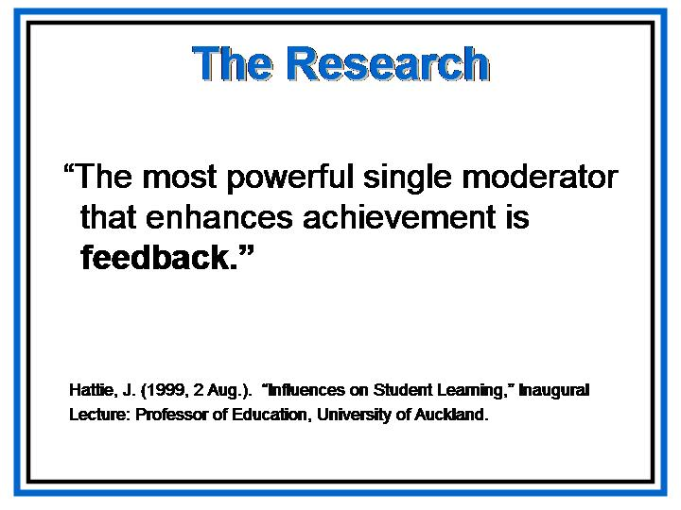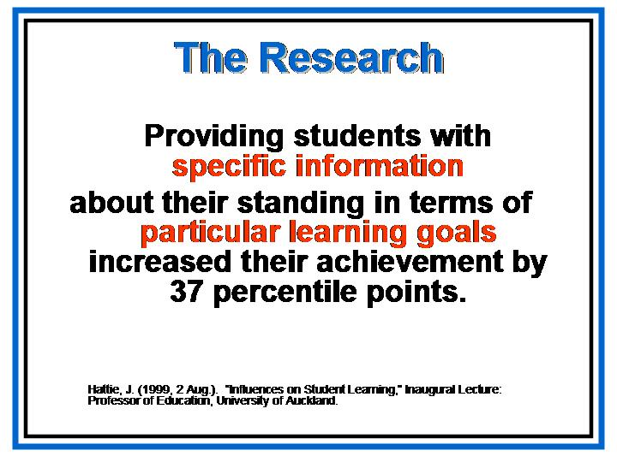  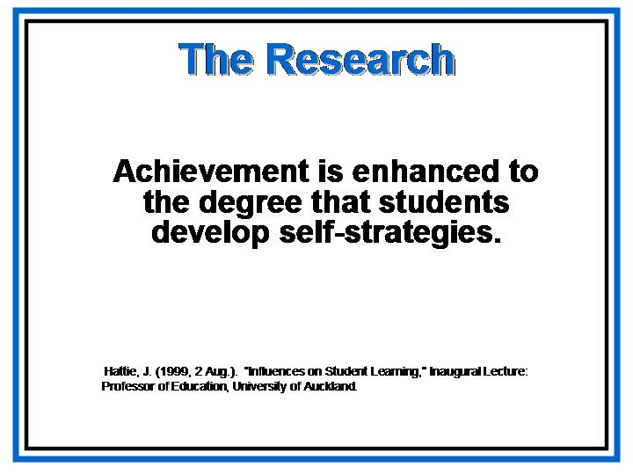  - Present:  - Although not as well known as Paul Black and Dylan Wiliam, John Hattie is a leading researcher in teaching and learning. In his research, Hattie has worked to determine the factors that have the greatest impact on teaching and learning.  - Hattie looked at the effects of computers and other technology, the effects of class size, and the effects of television viewing, just to name a few.  - He found that “the most powerful single moderator that enhances student achievement is feedback.”  - Ultimately, Hattie concluded that “a combination of goal setting plus feedback is most effective—goals and challenging goals are mutually supportive. The greater the challenge the higher the probability of the student seeking, receiving, and assimilating feedback.”

- Present:
- Hattie also found that not all forms of feedback are equally effective. Feedback that has the most positive effect on learning includes reinforcement, corrective comments, remediation, and/or diagnosis.
- This feedback provides a student with information about what s/he understands and/or misunderstands, as well as information about what that student needs to do to improve.
- Extrinsic rewards, delayed feedback, and/or punishment, however, have little or no positive effect on student learning.
- Present:
- The positive effects of feedback Hattie found were not insignificant; with feedback, achievement increased by 37 percentile points.
- Perhaps most significant of all, Hattie notes that “Achievement is enhanced to the degree that students develop self-strategies.”
- In other words, the ultimate goal of feedback is to improve students’ self-assessment skills in order to make students responsible for their own learning.

PG - 18  FG - 59 | - Present:  Groundbreaking work reported in 1998 and 2004 by Paul Black and Dylan Wiliam clearly supports feedback and assessment for learning. Their 2004 article, “Working Inside the Black Box: Assessment for Learning in the Classroom,” is reprinted, with permission, beginning in the Participant’s Guide. We strongly recommend that you take the time to read this article.  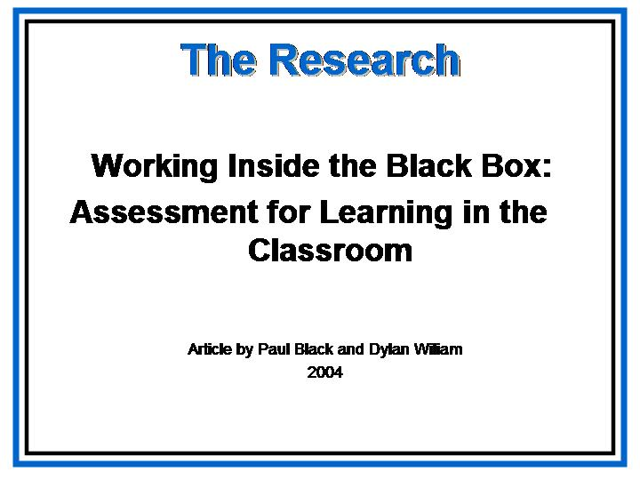  Show slide:

 | - Transition: Before we proceed any further, we need to make sure we’re all using a common vocabulary when we talk about assessment.
Slide | Coming to Terms with Assessment  - Say: If we’re going to work effectively today, we need to make sure we’re all talking about the same concepts when we use particular terms.  - Show slide.  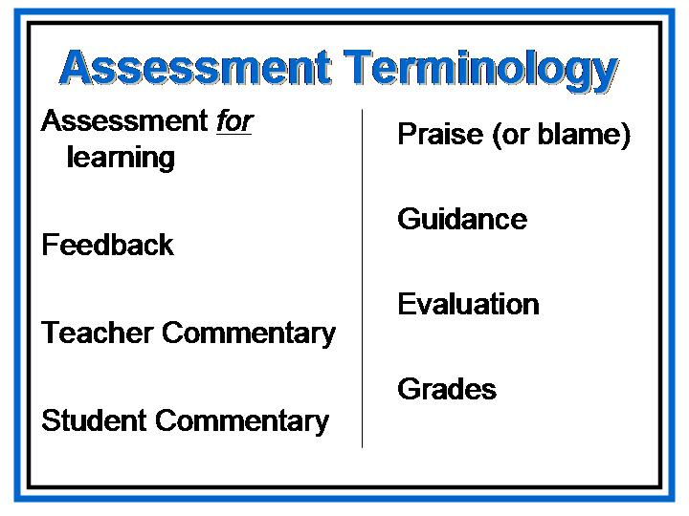
PG-8  FG - 23 | - Present: Turn in the Participant’s Guide to see how Marzano and Wiggins, among others, define these terms.
- Go over definitions with participants, then say:
- These are the definitions we’ll be using today.
- It’s also important to note that effective teacher commentary is often comprised of some feedback, some guidance, and some praise; and while feedback is effective alone, neither guidance nor praise is effective in helping students develop skills in self-assessing and self-adjusting unless the guidance and/or praise is provided along with feedback.

Assessment Terminology

assessment for learning: assessment to promote greater learning that not only guides instruction but also involves students in the process

praise (or blame): affirmation (or the opposite)

feedback: descriptive comments about what student is/is not doing

guidance: providing information about what to do next; steps or strategies to try in order to improve and progress toward learning goals

teacher commentary: oral or written comments made by the teacher that provide feedback to the student regarding his/her progress toward the specified learning goals; comments may include praise in addition to feedback and will often include guidance in addition to the feedback

student commentary: oral or written self-reflective, metacognitive comments made by the student that self-assess his or her progress toward the specified learning goals and that provide feedback to the teacher in terms of student understanding; as a result of effective self-assessment, students develop the skills necessary to self-adjust and become more independent learners

evaluation: the process of making judgments about the level of student understanding or performance

grades: numbers or letters used to translate the evaluative judgments for reporting purposes

 | Transition: Much of today’s workshop will involve hands-on group work—actually examining student work and providing commentary, but before we move on to those activities, we need to establish overall criteria for exemplary feedback.
PG-9  FG - 25  Slide | Characteristics of Exemplary Feedback and Commentary  - Present: At the same conference on teaching and learning mentioned earlier, Grant Wiggins presented a list of criteria for excellent feedback. This list is in the Participant’s Guide.  - Show slide.  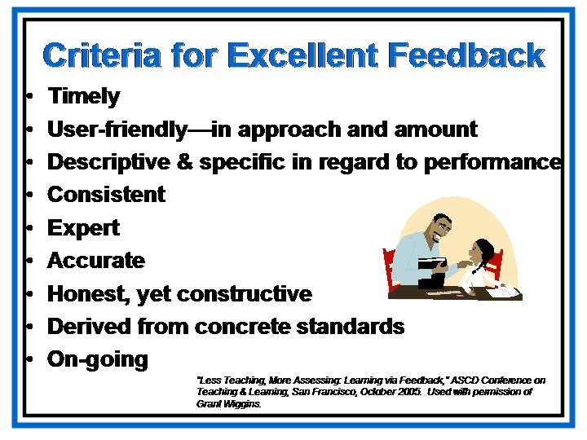
 | - Present: The first two criteria may require some elaboration. What do you think Wiggins means by “timely” and “user-friendly”? [Allow participants time to respond before continuing.]
4. Present:
  - In Making the Most of College, Harvard students overwhelmingly report that the single most important ingredient for making a course effective is “timely” feedback—getting rapid response on assignments and quizzes.

Criteria for Excellent Feedback

- Timely
- User-friendly—in approach and amount
- Descriptive & specific in regard to performance
- Consistent
- Expert
- Accurate
- Honest, yet constructive
- Derived from concrete standards
- On-going

from “Less Teaching, More Assessing: Learning via Feedback,” ASCD Conference on Teaching & Learning, San Francisco, October 2005. Used with permission of Grant Wiggins.

- According to Grant Wiggins, teachers should not only be giving feedback, they should be seeking feedback from their students constantly. He recommends pausing every 7-10 minutes during a lecture, class discussion, or learning activity to solicit immediate feedback on how well students understand. In other words, teach for 7 minutes and then put up a problem for the students to solve.

- Ask: Are there any of the other criteria you’d like to discuss before we move on?

6. Present:
  - Let’s do a quick check to see whether we can recognize good commentary when we see it.
  - Remember, effective commentary may be feedback alone or feedback with praise and/or guidance. Praise or guidance alone, however, is not effective commentary.

- Conclude: By checking for understanding and misunderstanding regularly, teachers can modify instruction to meet students’ needs sooner rather than later.

Transition: Providing effective commentary takes practice, which is what we’re going to do next. Do you have any questions about this first part of the workshop before we go on? Allow for questions

Manipulating Manipulatives with Feedback and Commentary

Overview | In this section, participants will practice providing commentary for samples of student work, generalize this practice to student commentary [providing students with the skills they need to self-assess and self-adjust], and work with a protocol for collaboratively evaluating student work.
Objectives | - Provide effective teacher commentary for student work.  - Establish procedures to develop students’ metacognitive, self-evaluative skills.  - Become familiar and comfortable with the Pattern Blocks, Centimeter Cubes and Calculators that were sent to the schools.  - Establish protocols for examining student work collaboratively.
Activities | - Maximum/Minimum Measurements (Centimeter Cubes and Calculators)  - Review of Student Work  - Providing Teacher Commentary  - Oral Commentary  - Written Commentary  - Fraction Puzzles (Pattern Blocks and Calculators)  - Procedures for Students  - Group Practice with Commentary
Materials | - Overhead projector, computer and LCD projector  - PowerPoint presentation  - Participant's Guide  - Samples of student work  - Posters of student work sample for guided practice  - Centimeter Cubes  - Pattern Blocks  - TI-83 Plus Calculators  - Write-on transparencies and pens for overhead projector

 | Providing Teacher Commentary
Two Slides | - Present: Teacher commentary may be oral or written. Regardless, all effective teacher commentary will accomplish certain goals.  - Show slides.  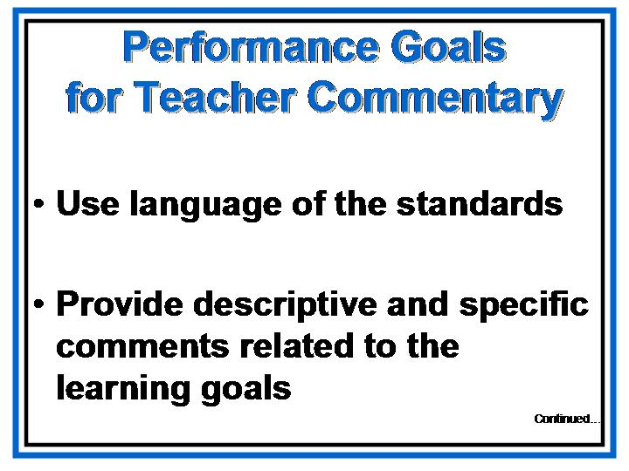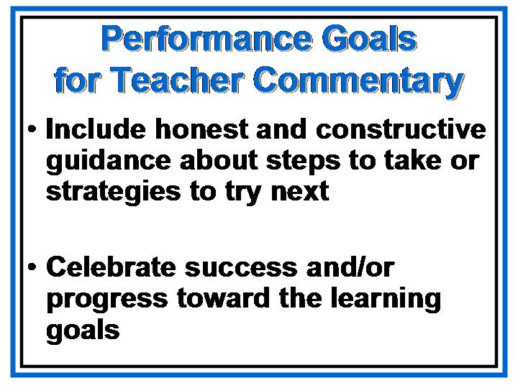  - Present:  - All effective teacher commentary uses the language of the standards. Keep in mind that the GPS involve conceptual teaching and learning. In writing commentary, no single standard or element has to be stated verbatim. The language of the standards will be pervasive, however, in the performance goals for an assignment or unit of instruction, and consequently, in any commentary related to the assignment.  - Students in any discipline need to be familiar with the rhetoric of that discipline and be able to converse using both the discourse of that discipline and specific and relevant content vocabulary from that discipline. As such, the language of the discipline, which is explicit in the standards and elements, should be the language of the classroom on a daily basis.  - In addition, effective teacher commentary includes specific and descriptive feedback, guidance regarding what to do next, and praise that is specifically related to progress toward the learning goals.

NOTE: It is possible that the video will be a science one instead of mathematics. At the time of the deadline for this module, the mathematics one is not ready. | Oral Teacher Commentary  - Say:  - First we’re going to see a video clip of a 6th grade Mathematics student-teacher conference that took place a few weeks ago in a Georgia middle school.  - The assigned task, relevant standards, and learning goals are the ones that we just completed – The Grab Bag Activity.  - Let’s review this information so we’ll have a better idea of what to look for in the clip. [Read over and discuss the assigned task, relevant standards, and learning goals, before beginning the video clip.]

 | - As you watch this student-teacher conference, you may want to jot down a few notes to help you remember what you see and hear. In addition, if you hear the language of the standards, you might want to make a note concerning that as well.
Slide  DVD is linked to the slide to show an example of oral teacher commentary. | - Show slide. Click to start the video clip.    - Say:  - Describe what you saw. What did you see the teacher do? What did you see the student do? [Allow time for participants to respond.]  - Did the conference meet the performance goals for good commentary? Let’s take another look at those goals one by one to check.
Slides | - Show slides.  - Ask:  - Did the commentary use the language of the standards being addressed? [Allow time for participants to respond, but have some specific examples ready to provide if the participants have difficulty.]

- What specific words did you hear that you see in the standards? [Allow time for participants to respond, but have some specific examples ready to provide if the participants have difficulty.]
- Who used the language of the standards?

 | - Say: Now let’s look at the second performance goal for teacher commentary.
- Ask:
- What descriptive feedback did the teacher provide? [Allow time for participants to respond, but have some specific examples ready to provide if the participants have difficulty.]
- Was that feedback specific to the learning goals for the assignment? [Allow time for participants to respond, but have some specific examples ready to provide if the participants have difficulty.]
- How can this descriptive feedback help the student improve his/her performance?

Slide | - Say: Now let’s look at the last two performance goals for teacher commentary at the same time.  - Show slide.

- Ask:
- What direct evidence of guidance did you see in the clip? [Allow time for participants to respond, but have some specific examples ready to provide if the participants have difficulty.]
- Did you notice how the teacher allowed time for the student to think and to respond? Remember Wiggins’ mantra: “Give less advice and more feedback.” Did you see this exemplified in this oral commentary? [Allow time for participants to respond, but have some specific examples ready to provide if the participants have difficulty.]
- What other strategies did the teacher employ in providing feedback along with constructive guidance?
- How will this feedback and guidance improve student learning? [Allow time for participants to respond, but have some specific examples ready to provide if the participants have difficulty. Be sure to make the point that this kind of feedback with guidance helps students self-assess and self-adjust and become more responsible for their own learning.]

- Why might it be beneficial to include praise ALONG WITH the feedback and guidance? [Allow time for participants to respond.]

- Ask: Can praise ever be ineffective? [Allow time for participants to respond.]

- Present:
- Praise (or blame) is not effective without feedback. Students need specific, descriptive information about what they do well or what they do not do well. The same thing can be true of guidance. Guidance without feedback is ineffective. Did you see any examples of praise or guidance without feedback in the video?
- In addition, praise may be detrimental if it is undeserved. Praising a student for what s/he does well or for progress toward the learning goals is beneficial, but students will see right through undeserved praise.

- Ask:
- What can we conclude about the oral commentary you just analyzed? [Allow time for participants to respond, but have some specific examples ready to provide if the participants have difficulty. Be sure to make the point that throughout the conference, the teacher checks for understanding and for misconceptions.]
- Overall, what can we conclude about oral commentary in general? [Allow time for participants to respond.]

- Ask: How and/or when might we use oral commentary to enhance student learning in our own classrooms? [Allow time for participants to respond, but have some specific examples ready to provide if the participants have difficulty.]

- Present:
- We can’t complete any discussion of oral commentary without addressing the issue of time. We all know that lengthy student-teacher conferences are not possible with every student on every assignment, but oral commentary is essential for improving student learning.
- In your table groups, brainstorm ways you might incorporate or adapt oral commentary in your classrooms. For example, have you ever tried pyramiding or training trainers in your classroom—conferencing with three to five students and then asking them to peer conference with others in the class? You have 10 minutes to brainstorm in your table groups, then we’ll share ideas. [Allow 10 minutes, then ask groups to share.]

Maximum/Minimum Measurements

Materials: For each pair of students: about 100 Centimeter Cubes.  PG – 60 | 1. Challenge the participants to use the Centimeter Cubes to build all  possible rectangular prisms using 12 cubes.  2. Have them record their work by sketching each prism in a math  log, labeling the surface area.  3. Discuss which prisms have the greatest and least surface areas for  a volume of 12 cm³.
 | Explore
1. Invite the participants to use Centimeter Cubes to investigate the
possible rectangular prisms with volumes of 16, 24, and 36 cubes.
Record the dimensions and surface area of each in a table. Circle
the maximum and minimum surface areas for each volume.
2. Ask the participants to look at the sketches for all three volumes
and compare the prisms having the greatest surface areas with
those that have the smallest surface areas. They should describe
any patterns they see.
Reflect and Connect

Ask participants the following questions:
1. What strategy did you use to make sure that you had
built all possible prisms with a given volume?
2. How can figures with the same volume have different
surface areas? Explain.
3. Can you think of a method for finding the maximum
volume for a given surface area? Try your plan by finding
the maximum volume for a surface area of up to 24
square units. (Use only whole number dimensions.)

 | Communicate
A video clip is attached to the power point presentation that shows sixth grade students involved in this activity. | Teachers could ask their students to write a proposal to a cereal company for a box that uses the least amount of material for a volume of 4913 cubic centimeters. Each dimension should be a whole number. Students should describe the benefits and drawbacks of their designs.  It would be beneficial for the students to “discover” the relationship of the dimensions as factors of the volume.

Slide  PG – 39  (Note that supplemental pages of student work on the Maximum / Minimum Activity may be used instead if it is available.) | Written Teacher Commentary  - Say: Now let’s move on to an example of written teacher commentary.  - Show slide.  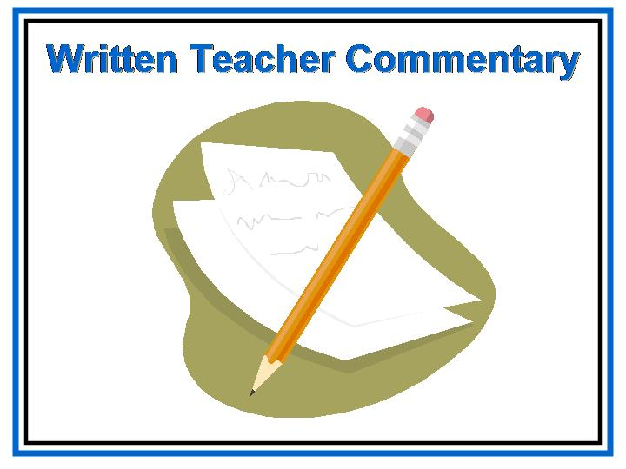  - Present:  - Turn to the Participant’s Guide where you’ll find the sample of student work and teacher commentary (cylinder task). [Hopefully, by the time of training, we may use actual Georgia student work samples with teacher commentary using the previous Maximum/Minimum Measurement activity. Unfortunately, at the time of printing this module, these work samples are not yet available.]  - Take a minute to read the student work and teacher commentary. [Allow time for participants to read student work.]  - Remember that feedback and teacher commentary are most effective in small segments. Too much feedback at once is as ineffective as too little feedback.  - How might we provide feedback on these learning goals without overwhelming the student writer?  - What suggestions do you have for improving the example of teacher commentary?
SIXTH GRADE MATHEMATICS
GEORGIA STUDENT WORK SAMPLE:
Cylinder Task

- Explain what is meant by surface area. What steps would you take to find the surface area of a cylinder?

- One of the major expenses in manufacturing a can is the amount of metal that goes into it. How many square centimeters of metal would be required to manufacture a can that has a diameter of 8 cm and a height of 20 cm? Estimate and then solve.

- Draw a net (pattern) for the manufacturer to use to make the can.

- Use your work in parts a – c to write a rule in words for finding the surface area of a cylinder. Now write your rule using letters, numbers, and mathematical symbols (a formula).

- Michael bakes a round two-layer birthday cake that is to be covered with frosting on the top, sides, and in between the layers. Each layer has a height of 4 cm and diameter of 24 cm. The label on the can of frosting he bought claims that the contents will cover the top and sides of a one-layer rectangular sheet cake that is 32 cm by 22 cm by 4 cm. Will Michael have enough frosting? Show how you know.

M6N1. Students will understand the meaning of the four arithmetic operations as related to positive rational numbers and will use these concepts to solve problems.
g. Solve problems involving fractions, decimals, and percents.

M6M4. Students will determine the surface area of solid figures (right rectangular prisms and cylinders).
a. Find the surface area of right rectangular prisms and cylinders using manipulatives and
constructing nets.
b. Compute the surface area of right rectangular prisms and cylinders using formulae.
c. Estimate the surface areas of simple geometric solids.
d. Solve application problems involving surface area of right rectangular prisms and
cylinders.

SIXTH GRADE MATHEMATICS
GEORGIA STUDENT WORK SAMPLE:
Cylinder Task
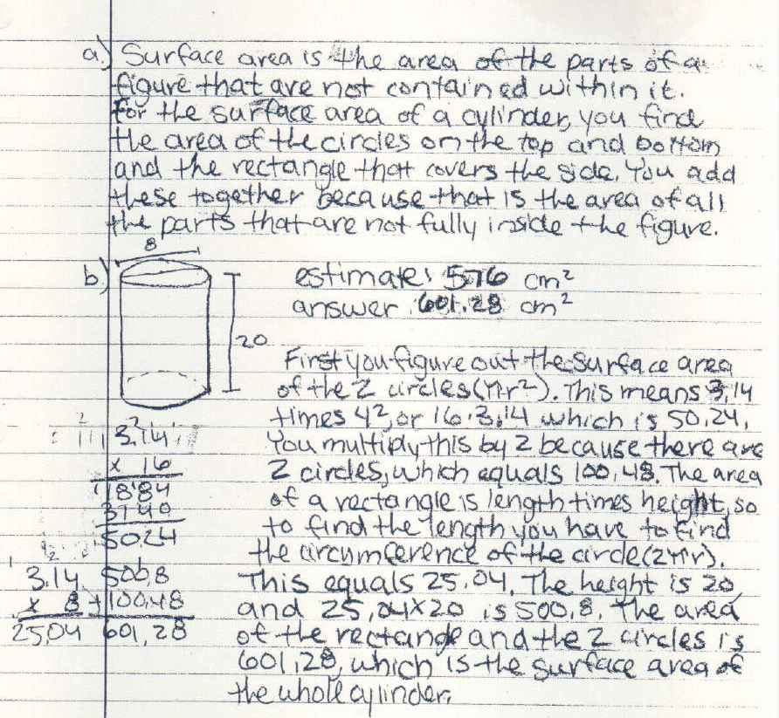

a)
1

2

b)
3

4

a)
1. The student shows a clear understanding of the meaning of surface
area.
2. The student demonstrates that he/she is able to determine the surface
area of a cylinder. (M6M4)

b)
3. Although the estimate of the surface area of the cylinder is reasonable,
there is no explanation of the process. (M6M4c)

4. Even with a slight computational error, it is evident that the student
does understand the meaning of addition and multiplication as related
to positive rational numbers and is able to use these concepts to solve
problems. (M6N1)

Continued…
SIXTH GRADE MATHEMATICS
GEORGIA STUDENT WORK SAMPLE:
Cylinder Task
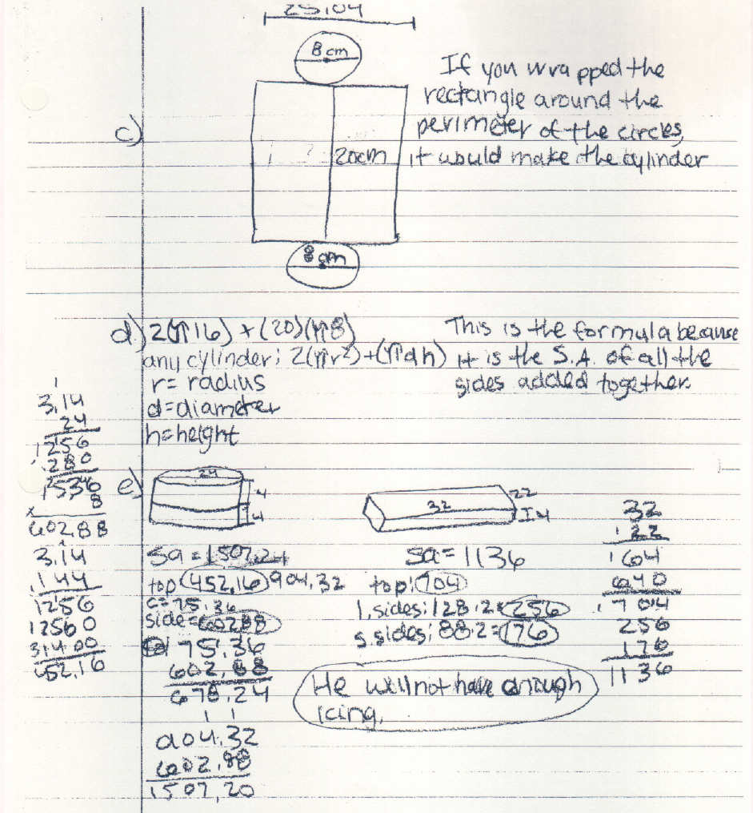

c)
5

d)
6

e)
7

8

c)
5. It is apparent that the student is able to construct a net for the cylinder.
(M6M4a)

d)
6. The work shown indicates understanding of the development of the
formula for surface area of a cylinder. (M6M4)

e)
7. The computational error mentioned in comment 4 is corrected here.

8. All work is accurate and indicates mastery of the standard M6M4 and
element M6M4d.

 | Guided Practice
NOTE: Additional student work samples are in the PG. | - Present:  - Remember, nothing worth doing is done perfectly the first time. Providing effective teacher commentary takes practice and involves trial and error.  - Just as in the model learning process we discussed earlier, we’ve established performance goals for teacher commentary; we’ve experienced initial teaching and modeling; and now we’re ready for some guided practice with feedback.

 | - Present: We’re going to follow a specific protocol for this activity. When examining student work collaboratively with your building or system colleagues, you’ll want to establish protocols similar to the one we’re using today or to one of the protocols described in detail in the Facilitator’s Guide for the Day 3 training module. The protocol we’re using today is adapted from one developed by the Chicago Learning Collaborative and the Annenberg Institute for School Reform. You can find a virtual example of this protocol at www.lasw.org/. There is also a link to this website on the School Improvement page of the DOE website.
Slides | - Show slides.  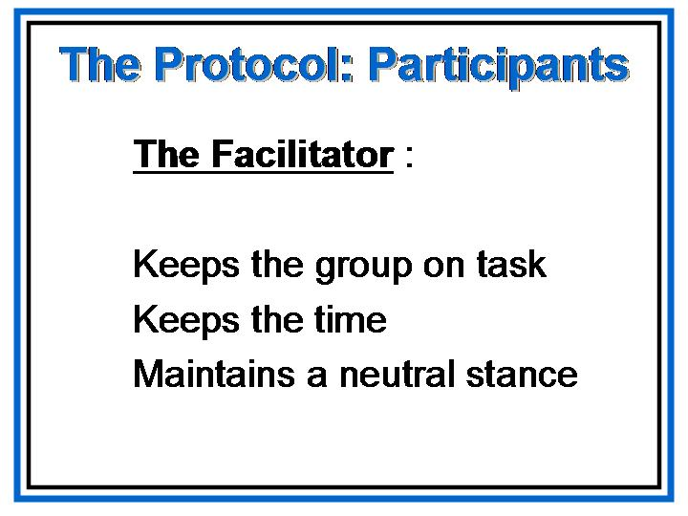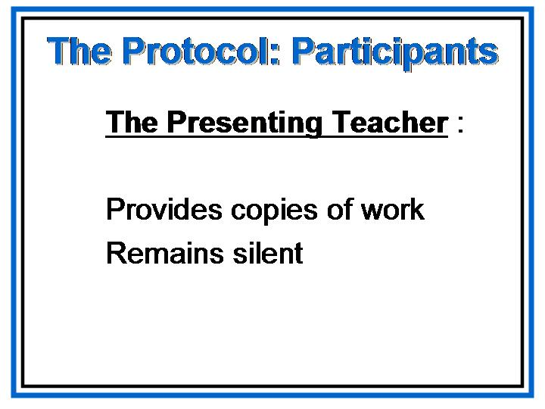  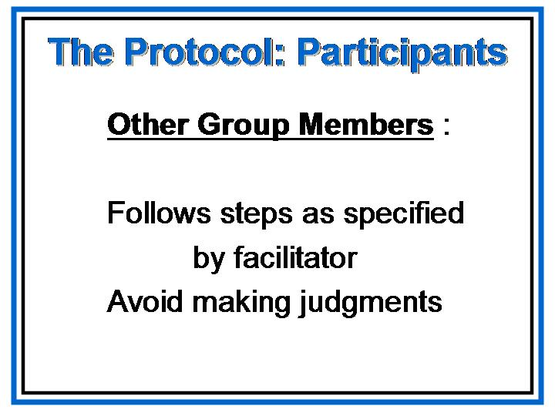  - Present: For this particular practice, I will serve as the facilitator for the whole group and will also provide the sample of student work. You will work in your table groups and follow the following five steps of the protocol.
Slide | - Show slide.  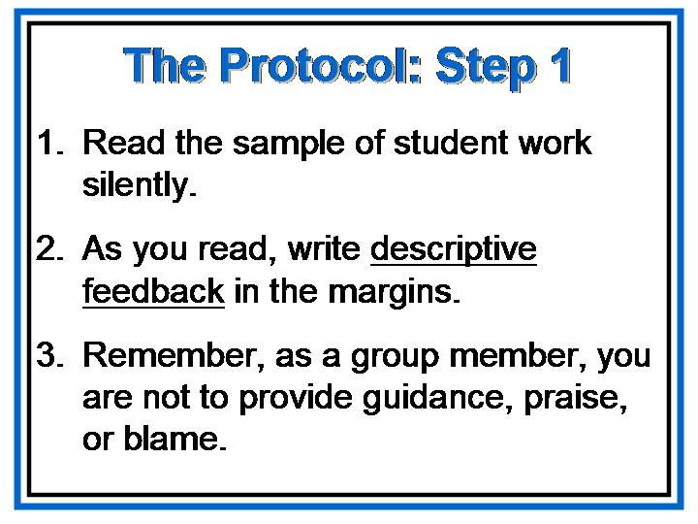
- Present:
- Work individually during Step 1 of the protocol. As you read the student sample silently, write descriptive feedback in the margins.

- Try to remain neutral in your comments at this stage in the protocol; in other words, avoid making any positive or negative judgments—praise or blame—about what you see; also try to avoid providing guidance or suggestions for what to do to improve the work.

- Remember, the purpose at this stage of the protocol is to describe just what you see without making any judgments. When working collaboratively to examine student work, we are discussing work that has been generated in our classroom or the classroom of a colleague. As such, we need to follow clearly defined procedures that will maintain a sense of professionalism and prevent anyone from feeling criticized personally. Maintaining this collegial atmosphere is a primary task of the facilitator.

PG – 41 and 43  (Note that different work samples may be used.) | - You have 10 minutes to complete Step 1 of the process. Please do not consult with one another at this stage. The sample of student work is in the Participant’s Guide. [Allow 10 minutes, then go to the next step.]
Slide | - Show slide.  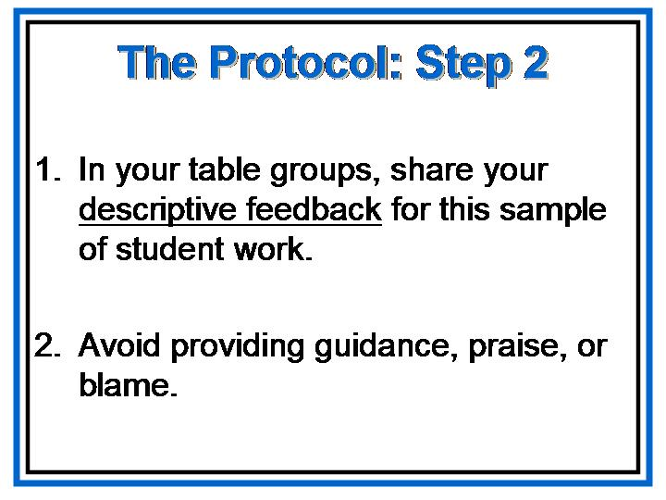
 | Present: For step 2 of the protocol, share the descriptive feedback that has been individually noted. You may add to your notes if you wish. Again, at this stage in the protocol, all discussion should center on what you “see” in the student work. Continue trying to remain neutral in your comments, avoid making any positive or negative judgments—praise or blame—about what you see, and avoid providing guidance or suggestions for what to do to improve the work. You have 10 minutes for Step 2. [Allow 10 minutes, then go to the next step.]

Slide | - Show slide.  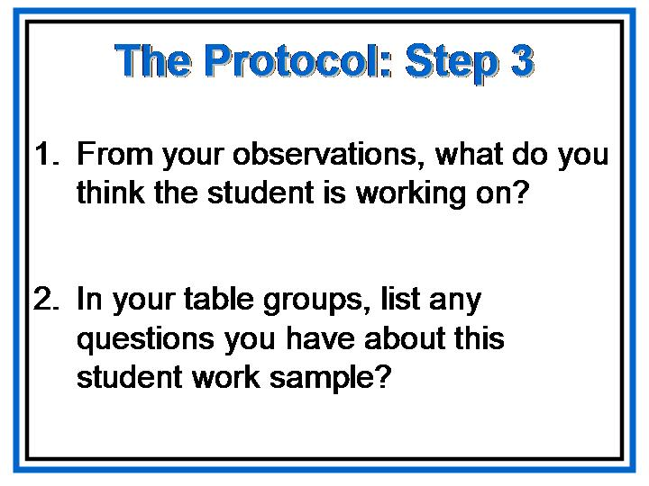
- Present:
- Step 3 of the protocol requires speculation about the purpose or focus of the assignment that generated this student work. From what you see, what might the learning goals for the assignment be?
- Work in your table groups to answer the questions in the first part of Step. You have 5 minutes for this, and then we’ll address the second part of Step 3 all together. [Allow 5 minutes.]

- Ask:
- What did your groups decide? What do you think the primary purpose of this student work is? [Allow time to participants to present their ideas.]
- If the student sample meets the learning goals or fulfills the primary purpose of the assignment, do you think a reader should be able to determine that purpose or the overall learning goals? [Answers may vary, but in general, the primary purpose or overall learning goals will usually be discernable in effective student work.]
- Ask: What questions do you have about the student work? [Again, answers may vary, but expect participants to ask about the standards being addressed, the task, etc.]

Slide | - Say: Let’s move on to the next step of the protocol.  - Show slide.  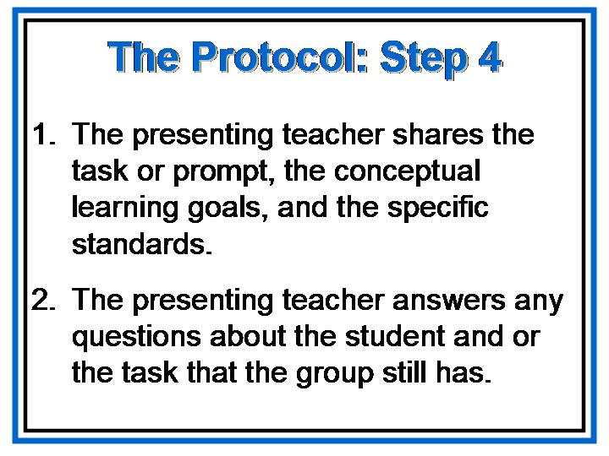
- Present:
- At this point, the presenting teacher would share the task, learning goals, and standards for the work sample.

- Please note that a rubric was not provided for this student work at this time. This is intentional. The purpose is to keep feedback separate from evaluation. Teacher commentary is not the same thing as scoring or grading the student.

- Likewise, the student would be provided with the criteria and the descriptors for what it will take to “meet the standard” on those criteria, but without any points or grade attached and without the other “does not meet” levels of performance. This promotes the idea that even though they may do so in different ways and at different rates, ALL students are expected to meet the learning goals.
- Also note that the student may not be provided with the criteria for the other levels of the rubric at this point in the learning process. However, those criteria would be a part of the unit planning; and when providing feedback to the student, language specific to the other levels of the rubric would be used to describe what the student has accomplished and what the student has not yet accomplished.

- For years we’ve been told to provide the grading rubrics when we make the assignment, so this is a big change in mindset for all of us. Current research, however, advocates separating feedback from evaluation for a variety of reasons.
- Allowing students to participate in the development of a rubric can be a valuable learning tool, and rubrics that grow out of classroom work often make better sense to student learners.
- Furthermore, by providing the students with just the criteria for meeting the standards, we preclude having students decide to “work for a B,” or be “happy with a C.”
- In addition, students can become anesthetized by rubrics to the point that they use the descriptors as a check list, whether or not they have met the criteria.
- Finally, the practice of initially providing students with just those criteria for meeting the standards supports the basic tenets of the Georgia Performance Standards—
1) the standards are for all students;
2) students have the entire course to meet the
standards;
3) it’s all about growth; and
4) if a student does not meet the standard on the first
or second try, we provide more feedback and more
tries until s/he does.
- The task was the same one that we just did, “Minimum/Maximum Measurements”. Since we have already worked through this task, discussed the conceptual learning goals and the standards; unless there are any questions, we will move on at this time.
 | - Do you have any questions about the task or the standards? [Address any questions.]
 | - Present: Let’s move on to the final step of the protocol.
Slide | - Show slide.  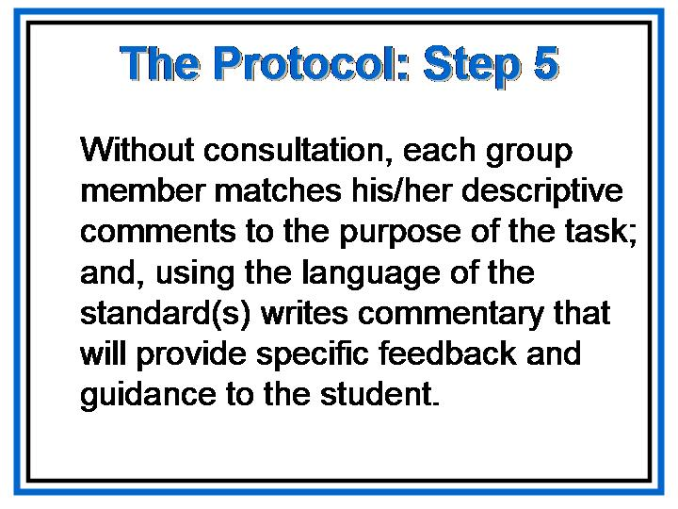

- Present:
- In the final step of the protocol, you have 10 minutes to write one or more short pieces of commentary specific to the learning goals delineated in the task. These must include descriptive feedback, but at this point in the protocol, you may also include some praise as well as guidance about what steps to take next in order to progress toward the learning goals of the assignment.
- Write each piece of commentary on a separate yellow post-it. This is an individual activity. Please do not consult one another during this step.
- When you have finished, please attach your post-it notes of feedback to an appropriate place on the work sample poster closest to your table. [Allow 10 minutes.]

- After 10 minutes, Present:
- For this guided practice to be effective, you need feedback. The process for giving and receiving feedback should mirror the process you followed for the commentary that you wrote for the student sample.
- The feedback you give and receive on the commentary you wrote should
- Use the language of the performance goals for teacher commentary, and
- Provide descriptive and specific comments related to the learning goals.
- You may also choose to
- Include honest and constructive guidance about steps to take or strategies to try next, and
- Celebrate success and/or progress toward the learning goals.
- Posters will be displayed for reference during subsequent practices with writing teacher commentary.

- Present: Let’s debrief this process.
- What worked well?
- What changes might we make in the protocol to improve the process?
- Why is this process important for teachers to experience?
- How can this process improve student learning?
- When and where might you use teacher commentary in your own classrooms?
- How might you use this process to help students become better assessors of their own work and the work of their peers?

- Present: We need to address a few final questions before we move on.
- How often should we provide feedback to our students? [The correct response is constantly, on a daily basis.]
- Will all the feedback be lengthy? [The correct response is “no”; feedback is most effective in frequent small doses.]
- How often should we provide more detailed commentary? [There’s no single correct answer to this question; however, commentary should be a regular part of the learning process.]
- How can this process improve student learning?

 | Procedures for Students
- Present:
- Commentary is part of assessment for learning rather than of assessment of learning.
- The goal of teacher commentary, both oral and written, is to provide the student with the knowledge and skills to self-assess and self-adjust.
- To maximize student learning, not only do we need to provide effective feedback and commentary, we also need to train students to provide effective feedback and commentary for their own work and the work of their peers.

Slide | - Show slide.  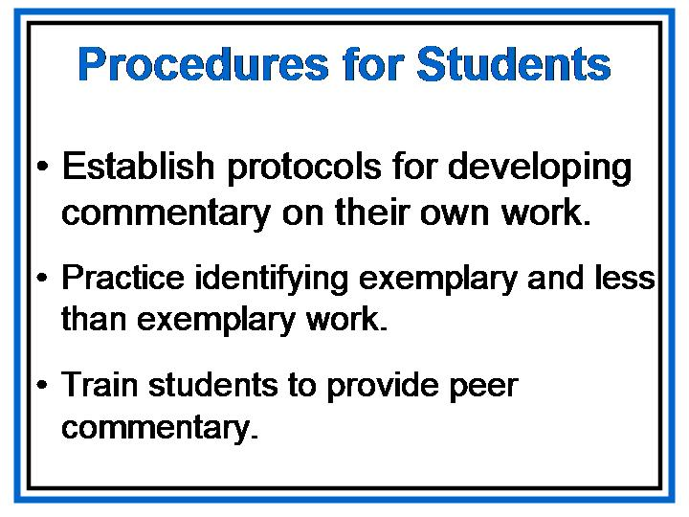
- Present:
- We can adapt or modify the protocol we just used in order to train students to provide feedback and commentary on their own work and the work of their peers.
- We can provide students with exemplary models of products or performances, along with products or performances that are not exemplary, and have the students work in groups to determine what makes an exemplary product or performance.
- What other strategies can you think of that will help students become adept at self-assessing their own work in order to adjust and improve that work? [Allow time for participants to respond.]

Slide | 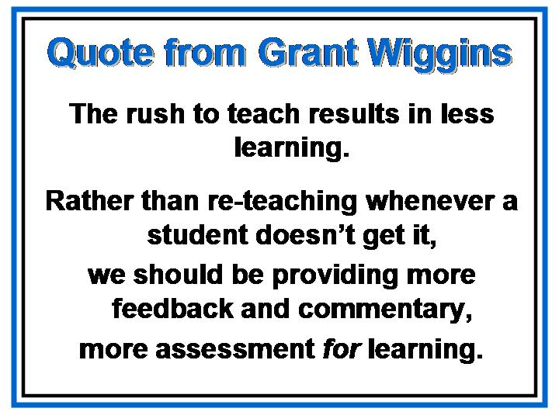  - Show slide:
- Present:
  - When asked how anyone could possibly have the time to provide and solicit effective commentary, Grant Wiggins responded that “the rush to teach results in less learning.” He added that we shouldn’t confuse “coverage” with “everyone getting it,” and that rather than re-teaching whenever a student doesn’t get it, we should be providing more feedback and commentary, more assessment for learning.
  - Indirectly, Wiggins is affirming the importance of conceptual teaching and learning.
  - Our ultimate goal should be our own planned obsolescence—to help our students become proficient enough in assessing and adjusting their own learning that they no longer need us!

 | - Present: Providing feedback and commentary so that students learn to self-assess and self-adjust may be another change in mindset for many of us. As such, we may experience frustration as we venture beyond our comfort zones; but the results of an effective feedback/self-assessment system speak for themselves.
- Present:
- It has been a while since we did some math.
- At this time, look in your Participant’s Guide at the Fraction Puzzle Activity.

PG - 63  Slide | - Present:  - This activity may be found on pages 50-53 in the Pattern Blocks: the Super Source booklet by ETA/Cuisenaire® that accompanied the manipulatives that were shipped to schools.  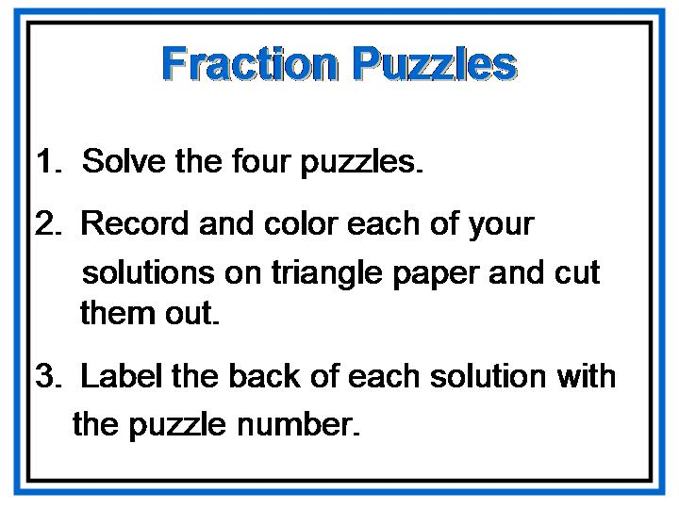  Show slide:
- Place the shape of an equilateral triangle on the overhead.
- Say:
- Build this shape using four green triangles.
- What fractional part is each small triangle?
- Substitute a blue block for two of the green blocks in the large triangle.
- Ask:
What fractional part of the triangle is the blue block?

- Present:
- At this time, take a few minutes to solve the four puzzles.
Allow a few minutes for the participants to solve the puzzles.

- Put up four pieces of chart paper. Each one should be labeled with one of the Puzzle numbers. Encourage the participants to tape their solutions beneath the appropriate headings.
- Allow time for discussion with questions such as the following:
- What discoveries did you make as you solved the puzzles?
- What strategies did you use to find solutions?
- How many possible solutions do you think there are to each of the puzzles?
- How are the solutions for each puzzle the same? How are they different?
- How can you convince us that a particular solution is correct?

Fraction Puzzles

Materials: Pattern Blocks, about 12 green, blue, and red  blocks per pair;  Pattern Blocks; Triangle Paper; Crayons;  Scissors;  Overhead Pattern Blocks;  Chart paper;  Tape | Have the participants:  - Build this Pattern Block shape using four green triangles.  - Ask them what fractional part each small triangle is.  - Substitute a blue block for two of the green blocks in the large triangle. Have the participants confirm that the blue block – since it is equivalent to two of the green triangles – is two-fourths, or one-half, of the triangle.
Can you solve these Pattern Block fraction puzzles?

Working with a partner, use pattern Blocks to solve each of these fraction puzzles in at least two different ways:
Puzzle 1: Build a triangle that is one-third green and two-thirds red.
Puzzle 2: Build a triangle that is two-thirds red, one-ninth green, and two-ninths
blue.
Puzzle 3: Build a parallelogram that is three-fourths blue and one-fourth green.
Puzzle 4: Build a parallelogram that is two-thirds blue and one-third green.
Record and color each of your solutions on triangle paper and cut them out. Label the back of each solution with the puzzle number.
Divide four pieces of chart paper, labeling them Puzzle 1, Puzzle 2, and so on. Have each pair post its solutions beneath the appropriate headings. Use prompts such as these to promote discussion:

- What discoveries did you make as you solved the puzzles?
- What strategies did you use to find solutions?
- How many possible solutions do you think there are to each of the puzzles?
- How are the solutions for each puzzle the same? How are they different?
- How can you convince us that a particular solution is correct?

Continued…

Fraction Puzzles
Continued…
Extending the Activity

- Participants may work with their partners to create their own fraction puzzles with triangles or parallelograms. They may trace and color two possible solutions for each puzzle, and write the puzzle itself on the other side of the paper. Encourage them to share puzzles, perhaps in a “class puzzle book” or “class puzzle box” to be used at an independent math center.
- Have the participants create puzzles in which a square or a hexagon represents the whole.

Pattern Block Shapes

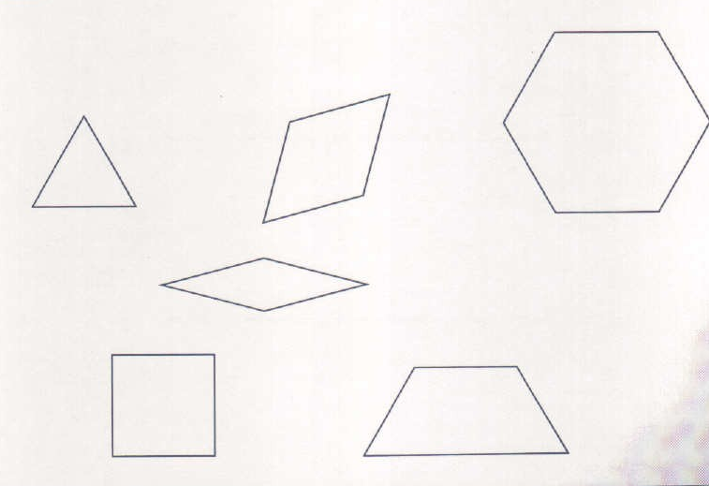


Practicing Student Commentary
Say: You were the students for this activity. Now let us follow the procedures for students in providing self-assessment and self-adjustment. This practice will help us to help our students reach that “ultimate goal”.
Say: You will have about 10 minutes to work with a partner and provide commentary on each of your results from the “Fraction Puzzle” activity.

After about 10 – 15 minutes allow discussion concerning this commentary.

 | Group Practice
PG – 10  FG - 54 | - Present:  - You were asked to bring four copies of a student work sample.  - Please organize yourselves into groups of no fewer than three persons and no more than four persons. These groups may be smaller than those you usually work with in your building or your system, but this size allows us to accomplish more in a relatively short period of time.  - Still, you may not have enough time to write commentary for everyone’s student work. Follow the protocol for one student sample at a time, and finish as many as you can in the time allotted.  - We’ll follow the same protocol we used in the guided practice. You can find that protocol in the Participant’s Guide.
Slide | - Show slide.  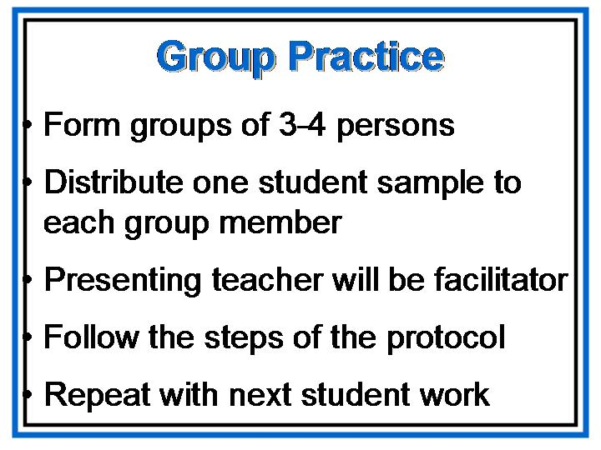
 | - Say: You have 1 hour for this group practice.

Protocol for Collaborative Writing of Teacher Commentary

The Participants

The Facilitator—keeps the group on task; keeps the time; maintains a neutral stance
The Presenting Teacher—provides copies of the work; remains silent until Step IV
Other Group Members —follow steps as specified by facilitator; avoid making judgments

Step 1

- Read the sample of student work silently.
- As you read, write descriptive feedback.
- Remember, as a group member, you are not to provide guidance, praise, or blame.

Step 2

- In your group, share your descriptive feedback for this sample of student work.
- Avoid providing guidance, praise, or blame.

Step 3

- From the observations you’ve made about the student work, what do you think the student is working on? In other words, from what you see in the student work, what do you think is the purpose of this assignment?
- In your group, list any questions you have about this student work sample?

Step 4

- The presenting teacher shares the task or prompt, the conceptual learning goals, and the specific standard or standards.
- The presenting teacher answers any questions about the student and/or the task that the group still has.

Step 5

- Without consulting one another, each group member matches his/her descriptive comments to the purpose of the task; and, using the language of the standard(s) writes commentary that will provide specific feedback and guidance to the student.

Debrief—Share your commentaries within your group and provide each other with descriptive feedback in terms of performance goals for effective commentary.

Slide | - Show slide [after the hour for Group Practice].  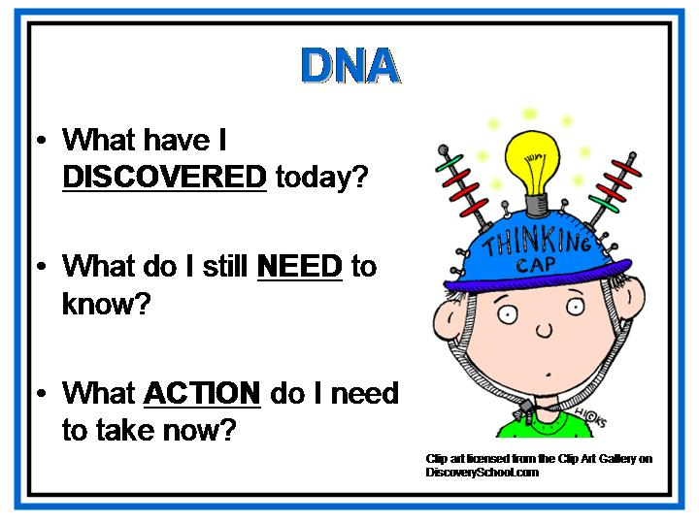
- Present:
- To conclude the commentary section of today’s workshop, let’s think about what we’ve done.
- What have you discovered today about providing teacher commentary? [Allow time for participant’s to share.]
- What do you still need to know? [Allow time for participant’s to share.]
- What action do you need to take as a result of this training? [Allow time for participant’s to share.]

 | - Conclusion: Providing effective teacher commentary and developing our students’ skills in self-assessing and self-adjusting enhance student learning and, as a result, improve student achievement. As one of the four parts of the Georgia Performance Standards, teacher commentary must be a part of our implementation plans. Begin with what’s doable, then practice and work collaboratively to develop consistency in your commentary.

Where Do We Go From Here
Overview | Participants will discuss a survey they will use to convey information about Georgia Performance Standards implemented in Phase I. Trainers will preview Day 8. The workshop will wrap up with a slide show representing the importance of improving achievement for all students.
Objective | - Gather information and prepare for Day 8.
Activities | - Feedback on the GPS  - What It’s All About
Materials | - Overhead projector or computer and LCD projector  - Transparencies or PowerPoint presentation  - Participant's Guide  - Survey for Day 8

Feedback on the GPS

  - Present:
- Last fall we asked you to begin keeping critical comments about particular standards (e.g., gaps that need filling, elements that are problematic, terms that need defining, etc.), as well as information about any tasks, strategies, assessments, etc., that worked especially well, suggestions for teachers/instructional leaders in Phase II who will be implementing the following year, and thoughts or ideas about the second year of your implementation; etc.
- The State Board of Education will be reviewing the GPS this spring, and any comments you share with us will provide information for this review.

PG - 11  FG - 58 | - [Local System Trainer’s note: When redelivering Day 7, refer participants to the survey in their Participant’s Guide. Set a date and procedures for participants to return the surveys to you, then continue.]
Slide | - Show slide.  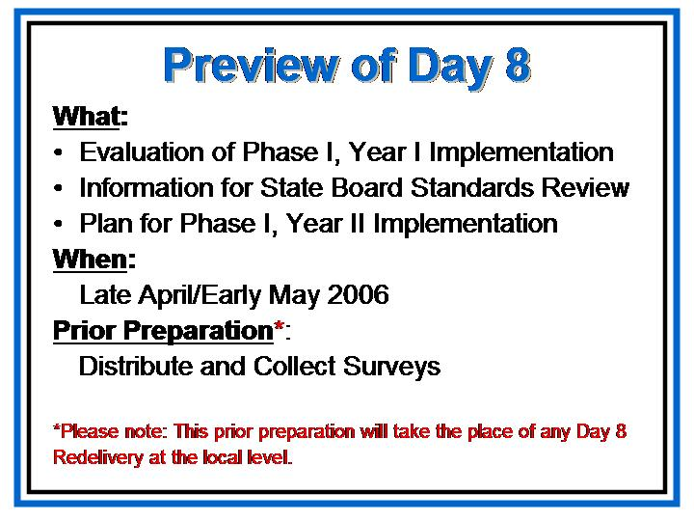
PG - 11  FG - 58 | - Present: Day 8 will focus on the assessment of the GPS and the first year of GPS implementation. Prior to attending Day 8 of GPS training, please ask your colleagues to complete and return the survey in the Participant’s Guide. Bring these surveys to Day 8 of training.
Thank you for all that you do.
I look forward to seeing you for our final day together, Day 8.

The Survey

The State Board of Education will be reviewing the GPS early next summer. We need your feedback on the GPS for this review and on the implementation of the GPS to use as we implement Phase II and Phase III. This document will be available in the Participant’s Guide for Day 7 of GPS Training on <georgiastandards.org>. You may copy and paste the document from this site, which will allow you to increase space for your responses as needed.

      - List any terms or concepts in the GPS that you found to be ambiguous or confusing.

      - Identify and explain any gaps in the GPS within a specific grade or course. By gaps, we mean knowledge, skills, or concepts that were absent but that were needed.

      - Identify and explain any gaps in the GPS between grades or courses. Do not include gaps that might be present between QCC and GPS that will be eliminated when GPS are fully implemented.

      - Identify any parts of a standard and its elements that you would change in some way if you could; explain why you would make each change.

      - Describe the topics/components of the GPS training that worked the best in terms of helping you implement the GPS.

      - Describe the topics/components of the GPS training that did not work in terms of helping you implement the GPS.

Appendix

Suggested Reading: “Working Inside the Black Box”

-------------------------------------------------------------------------------------------------------------------------
Please note: PDK does not hold the copyright to the Black and Wiliam, et al., article. Reprinted below is the original article, published in the UK in 2002. Certain word choice, punctuation, and spelling adhere to British rules rather than American rules. Copyright information appears at the end of the article.
-------------------------------------------------------------------------------------------------------------------------

Department of Education & Professional Studies King’s College, London

Working inside the black box
Assessment for learning in the classroom

Paul Black, Christine Harrison, Clare Lee, Bethan Marshall & Dylan Wiliam

Assessment for learning is any assessment for which the first priority in its design and practice is to serve the purpose of promoting students’ learning. It thus differs from assessment designed primarily to serve the purposes of accountability, or of ranking, or of certifying competence. An assessment activity can help learning if it provides information to be used as feedback, by teachers, and by their students, in assessing themselves and each other, to modify the teaching and learning activities in which they are engaged. Such assessment becomes ‘formative assessment’ when the evidence is actually used to adapt the teaching work to meet learning needs.

The starting point: from Inside the Black Box

In 1998 we published this article’s predecessor Inside the Black Box (Black & Wiliam, 1998b). Since then we have learnt a great deal about the practical steps needed to meet the purpose expressed in the article’s subtitle: Raising standards through classroom assessment.
The first part of Inside the Black Box set out to answer three questions. For the first of these:
Is there evidence that improving formative assessment raises standards? the answer was an unequivocal yes, a conclusion based on a review, by Black & Wiliam (1998a), of evidence published in over 250 articles by researchers from several countries. There have been few initiatives in education with such a strong body of evidence to support a claim to raise standards.
This positive answer led naturally to the second question: Is there evidence that there is room for improvement? Here again, the published evidence gave a clear and positive answer, presenting a detailed picture which identified three main problems. The first was that the assessment methods that teachers use are not effective in promoting good learning. The second was that grading practices tend to emphasize competition rather than personal improvement. The third problem was that assessment feedback often has a negative impact, particularly on students with low attainments who are led to believe that they lack ‘ability’ and are not able to learn.
However, for the third question the answer was less clear: Is there evidence of how to improve formative assessment? Whilst the evidence provided many ideas for improvement, it lacked the detail that would enable teachers to implement them in classroom practice. It was argued that what teachers needed was: A variety of living examples of implementation, by teachers with whom they can identify and from whom they can both derive conviction and confidence that they can do better, and concrete examples of what doing better means in practice. Since that article was published, we have planned and implemented a program in which a group of teachers has been supported in developing innovative practices in their classrooms, drawing on the ideas in the article. Whilst this has amply confirmed the original proposals, it has also added a wealth of new findings which are both practical and authentic. Thus, we are now confident that we can set out sound advice for the improvement of classroom assessment.
In the sections that follow, we first describe this work, and the evidence that it did raise standards. We then set out the main findings, starting with those relevant to classroom work, and then discuss the more fundamental issues involved. A final section sets out recommendations for taking these ideas forward in schools.

The journey: learning with teachers

The KMOFAP project

To carry out the exploratory work that was called for, we needed to collaborate with a group of teachers willing to take on the risks and extra work involved, and to secure support from their schools and their LEAs. The funding for the project was provided through the generosity of the Nuffield Foundation. We were fortunate to find, in the Medway and Oxfordshire LEAs, advisory staff who understood the issues and who were willing to work with us. Each authority selected three secondary schools, spanning a range of catchment backgrounds; they included one boys’ and one girls’ school, the other four being mixed. Each school selected two science and two mathematics teachers. We discussed the plans with the head of each school, and then called the first meeting of the 24 teachers – so in January 1999 the King’s-Medway-Oxfordshire Formative Assessment Project (KMOFAP) was born.
The ways in which the partners involved worked together will be written up elsewhere. For the present purpose, it is the outcomes that are important. The findings presented here are based on the observations of classrooms by the King’s team, records of meetings of the whole group, interviews with and writing by the teachers, and a few discussions with student groups. Whilst we worked initially in science and mathematics, the work has been extended more recently to involve teachers of English in the same schools.

Spreading the word

Throughout the development of the project, members of the King’s team have responded to numerous invitations to talk to other groups of teachers and advisers; over three years they have made over 100 such contributions. These have ranged across all subjects, and across both primary and secondary phases. In addition, there has been sustained work with some primary schools. All of this makes us confident that our general findings will be of value to all, although some important details may vary between different age groups and different subjects. A USA version of Inside the Black Box has been published (Black & Wiliam 1998b) and a group at Stanford University obtained funding from their National Science Foundation to set up a similar development project, in collaboration with King’s, in Californian schools. We acknowledge that extension of our work has been made possible by this funding.

The learning gains

From our review of the international research literature, we were convinced that enhanced formative assessment would produce gains in student achievement, even when measured in such narrow terms as national curriculum tests and examinations. At the outset we were clear that it was important to have some indication of the kinds of gains that could be achieved in real classrooms, and over an extended period of time. Since each teacher in the project was free to decide the class with which they would work on these ideas, we discussed what data were available within the school, and set up a ‘mini-experiment’ for each teacher.
Each decided what was to be the ‘output’ measure for their class. For year 11 classes this was generally the GCSE grades achieved, and for year 9 classes it was generally the score or level achieved in the national curriculum tests. For other classes, a variety of measures were used, including end-of-module-test scores and scores on the school’s end-of-year examinations.
For each project class, the teacher identified a control class. In some cases this was a parallel class taught by the same teacher in previous years (and in one case in the same year). In other cases, we used a parallel class taught by a different teacher and, failing that, a nonparallel class taught by the same or a different teacher. Where the project and the control classes were not strictly parallel, we controlled for possible differences in ability by the use of ‘input’ measures, such as scores on the NFER’s Cognitive Abilities Test, or school test scores from the previous year.
This meant that the size of the improvement was measured differently for each teacher. For example, a year 11 project class might outperform the control class by half a GCSE grade, but another teacher’s year 8 project class might outscore its control class by 7% on an end-of-year exam. To enable us to aggregate the results across the teachers, we adopted a common ‘measuring stick’ called the standardized effect size. This was calculated by taking the difference between the scores of the experimental and control groups, and then dividing this by the standard deviation, which is a measure of the spread in the scores of the groups.
For the 19 teachers for whom we had reliable data, the average effect size was around 0.3. This is equivalent to just under half a level at key stage 2, just over half a level at key stage 3, and just over half a grade at GCSE. Such improvements, produced across a school, would raise a school in the lower quartile of the national performance tables to well above average. It is clear, therefore, that, far from having to choose between teaching well and getting good national curriculum test and examination results, teachers can actually improve their students’ results by working with the ideas we present here.

The findings: how change can happen

Questioning

Many teachers do not plan and conduct classroom dialogue in ways that might help students to learn. Research has shown that many leave less than one second after asking a question before, if no answer is forthcoming, asking another question, or answering their own question (Rowe, 1974). A consequence of such short ‘wait time’ is that the only questions that ‘work’ are those that can be answered quickly without thought, i.e. questions that call for memorized facts. In consequence, the dialogue is at a superficial level. As one teacher put it:

I’d become dissatisfied with the closed Q & A style that my unthinking teaching had fallen into, and I would frequently be lazy in my acceptance of right answers and sometimes even tacit complicity with a class to make sure none of us had to work too hard…They and I knew that if the Q & A wasn’t going smoothly, I’d change the question, answer it myself or only seek answers from the ‘brighter students’. There must have been times (still are?) where an outside observer would see my lessons as a small discussion group surrounded by many sleepy onlookers.
James, Two Bishops School

The key to changing such a situation is to allow longer wait time. Many teachers find it hard to do this – they have to break their established habits and, as they change, the expectations of their students are challenged:

Increasing waiting time after asking questions proved difficult to start with – due to my habitual desire to ‘add’ something almost immediately after asking the original question. The pause after asking the question was sometimes ‘painful’. It felt unnatural to have such a seemingly ‘dead’ period, but I persevered. Given more thinking time students seemed to realize that a more thoughtful answer was required. Now, after many months of changing my style of questioning I have noticed that most students will give an answer and an explanation (where necessary) without additional prompting.
Derek, Century Island School

One teacher summarized the overall effects of her efforts to improve the use of question and answer dialogue in the classroom as follows:

Questioning
• My whole teaching style has become more interactive. Instead of showing how to find solutions, a question is asked and students given time to explore answers together. My year 8 target class is now well-used to this way of working. I find myself using this method more and more with other groups.
No hands
• Unless specifically asked, students know not to put their hands up if they know the answer to a question. All students are expected to be able to answer at any time, even if it is an ‘I don’t know’.

Supportive climate
• Students are comfortable with giving a wrong answer. They know that these can be as useful as correct ones. They are happy for other students to help explore their wrong answers further.
Nancy, Riverside School

Increasing the wait time can lead to more students being involved in question and answer discussions, and to an increase in the length of their replies. One particular way to increase participation is to ask students to brainstorm ideas, perhaps in pairs, for two to three minutes prior to the teacher asking for contributions. Overall, a consequence of such changes has been that teachers learnt more about the preknowledge of their students, and about any gaps and misconceptions in that knowledge, so that their next moves could address the learners’ real needs.
To exploit such changes it is necessary to move away from the routine of limited factual questions and to refocus attention on the quality and the different functions of classroom questions. An example is the use of a ‘big question’: an open question, or a problem-solving task, which can set the scene for a lesson by evoking a broad-ranging discussion, or by prompting small group discussions, so involving many students. However, if this is to be productive, both the responses that the task might evoke and the ways of following up these responses have to be anticipated. Collaboration between teachers to exchange ideas and experiences about questions is very valuable. The questions themselves then become a more significant part of teaching, with attention focused on how they can be used to explore and then develop students’ learning.

I chose a year 8 middle band group and really started to think about the type of questions I was asking – were they just instant one-word answers, what were they testing – knowledge or understanding, was I giving the class enough time to answer the question, was I quickly accepting the correct answer, was I asking the girl to explain her answer, how was I dealing with the wrong answer? When I really stopped to think, I realized that I could make a very large difference to the girls’ learning by using all their answers to govern the pace and content of the lesson.
Gwen, Waterford School

Effective questioning is also an important aspect of the impromptu interventions that teachers make once the students are engaged in an activity. These often include simple questions such as ‘Why do you think that?’ or ‘How might you express that?’, or – in the ‘devil’s advocate’ style – ‘You could argue that...’. This type of questioning can become part of the interactive dynamic of the classroom and can provide an invaluable opportunity to extend students’ thinking through immediate feedback on their work.
Overall, the main suggestions for action that have emerged from the teachers’ experience are:
• More effort has to be spent in framing questions that are worth asking, i.e. questions which explore issues that are critical to the development of students’ understanding.
• Wait time has to be increased to several seconds in order to give students time to think and everyone should be expected to have an answer and to contribute to the discussion. Then all answers, right or wrong, can be used to develop understanding. The aim is thoughtful improvement rather than getting it right first time.
• Follow-up activities have to be rich, in that they provide opportunities to ensure that meaningful interventions that extend the students’ understanding can take place.
Put simply, the only point of asking questions is to raise issues about which the teacher needs information or about which the students need to think. Where such changes have been made, experience has shown that students become more active as participants, and come to realize that learning may depend less on their capacity to spot the right answer and more on their readiness to express and discuss their own understanding. The teachers also shift in their role, from presenters of content to leaders of an exploration and development of ideas in which all students are involved.

Feedback through grading

It is the nature, rather than the amount, that is critical when giving students feedback on both oral and written work. Research experiments have established that, whilst students’ learning can be advanced by feedback through comments, the giving of grades has a negative effect in that students ignore comments when grades are also given (Butler, 1988). These results often surprise teachers, but those who have abandoned the giving of grades find that their experience confirms the findings: students do engage more productively in improving their work.
Many teachers will be concerned about the effect of returning students’ work with comments but no grades. There may be conflicts with school policy:

My marking has developed from comments with targets and grades, which is the school policy, to comments and targets only. Students do work on targets and corrections more productively if no grades are given. Clare [King’s researcher] observed on several occasions how little time students spend reading my comments if there were grades given as well. My routine is now, in my target class, to: i) not give grades only comments, ii) give comments that highlight what has been done well and what needs further work, iii) give the minimum follow-up work expected to be completed next time I mark the books.
Nancy, Riverside School

Initial fears about how students might react turned out to be unjustified, and neither parents nor OFSTED inspectors have reacted adversely. Indeed, the provision of comments to students helps parents to focus on the learning issues rather than on trying to interpret a score or grade. We now believe that the effort that many teachers devote to grading homework may be misdirected. A numerical grade does not tell students how to improve their work, so an opportunity to enhance their learning has been lost. A policy of improving their comments requires more work initially, as teachers have to attend to the quality of the comments that they write on students’ work. Collaboration between teachers to share examples of effective comments can be very helpful, and experience will lead to more efficient fluency. There is, however, more involved because comments only become useful feedback if students use them to guide further work, so new procedures are needed:

After the first INSET I was keen to try out a different way of marking books to give students a more constructive feedback. I was keen to try and have a more easy method of monitoring students’ response to my comments without having to trawl through their books each time to find out if they’d addressed my comments. I implemented a comment sheet at the back of my year 8 class’s books. It is A4 in size and the lefthand side is for my comments and the right-hand side is for the students to demonstrate by a reference to the page in their books where I can find the
evidence to say whether they have done the work…The comments have become more meaningful as the time has gone on and the books still only take me one hour to mark.
Sian, Cornbury Estate School

We have met a variety of ways of accommodating the new emphasis on comments. Some teachers cease to assign scores or grades at all, some enter scores in record books but do not write them in the students’ books, whilst others give scores or grades only after a student has responded to their comments. Some teachers spend more time on certain pieces of work to ensure that they give good feedback and, to make time for this, either do not mark some pieces, or mark only a third of their students’ books each week, or involve the students in checking straightforward tasks.
A particularly valuable method is to devote some lesson time to rewriting selected pieces of work, so that emphasis can be put on feedback for improvement within a supportive environment. This can change students’ expectations about the purposes of classwork and homework.
As they tried to create useful comments, many of the teachers realized that they needed to reassess the work that they had asked students to undertake. They found that some tasks were useful in revealing students’ understandings and misunderstandings, but that others focused mainly on conveying information. So some activities were eliminated, others modified, and new and better tasks actively sought.
Overall, the main ideas for improvement can be summarized as follows:
• Written tasks, alongside oral questioning, should encourage students to develop and show understanding of the key features of what they have learnt.
• Comments should identify what has been done well and what still needs improvement, and should give guidance on how to make that improvement.
• Opportunities for students to follow up comments should be planned as part of the overall learning process.
The central point here is that, to be effective, feedback should cause thinking to take place.
Implementation of such reforms can change the attitudes of both teachers and students to written work: the assessment of students’ work will be seen less as a competitive and summative
judgement and more as a distinctive step in the process of learning.

Peer-assessment and self-assessment

Students can only achieve a learning goal if they understand that goal and can assess what they need to do to reach it. So self-assessment is essential to learning (Sadler, 1989). Many who have tried to develop self-assessment skills have found that the first and most difficult task is to get students to think of their work in terms of a set of goals. Insofar as they do, so they begin to develop an overview of that work so that it becomes possible for them to manage and control it for themselves: in other words, they are developing the capacity to work at a meta-cognitive level.
In practice, peer-assessment turns out to be an important complement to self-assessment.
Peer-assessment is uniquely valuable because students may accept, from one another, criticisms of their work, which they would not take seriously if made by their teacher. Peer work is also valuable because the interchange will be in a language that students themselves would naturally use, and because students learn by taking the roles of teachers and examiners of others (Sadler, 1998):

As well as assessing and marking (through discussion and clear guidance) their own work they also assess and mark the work of others. This they do in a very mature and sensible way and this has proved to be a very worthwhile experiment. The students know that homework will be checked by themselves or another girl in the class at the start of the next lesson. This has lead to a well-established routine and only on extremely rare occasions have students failed to complete the work set. They take pride in clear and well-presented work that one of their peers may be asked to mark. Any disagreement about the answer is thoroughly and openly discussed until
agreement is reached.
Alice, Waterford School

The last sentence of this quotation brings out an important point – when students do not understand an explanation, they are likely to interrupt a fellow student when they would not interrupt a teacher. In addition to this advantage, peer assessment is also valuable in placing the work in the hands of the students. The teacher can be free to observe and reflect on what is happening and to frame helpful interventions:

We regularly do peer marking – I find this very helpful indeed. A lot of misconceptions come to the fore and we then discuss these as we are going over the homework. I then go over the peer
marking and talk to students individually as I go round the room.
Rose, Brownfields School

However, self-assessment will only happen if teachers help students, particularly the low-achievers, to develop the skill. This takes time and practice:

The kids are not skilled in what I am trying to get them to do. I think the process is more effective long term. If you invest time in it, it will pay off big dividends, this process of getting the students to be more independent in the way that they learn and taking the responsibility themselves.
Tom, Riverside School

One simple and effective idea is for students to use ‘traffic light’ icons, labelling their work green, amber or red according to whether they think they have good, partial or little understanding. These labels serve as a simple means of communication of students’ self-assessments. Students may then be asked to justify their judgements in a peer group, so linking peer- and self-assessment. This linkage can help in the development of the skills and the detachment needed for effective self-assessment.
Another approach is to ask students first to ‘traffic-light’ a piece of work, and then to indicate by hands-up whether they put green, amber or red; the teacher can then pair up the greens and ambers to deal with problems between them, whilst the red students can be helped as a group to deal with their deeper problems. For such peer-group work to succeed, many students will need guidance about how to behave in groups, e.g. in listening to one another and taking turns.
In some subjects, making students familiar with grade or level descriptions is also very helpful. Students can be given simplified versions of examination board criteria, or encouraged to rewrite them or to create their own. Again peer- and self-assessment are intimately linked. Observations made in several English classrooms saw children engaged in peer assessment apply lessons learned during this activity to their own work. A frequently heard comment was ‘I didn’t do that either’ or ‘I need to do that too’.
Students’ reflection about their understanding can also be used to inform future teaching – their feedback can indicate where more time needs to be spent on some topics and where it can be saved on others. A useful guide is to ask students to ‘traffic-light’ an end-of-topic test in the first lesson on the topic: the amber and red items can be used to readjust priorities within the teaching plan. Our experience of work on this theme leads to the following recommendations for improving classroom practice:
• The criteria for evaluating any learning achievements must be made transparent to students to enable them to have a clear overview both of the aims of their work and of what it means to complete it successfully. Such criteria may well be abstract – concrete examples should be used in modeling exercises to develop understanding.
• Students should be taught the habits and skills of collaboration in peer assessment, both because these are of intrinsic value and because peer assessment can help develop the objectivity required for effective self-assessment.
• Students should be encouraged to keep in mind the aims of their work and to assess their own progress to meet these aims as they proceed. They will then be able to guide their own work, and so become independent learners.
The main point here is that peer- and self-assessment make unique contributions to the development of students’ learning – they secure aims that cannot be achieved in any other way.

The formative use of summative tests

The practices of self- and peer assessment can be applied to help students prepare for examinations, for example in tackling the following problem:

They did not mention any of the reviewing strategies we had discussed in class. When questioned more closely it was clear that many spent their time using very passive revision techniques. They would read over their work doing very little in the way of active revision or reviewing of their work. They were not transferring the active learning strategies we were using in class to work they did at home.
Tom, Riverside School

To change this situation, students can be asked to ‘traffic-light’ a list of key words or topics on which the test will be set. The point of this is to stimulate the students to reflect on where they feel their learning is secure, which they mark in green, and where they need to concentrate their efforts, in amber and red. These traffic lights then form the basis of a revision plan. Students can be asked to identify questions on past examination papers that test their red areas and then work with books and in peer groups to ensure that they can successfully answer those questions.
The aftermath of tests can also be an occasion for formative work. Peer marking of test papers can be helpful, as with normal written work, and is particularly useful if students are required first to formulate a scoring rubric, an exercise which focuses attention on criteria of quality relevant to their productions. After peer marking, teachers can reserve their time for discussion of the questions that give particular difficulty; peer tutoring can tackle those problems encountered by only a minority.
A further idea has been introduced by research studies (Foos et al., 1994; King, 1992) which have shown that students trained to prepare for examinations by generating and then answering their own questions out-performed comparable groups who prepared in conventional ways. Preparation of test questions calls for, and so develops, an overview of the topic:

Students have had to think about what makes a good question for a test and in doing so need to have a clear understanding of the subject material. As a development of this, the best questions have been used for class tests. In this way the students can see that their work is valued and I can make an assessment of the progress made in these areas. When going over the test good use can be made of group work and discussions between students concentrating on specific areas of concern.
Angela, Cornbury Estate School

These developments challenge common expectations. Some have argued that formative and summative assessments are so different in their purpose that they have to be kept apart, and such arguments are strengthened by experience of the harmful influence that narrow ‘high-stakes’ summative tests can have on teaching. However, it is unrealistic to expect teachers and students to practice such separation, so the challenge is to achieve a more positive relationship between the two. This section has set out ways in which this can be done: they can all be used for tests where teachers have control over the setting and the marking, but their application may be more limited for tests where the teacher has little or no control.
Overall, the main possibilities for improving classroom practice are as follows:
• Students should be engaged in a reflective review of the work they have done to enable them to plan their revision effectively.
• Students should be encouraged to set questions and mark answers to help them, both to understand the assessment process and to focus further efforts for improvement.
• Students should be encouraged through peer- and self-assessment to apply criteria to help them understand how their work might be improved.
The main overall message is that summative tests should be, and should be seen to be, a positive part of the learning process. By active involvement in the test process, students can see that they can be beneficiaries, rather than victims, of testing because tests can help them improve their learning.

Reflections: some underlying issues

Learning theory

One of the most surprising things that happened during the early inset sessions was that the participating teachers asked us to run a session on the psychology of learning. In retrospect, perhaps, we should not have been so surprised. We had, after all, stressed that feedback functioned formatively only if the information fed back to the learner was used by the learner in improving performance. But whilst one can work out after the event whether or not any feedback has had the desired effect, what the teachers needed was to be able to give their students feedback that they knew in advance was going to be useful. To do that they needed to build up models of how students learn.
So the teachers came to take greater care in selecting tasks, questions and other prompts to ensure that the responses made by students actually helped the teaching process. Such responses can ‘put on the table’ the ideas that students bring to a learning task. The key to effective learning is to then find ways to help students restructure their knowledge to build in new and more powerful ideas.
In the KMOFAP classrooms, as the teachers came to listen more attentively to the students’ responses, they began to appreciate more fully that learning was not a process of passive reception of knowledge, but one in which the learners were active in creating their own understandings. Put simply, it became clear that, no matter what the pressure to achieve good test and examination scores, learning cannot be done for the student; it has to be done by the student.
Students came to understand what counted as good work through exemplification. Sometimes this was done through focused whole-class discussion around a particular example; at others it was achieved through students using criteria to assess the work of their peers.
Engaging in peer- and self-assessment is much more than just checking for errors or weaknesses. It involves making explicit what is normally implicit, and thus requires the students to be active in their learning. As one student wrote:

After a student marking my investigation, I can now acknowledge my mistakes easier. I hope that it is not just me who learnt from the investigation but the student who marked it did also. Next time I will have to make my explanations clearer, as they said ‘It is hard to understand’ ... I will now explain my equation again so it is clear.

The students also became much more aware of when they were learning, and when they were not. One class, which was subsequently taught by a teacher not emphasising assessment for learning, surprised that teacher by complaining: ‘Look, we’ve told you we don’t understand this. Why are you going on to the next topic?’ While students in tune with their learning can create difficulties for teachers, we believe that these are problems we should want to have.

Subject differences

From hearing about research, and from discussing ideas with other colleagues, the teachers built up a repertoire of generic skills. They planned their questions, allowed appropriate wait time, and gave feedback that was designed to cause thinking. They ensured that students were given time in lessons to evaluate their own work, and that of others.
However, after a while it became clear that these generic strategies could go only so far. Choosing a good question requires a detailed knowledge of the subject, but this is not the knowledge that is gained from advanced study in a subject. A high level of subject qualification is less important than a thorough understanding of the fundamental principles of the subject, an understanding of the kinds of difficulties that students might have, and the creativity to think up questions that can stimulate productive thinking. Furthermore, such pedagogical content knowledge is essential in interpreting responses – what students say will contain clues to aspects of their thinking that may require attention, but picking up on these clues requires a thorough knowledge of common difficulties in learning the subject. Thus, although the general principles of formative assessment apply across all subjects, the ways in which they manifest themselves in different subjects may differ. We have encountered such differences in making comparisons between teachers of mathematics, science and English.
In mathematics, students have to learn to use valid procedures and to understand the concepts that underpin these. Difficulties can arise when they learn strategies that only apply in limited contexts but do not realize that these are inadequate elsewhere. Questioning must then be designed to bring out these strategies for discussion and to explore problems in the understanding of the concepts so that the need to change can be grasped. In such learning, there is usually a well-defined correct outcome. In more open exercises, as in investigations of the application of mathematical thinking to everyday problems, there may be a variety of good solutions; then an understanding of the criteria of quality is harder to achieve and may require an iteration in discussion between examples and the abstract criteria which they exemplify.
In science, the situation is very similar. There are many features of the natural world for which science provides a ‘correct’ model or explanation. However, outside school, many students acquire different ideas. Examples are the belief that, whilst animals are living, trees and flowers are not because they don’t move, or the belief that astronauts seem almost weightless on the moon because there is no air there. Many of these ‘alternative conceptions’ can be anticipated for they have been well documented. What has also been documented is that mere presentation of the ‘correct’ view has been shown to be ineffective. The task in such cases is to open up discussion of such ideas, and then provide feedback that challenges them by introducing new pieces of evidence and argument that support the scientific model.
There are other aspects for which an acceptable outcome is less well-defined. As in mathematics, open-ended investigations call for different approaches to formative assessment. Even more open are issues about social or ethical implications of scientific achievements, for there is no ‘answer’, and so the work has to be ‘open’ in a more fundamental way. Then the priority in giving feedback is to challenge students to tease out their assumptions and to help them to be critical about the quality of any arguments.
In English, peer- and self- assessment have a long history. It follows from the nature of the subject and the open outcome of many of the tasks characteristically set, that they are central to one of its overall aims – which is to enhance the critical judgement of the students.
A second important function of peer and self-assessment was brought out by Sadler (1989), who argued that criteria alone are unhelpful in judging the quality of a piece of work or in guiding progression because there will always be too many variables. The key lies in knowing how to interpret the criteria in any particular case – which involves ‘guild knowledge’. Teachers acquire this through assessing students’ work and it is this process that allows them to differentiate between grades and gain a sense of how progression is achieved. Peer- and self-assessment provide similar opportunities for students to be apprenticed into the guild, provided the criteria of quality are clearly understood.
In English, as with science and mathematics, attention needs to be given to the central activities. Those that are the most successful are those rich tasks that provide students with an opportunity either to extend their understanding of a concept within the text or to ‘scaffold’ their ideas before writing. Characteristically, these include small group and pair work, the reflections often being fed back into a whole class discussion. Again, this type of work is not uncommon in English, the skill being to make the task sufficiently structured to scaffold learning but not so tightly defined as to limit thinking. Such activities not only provide students with a chance to develop their understanding through talk, they also provide the teacher with the opportunity to give feedback during the course of a lesson through further questioning and guidance. The better the quality of the task, the better the quality of the interventions.
Differences between learning tasks can be understood in terms of a spectrum. At one end are ‘closed’ tasks with a single well-defined outcome, at the other are ‘open’ tasks with a wide range of acceptable outcomes. Tasks in English are mainly at the open end, e.g. the writing of a poem, but there are closed components, e.g., for grammatical or genre conventions. Tasks in (say) mathematics are more often closed, but applications of mathematics to everyday problems can require open-ended evaluations. Thus, in varying measure, the guidance needed for these two types of learning work will be needed in all subjects.
Despite these differences, experience has shown that the generic skills that have been developed do apply across subjects. One of the project’s science teachers gave a talk to the whole staff about his experiences, and subsequently found that other teachers:

. . .do more of it than us as part of their normal teaching. Art and drama teachers do it all the time, so do technology teachers (something to do with open-ended activities, long project times, and perhaps a less cramped curriculum?). But an English teacher came up to me today and said: ‘Yesterday afternoon was fantastic. I tried it today with my year 8s, and it works. No hands up, and giving them time to think. I had fantastic responses from kids who have barely spoken in class all year. They all wanted to say something and the quality of answers was brilliant. This is the first
time for ages that I’ve learnt something new that’s going to make a real difference to my teaching’.
James, Two Bishops School

Motivation and self-esteem

Learning is not just a cognitive exercise: it involves the whole person. The need to motivate students is evident, but it is often assumed that this is best done by offering such extrinsic rewards as merits, grades, gold stars and prizes. There is ample evidence that challenges this assumption.
Students will only invest effort in a task if they believe that they can achieve something. If a learning exercise is seen as a competition, then everyone is aware that there will be losers as well as winners: those who have a track record as losers will see little point in trying. Thus, the problem is to motivate everyone, even though some are bound to achieve less than others. In tackling this problem, the type of feedback given is very important. Many research studies support this assertion. Examples are:
• Students told that feedback ‘...will help you to learn’ learn more than those told that ‘how you do tells us how smart you are and what grades you’ll get’; the difference is greatest for low achievers (Newman & Schwager, 1995).
• Those given feedback as marks are likely to see it as a way of comparing themselves with others (egoinvolvement), those given only comments see it as helping them to improve (task-involvement): the latter group out-performs the former (Butler,1987).
• In a competitive system, low achievers attribute their performance to lack of ‘ability’, high achievers to their effort; in a task-oriented system, all attribute to effort, and learning is improved, particularly amongst low achievers (Craven et al. 1991).
• A comprehensive review of research studies of feedback showed that feedback improved performance in 60% of them. In the cases where it was not helpful, the feedback turned out to be merely a judgement or grading with no indication of how to improve (Kluger & DeNisi, 1996).
In general, feedback given as rewards or grades enhances ego — rather than task — involvement. It can focus students’ attention on their ‘ability’ rather than on the importance of effort, damaging the self-esteem of low achievers and leading to problems of ‘learned helplessness’ (Dweck 1986). Feedback that focuses on what needs to be done can encourage all to believe that they can improve. Such feedback can enhance learning, both directly through the effort that can ensue, and indirectly by supporting the motivation to invest such effort.

The big idea: focus on learning

Our experiences in the project all point to the need to rethink a teacher’s core aim – enhancing students’ learning. To achieve this calls for a willingness to rethink the planning of lessons, together with a readiness to change the parts both teacher and students play in supporting the learning process.

A learning environment: principles and plans

Improvement in classroom learning requires careful forethought:

Actually thinking about teaching has meant that I have been able to come up with ideas and strategies to cope with whatever has arisen, and has contributed greatly to my professional development. I now think more about the content of the lesson. The influence has shifted from ‘What am I going to teach and what are the students going to do?’ towards ‘How am I going to teach this and what are the students going to learn?’
Susan, Waterford School

One purpose of a teacher’s forethought is to plan to improve teaching actions. So, for example, the planning of questions and activities has to be in terms of their learning function:

I certainly did not spend sufficient time developing questions prior to commencing my formative training...Not until you analyze your own questioning do you realize how poor it can be. I found myself using questions to fill time and asking questions which required little thought from the students. When talking to students, particularly those who are experiencing difficulties, it is important to ask questions which get them thinking about the topic and will allow them to make the next step in the learning process.
Derek, Century Island

Of equal importance is care for the quality of the responses that teachers make, whether in dialogue or in feedback on written assignments. Effective feedback should make more explicit to students what is involved in a high-quality piece of work and what steps they need to take to improve. At the same time it can enhance students’ skills and strategies for effective learning.
There is also a deeper issue here. A learning environment has to be ‘engineered’ to involve students more actively in the tasks. The emphasis has to be on the students doing the thinking and making that thinking public. As one teacher said:

There was a definite transition at some point, from focusing on what I was putting into the process, to what the students were contributing. It became obvious that one way to make a significant sustainable change was to get the students doing more of the thinking. I then began to search for ways to make the learning process more transparent to the students. Indeed, I now spend my time looking for ways to get students to take responsibility for their learning and at the same time making the learning more collaborative.
Tom, Riverside School

Collaboration between teachers and students and between students themselves can produce a supportive environment in which students can explore their ideas, hear alternative ideas in the language of their peers, and evaluate them:

One technique has been to put the students into small groups and give each student a small part of the unit to explain to their colleagues. They are given a few minutes’ preparation time, a few hints, and use of their exercise books. Then each student explains their chosen subject to the rest of their group. Students are quick to point out such things as, ‘I thought that the examples you chose were very good as they were not ones in our books. I don’t think I would have thought of those.’ Or, ‘I expected you to mention particles more when you were explaining the difference between liquids and gases.’ These sessions have proven invaluable, not only to me, in being able to discover the level of understanding of some students, but to the students too.
Philip, Century Island

An additional advantage of such an environment is that a teacher can work intensively with one group, challenging their ideas and assumptions, knowing that the rest of the class are working hard.
So the main actions to be taken to engineer an effective learning environment are:
• Plan classroom activities to give students the opportunity to express their thinking so that feedback can help develop it.
• Formulate feedback so that it guides improvement in learning.
• Use activities that demand collaboration so that everyone is included and challenged, and train students to listen to and respect one another’s ideas.
• Be sure that students are active participants in the lessons. Emphasize that learning may depend less on their capacity to spot the right answer and more on their readiness to express and discuss their own understanding.

A learning environment: roles and expectations

It is one thing to plan new types of classroom activity; quite another to put them into practice in ways that are faithful to the aims that they were developed to serve. Here there are no recipes for all to follow in a uniform way. Inside the Black Box was clear in stating that the effective development of formative assessment would ‘only come about if each teacher finds his or her own ways of incorporating the lessons and ideas that are set out above into her or his own patterns of classroom work’.
A second principle is that the learning environment envisaged requires a classroom culture that may well be unfamiliar and disconcerting for both teachers and students. The effect of the innovations implemented by our teachers was to change the ‘classroom contract’ between the teacher and the student – the rules, usually implicit, that govern the behaviors that are expected and seen as legitimate by teachers and students.
For the students, they have to change from behaving as passive recipients of the knowledge offered by the teacher to becoming active learners who could take responsibility for, and manage, their own learning.
For the teachers, courage is necessary. One of the striking features of the project was the way in which, in the early stages, many spoke about the new approach as ‘scary’, because they felt that they were going to lose control of their classes. Towards the end of the project, they described this same process not as a loss of control, but one of sharing responsibility for the class’s learning with the class – exactly the same process, but viewed from two very different perspectives. In one perspective, the teachers and students are in a delivery-recipient relationship, in the other they are partners in pursuit of a shared goal:

What formative assessment has done for me is made me focus less on myself but more on the children. I have had the confidence to empower the students to take it forward.
Robert, Two Bishops School

What has been happening here is that everybody’s expectations, i.e. what teachers and students think that being a teacher or being a student requires you to do, have been altered. Whilst it can seem daunting to undertake such changes, they do not have to happen suddenly. Changes with the KMOFAP teachers came slowly and steadily, as experience developed and confidence grew in the use of the various strategies for enriching feedback and interaction. For example, many started by using questions to encourage thinking, then improved their oral and written feedback so that it took thinking forward, and went on to develop peer- and self-assessment.
To summarize, expectations and classroom culture can be changed by:
• Changing the ‘classroom contract’ so that all expect that teacher and students work together for the same end, the improvement of everyone’s learning.
• Empowering students to become active learners, taking responsibility for their own learning.
• Incorporating the changes in the teacher’s role one step at a time, as they seem appropriate.
• Sustained attention to, and reflection on, assessment for learning issues.

What next – what you can do

As an individual teacher

To incorporate some of the ideas about formative assessment into your practice, the first step is to reflect on what you do at the moment. Discussion with colleagues, and observation of each other’s lessons, can help such reflection.
A next step must be to try out changes. Wholesale change can be too risky and demanding – so in any case it is best to think of one thing you feel confident to try, be it traffic lights, peer-assessment, improved questioning, whatever, and try it, at secondary with just one group, at primary with just one curriculum area. We found that, as teachers explored the power of allowing students, in just one area or group, to tell them what they know and what they need to know, and as they gained confidence in doing this, they decided that they must extend assessment for learning to the whole of their teaching.
Progress can then be made by taking on further strategies. Where several colleagues are collaborating, they can each start with different strategies, and then share findings. This should lead to explicit formulation of an ‘action plan’. A plan would comprise a set of strategies to be used, in combination, preferably starting with a class at the beginning of the school year so that there can be time to accustom both teacher and students to a new way of working. The experience of a year’s sustained work, with only a few classes, preferably alongside similar innovations by colleagues, can provide a firm basis for subsequent adoption of new practices on a wider scale.

Working with colleagues

Collaboration with a group that is trying out similar innovations is almost essential. Mutual observation and the sharing of ideas and experiences about the progress of action plans can give help and support both with the specific techniques and at a strategic level. Support for colleagues is particularly important in overcoming those initial uncertainties when engaging in the risky business of changing the culture and expectations in the classroom.

Across the whole school

For any innovations, support from school management is essential. One way to support is to help teacher peer-groups find time to meet on a regular basis so that they can work together effectively. Opportunities should also be found for them to report to faculty and staff meetings.
The work of any group experimenting with innovations is an investment for the whole school, so that support should not be treated as indulgence for idiosyncratic practices. Indeed, such work should be integrated into a school improvement plan, so that evaluation of findings, and dissemination of fruitful practices, should be anticipated as a future development that should follow, and be based on, evaluation of a group’s experiences.
At the same time, there may be a need to review current school policies. Policies can actually, or by interpretation, constrain use of formative assessment. A notable example would be a policy that, by demanding that a mark or grade be given on every piece of homework, prevents the serious use of comments. Five of the schools in the KMOFAP project have, following the experience of their science and mathematics teachers, modified their policies to allow comment-only marking; for two of these the modification was that no marks or grades be given on homework throughout the school. Another example would be that a target-setting system that requires very frequent review will inhibit any change in learning methods, which might slow down immediate ‘progress’ in order to produce medium to long-term gains in learning skills. Those engaged in innovations may need formal exemption from such policies.
It follows that support, evaluation and subsequent dissemination of innovation in assessment for learning will only be planned in a coherent way if responsibility for strategic oversight of the development is assigned to a member of the school leadership team. Our experience supports the view that to realize the promise of formative assessment by leaving a few keen individuals to get on with it would be unfair to them, whilst to do it by a policy requiring all staff immediately to change their personal roles and styles in their classrooms would be absurd.
What is needed is a plan, extending over at least three years, in which a few small groups are supported for a two-year exploration, and they then form a basis of experience and expertise for disseminating within the school and supporting their colleagues in making similar explorations for themselves.

Further resources

Only a few references to the literature are given here. Further information about publications and other resources can be obtained on the King’s College London website in the research pages of the King’s Department of Education & Professional Studies. Some of the publications can be downloaded from this site. The address is: http://www.kcl.ac.uk/depsta/education These pages include references to other useful websites.

References

Assessment Reform Group (1999). Assessment for Learning: Beyond the Black Box. Cambridge: University of Cambridge School of Education.

Black, P & Wiliam, D (1998a). Assessment and Classroom Learning. Assessment in Education, 5(1), 7-71.

Black, P & Wiliam, D (1998b). Inside the Black Box: Raising standards through classroom assessment. London: School of Education, King’s College. See also Phi Delta Kappan, 80(2), 139-148.

Butler, R (1987). Task-involving and Ego-involving Properties of Evaluation: Effects of Different Feedback Conditions on Motivational Perceptions, Interest and Performance. Journal of Educational Psychology, 79 (4), 474-482.

Butler, R (1988). Enhancing and, Undermining Intrinsic Motivation; the Effects of Task-involving and Egoinvolving Evaluation on Interest and Performance. British Journal of Educational Psychology, 58, 1-14.

Craven, R G, Marsh, H W & Debus, R L (1991). Effects of internally focused feedback on enhancement of academic self-concept. Journal of Educational Psychology, 83 (1), 17-27.

Dweck, C S (1986). Motivational processes affecting learning. American Psychologist (Special Issue: Psychological science and education), 41 (10), 1040- 1048.

Foos, P W, Mora, J J & Tkacz, S (1994). Student Study Techniques and the Generation Effect. Journal of Educational Psychology, 86 (4), 567-576.

King, A (1992). Facilitating Elaborative Learning through Guided Student-generated Questioning. Educational Psychologist, 27 (1), 111-126.

Kluger, A N & DeNisi A. (1996). The Effects of Feedback Interventions on Performance: A Historical Review, a Meta-Analysis, and a Preliminary Feedback Intervention Theory. Psychological Bulletin, 119 (2), 254-284.

Newman, R S & Schwager, M T (1995). Students’ Help Seeking During Problem Solving: Effects of Grade, Goal, and Prior Achievement. American Educational Research Journal, 32 (2), 352-376.

Rowe, M B (1974). Wait time and rewards as instructional variables, their influence on language, logic and fate control. Journal of Research in Science Teaching, 11, 81-94.

Sadler, R (1989). Formative assessment and the design of instructional systems. Instructional Science, 18, 119-144.

Sadler, R (1998). Formative assessment: revisiting the territory. Assessment in Education 5(1), 77-84.
Department of Education &

Working Inside the Black Box © Paul Black, Christine Harrison, Clare Lee, Bethan Marshall and Dylan Wiliam, 2002. Reproduced be permission of nferNelson Publishers.

