

Participant’s Guide
Mathematics Grade 6

Training for Georgia
Performance Standards
Day 7: Feedback, Commentary, & Evaluation
Also includes:
Manipulative and Calculator Training

Table of Contents
Acknowledgements 3
Use of This Guide 3
Agenda 4
Module Goal 5
Module Objectives 5
”What is Exemplary Feedback? Activity 6
Key Elements in a Model Learning Process 7
Assessment Terminology 8
Criteria for Excellent Feedback 9
Protocol for Collaborative Writing of Teacher Commentary 10
The Survey 11
Recommended Resources: Feedback, Commentary, & Evaluation 12
Suggested Reading: "Working Inside the Black Box" 18
References 37
Sample of Georgia Student Work and Teacher Commentary 39
Descriptions of Manipulatives 46
Grab Bag Activity 48
Maximum/Minimum Measurements 60
Fraction Puzzles 63
Pattern Block Shapes 66
Pattern Block Triangle Paper 68

Acknowledgements
This training program was developed by the Georgia Department of Education as part of a series of professional development opportunities to help teachers increase student achievement through the use of the Georgia Performance Standards.

For more information on this or other GPS training, contact Marcia Mayo at (404) 463-1933 or mmayo@doe.k12.ga.us.

Use of This Guide
The module materials, including a Content Facilitator’s Guide, Participant’s Guide, PowerPoint Presentation, and supplementary materials, are available to designated trainers throughout the state of Georgia who have successfully completed a Train-the-Trainer course offered through the Georgia Department of Education.

Agenda
This is a one-day course, with approximately 6 hours of instructional time.

Introduction
- Infomercial for the GPS IT Portal
- Grab Bag Activity (Centimeter Cubes and Calculators)
- Review of Goals of Assessment
- What is Exemplary Feedback? Activity
- Key Elements in a Model Learning Process
- Coming to Terms with Assessment
- Characteristics of Exemplary Feedback

Manipulating Manipulatives with Feedback and Commentary
- Maximum/Minimum Measurements (Centimeter Cubes and Calculators)
- Review of Student Work
- Providing Teacher Commentary
- Oral Commentary
- Written Commentary
- Fraction Puzzles (Pattern Blocks and Calculators)
- Procedures for Students
- Group Practice with Commentary

Where Do We Go from Here
- Feedback on the GPS
- What It’s All About

Module Goal
Demonstrate a deep understanding of the new Georgia Performance Standards and the standards-based education approach, through thoughtful determination of learning goals for specific units of instruction, development of a balanced assessment plan that includes formative and summative assessments, and the design of instruction that will provide students with the knowledge, skills, and understandings necessary to achieve the learning goals. This goal shall be measured by student performance on progress monitoring and on standardized criterion-referenced tests.

Note that the goal will not be reached by any single day of training. It will take preparation and follow up to master this goal.

Module Objectives
By the end of Day 7 of training, participants will be able to:

- Explain the importance of feedback in the standards-based education process.

- Apply a common vocabulary to demonstrate understanding of assessment and evaluation processes.

- Describe the characteristics of exemplary feedback.

- Provide effective teacher commentary for student work.

- Establish procedures to develop students’ metacognitive, self-evaluative skills.

- Establish protocols for examining student work collaboratively.

- Discuss the effectiveness of grading practices in standards-based classrooms.

- Gather information and prepare for Day 8.

”What is Exemplary Feedback? Activity
- Think back to your many prior experiences with learning via feedback, both in and out of school. What was the best feedback situation you have ever encountered as a learner? What features of the feedback—not any initial “teaching” or the content of the course or style or your interests—made the learning so effective? How did you receive and use the feedback and what made this approach so useful?

- Briefly describe the feedback situation below:

3. In sharing your recollections and analyses with your colleagues, build a list of generalizations that follow from the accounts. What do the best feedback situations have in common? In other words, what must be built in “by design” for any learning experience to be maximally effective for students?

The best learning from feedback is characterized by . . .
“Less Teaching, More Assessing: Learning via Feedback,” ASCD Conference on Teaching & Learning, San Francisco, October 2005. Used with permission of Grant Wiggins.

Key Elements in a Model Learning Process

- Initial engaging experience/pre-assessment

- Performance goals provided

- Initial teaching, modeling

- Feedback and guidance

- Opportunities to self-assess and self-adjust

- Repeated feedback and guidance, with opportunities to adjust, as needed

from “Less Teaching, More Assessing: Learning via Feedback,” ASCD Conference on Teaching & Learning, San Francisco, October 2005. Used with permission of Grant Wiggins.

Assessment Terminology
assessment for learning: assessment to promote greater learning that not only guides instruction but also involves students in the process

praise (or blame): affirmation (or the opposite)

feedback: descriptive comments about what student is/is not doing

guidance: providing information about what to do next; steps or strategies to try in order to improve and progress toward learning goals

teacher commentary: oral or written comments made by the teacher that provide feedback to the student regarding his/her progress toward the specified learning goals; comments may include praise in addition to feedback and will often include guidance in addition to the feedback

student commentary: oral or written self-reflective, metacognitive comments made by the student that self-assess his or her progress toward the specified learning goals and that provide feedback to the teacher in terms of student understanding; as a result of effective self-assessment, students develop the skills necessary to self-adjust and become more independent learners

evaluation: the process of making judgments about the level of student understanding or performance

grades: numbers or letters used to translate the evaluative judgments for reporting purposes

Criteria for Excellent Feedback
- Timely
- User-friendly—in approach and amount
- Descriptive & specific in regard to performance
- Consistent
- Expert
- Accurate
- Honest, yet constructive
- Derived from concrete standards
- On-going

Protocol for Collaborative Writing of Teacher Commentary

The Participants

The Facilitator—keeps the group on task; keeps the time; maintains a neutral stance
The Presenting Teacher—provides copies of the work; remains silent until Step IV
Other Group Members —follow steps as specified by facilitator; avoid making judgments

Step 1

- Read the sample of student work silently.
- As you read, write descriptive feedback.
- Remember, as a group member, you are not to provide guidance, praise, or blame.

Step 2

- In your group, share your descriptive feedback for this sample of student work.
- Avoid providing guidance, praise, or blame.

Step 3

- From the observations you’ve made about the student work, what do you think the student is working on? In other words, from what you see in the student work, what do you think is the purpose of this assignment?
- In your group, list any questions you have about this student work sample?

Step 4

- The presenting teacher shares the task or prompt, the conceptual learning goals, and the specific standard or standards.
- The presenting teacher answers any questions about the student and/or the task that the group still has.

Step 5

- Without consulting one another, each group member matches his/her descriptive comments to the purpose of the task; and, using the language of the standard(s) writes commentary that will provide specific feedback and guidance to the student.

Debrief—Share your commentaries within your group and provide each other with descriptive feedback in terms of performance goals for effective commentary.

The Survey
The State Board of Education will be reviewing the GPS early next summer. We need your feedback on the GPS for this review and on the implementation of the GPS to use as we implement Phase II and Phase III. This document will be available in the Participant’s Guide for Day 7 of GPS Training on <georgiastandards.org>. You may copy and paste the document from this site, which will allow you to increase space for your responses as needed.

      - List any terms or concepts in the GPS that you found to be ambiguous or confusing.

      - Identify and explain any gaps in the GPS within a specific grade or course. By gaps, we mean knowledge, skills, or concepts that were absent but that were needed.

      - Identify and explain any gaps in the GPS between grades or courses. Do not include gaps that might be present between QCC and GPS that will be eliminated when GPS are fully implemented.

      - Identify any parts of a standard and its elements that you would change in some way if you could; explain why you would make each change.

      - Describe the topics/components of the GPS training that worked the best in terms of helping you implement the GPS.

      - Describe the topics/components of the GPS training that did not work in terms of helping you implement the GPS.

Recommended Resources: Feedback, Commentary, & Evaluation
Note: A more general list of resources for standards-based education is contained in the materials for Day 1 of training.

Allen, D., and T. Blythe. (2004). The Facilitator’s Book of Questions: Tools for Looking Together at Student and Teacher Work. New York: Columbia UP.
This resource answers questions and provides information about using protocols for examining student and teacher work.

Andrade, H. (2000, Feb.). Using Rubrics to Promote Thinking and Learning. Educational Leadership, 56 (5), 13-19.
An excellent resource on using rubrics to support student learning, this article outlines the importance of rubrics by providing insight into their purpose, various uses, and effective designs. The author stresses that rubrics can help educators assess student work quickly and efficiently and help support student grades. When properly designed and used correctly, rubrics can support both learning and the assessment process.

Assessment to Promote Learning. (2005, Nov.). Educational Leadership, 63 (3).

The entire November 2005 issue of Educational Leadership focuses on assessment for learning. Articles by Jay McTighe and Ken O’Connor, Siobhan Leahy et al., Marilyn Burns, Jan Chappuis, and Tony Winger directly relate to the topics in the Day 7 training.

Black, P., and D. Wiliam. (1998, Oct.). Inside the Black Box: Raising Standards Through Classroom Assessment. Phi Delta Kappan. http://www.pdkintl.org/kappan/kbla9810.htm.

In this, one of the most often quoted articles on classroom assessment, Black and Wiliam make the case for formative assessment practices in the classroom.

Black, P., et al. (2004, Sept.). Working Inside the Black Box: Assessment for Learning in the Classroom. Phi Delta Kappan, 9-21.

Paul Black, Dylan Wiliam, and others, revisit the ideas they initiated in their widely read article, “Inside the Black Box,” in order to show how teachers and students have applied improved formative assessment strategies and raised student achievement.

Davies, A. (2000). Making Classroom Assessment Work. Merville, B C: Connections.

This provides a thoughtful framework for ways teachers and administrators can reconsider how assessment is working in classrooms in order to connect research to what teachers can do in their classrooms.

Gregory, K., Cameron, C., and A. Davies. (1997). Knowing What Counts. Merville, B C: Connections.

This series of seven books for use in middle grades and high school classrooms outlines practical ways for teachers to involve students in their own assessment. Additional information about Ann Davies’ work in assessment can be found at: www.connect2learning.com.

Guskey, T. (2004, Dec.). The Communication Challenge of Standards-Based Reporting. Phi Delta Kappan, 326-329.

Guskey offers suggestions for developing standards-based report cards that describe students’ levels of academic performance in meaningful ways to students, parents, and other stakeholders.

Hattie, J. (1999, 2 Aug.). “Influences on Student Learning,” Inaugural Lecture: Professor of Education, University of Auckland, 29 pp.

In this address, Hattie presents conclusions derived from his review of thousands of studies on learning and instruction. His conclusions strongly support the effective use of feedback in any model learning process.

http://intranet.cps.k12.il.us/Assessments/Ideas_and_Rubrics/ideas_and_rubrics.html

This excellent site by the Chicago Public Schools provides information about rubrics for performance assessments, performance assessment tasks, and assessment resources, as well as a rubric bank.
http://pareonline.net

Practical Assessment, Research and Evaluation (PARE) is an on-line journal supported, in part, by the Department of Measurement, Statistics, and Evaluation at the University of Maryland. Its purpose is to provide education professionals access to refereed articles that can have a positive impact on assessment, research, evaluation, and teaching practice.

http://www.rmcdenver.com/useguide/assessme/online.htm

This site provides links to a variety of websites dealing with creating assessments, assessment strategies and definitions, rubrics, etc.

Kohn, A. (1994, Oct.). Grading: The Issue Is Not How but Why. Educational Leadership. http://www.alfiekohn.org/teaching/grading.htm.

In this article, Alfie Kohn asks whether traditional grading is really necessary or useful and makes a strong case for supportive assessment in place of traditional grades.

Langer, G. M., and A. B. Colton. (2005, Feb.). Looking at Student Work. Educational Leadership, 62 (5), 22-26.

In this article, Langer and Colton make the case for collaborative analysis of student learning.

Little, J., et al. (2004, Nov.). Looking at Student Work for Teacher Learning, Teacher Community, and School Reform. Phi Delta Kappan, 185-192.

Little, et al., describe several examples of teachers working together to examine student work; and from these examples, they determine common elements of successful practice. In addition, they discuss three dilemmas and ways to deal with them.

Lockwood, R., and J. McLean. (1996). Why We Assess Students—And How. Thousand Oaks, CA: Corwin.

This book is a powerful, easy-to-read resource that describes types of assessments, the strengths and weaknesses of each type, uses of kinds of assessment data, and the cautions to be observed while interpreting assessment results. The book includes discussions on criterion-referenced testing and alternative or authentic testing methodologies. The last chapter demonstrates how to develop an ideal assessment program.

Marzano, R. (2000). Transforming Classroom Grading. Alexandria, VA: ASCD.
Grading has the potential for being a valuable learning tool to help both students and teachers clearly see how they can improve; however, this potential is seldom realized. In this book, Marzano presents viable alternatives to traditional assessment that are grounded in research yet practical at the same time.

Marzano, R., D. Pickering, and J. McTighe. (1993). Assessing Student Outcomes: Performance Assessment Using the Dimensions of Learning Model. Alexandria, VA: ASCD.
Marzano et al., make the case that performance tasks should be developed to help students achieve deep learning and promote active construction of knowledge. This book contains numerous examples of performance tasks, as well as several chapters on the construction of rubrics both to score performance and to provide useful feedback to students.

McTighe, J. (1996, Dec.; 1997, Jan.). What Happens Between Assessments? Educational Leadership, 54 (4), 6-12.

McTighe illustrates the effective use of performance assessments, including the use of necessary and appropriate feedback.

Miller, D. (2005, Oct.). The Joy of Conferring: One-on-One with Young Readers. Portland, ME: Stenhouse.

This 75-minute DVD includes clips of actual reading conferences with young children, as well as information about how to establish a successful independent reading program in an early elementary classroom. A viewing guide accompanies the DVD.

O’ Connor, K. (2002). How to Grade for Learning, 2nd ed. Arlington, IL: Skylight. <www.skylightedu.com>.

This book offers eight practical guidelines that encourage effective learning, support student success, and make grades meaningful. Each guideline defines the purpose, provides an example, discusses and analyzes key issues, and summarizes the bottom line. Additional topics include overviews of various grading programs, calculation strategies, the use of report cards and other reporting forms, and insights on future trends in student assessment.

Reeves, D. (1997). Making Standards Work: How to Implement Standards-Based Assessments in the Classroom, School and District. Denver: Advanced Learning.

An examination of the undeniable evidence of the importance of using performance assessment as part of an educator’s daily life, this book leads the reader through the steps of creating and using performance assessments to determine students’ achievement throughout the school year. The author advocates using performance assessments that contain real-world scenarios, multiple tasks, and clear, consistent scoring guides.

Sage Advice: The Wisdom of Crowds. (2005, Apr.). Edutopia. http://www.edutopia.org/ magazine/sagetemp.php?id=Art_1370&issue=apr_05#.

In this column, teachers acknowledge that report cards rarely provide a complete picture of a student’s performance. These teachers then suggest a number of different ways of conveying a more complete picture of how students are doing.

Stiggins, R. (2004, Sept.) New Assessment Beliefs for a New School Mission. Phi Delta Kappan, 22-27.

In this article Stiggins debunks common myths and misconceptions regarding assessment and makes a case for assessment for learning.

Stiggins, R. (2001). Student-Involved Classroom Assessment, 3rd ed. Upper Saddle River, NJ: Prentice-Hall.

An important resource for leaders who want to help teachers create quality classroom assessments, this third edition of Stiggins’ acclaimed textbook shows how classroom assessment can be used to build student confidence and to increase student performance; presents ways to use different assessment methods to reach achievement goals; and builds on Stiggins’ practical guidelines for developing quality classroom assessment practices.

Stiggins, R. (2002, June). Assessment Crisis: The Absence of Assessment FOR Learning. Phi Delta Kappan, 83(10), 758-765.
Written by Rick Stiggins, president of Assessment Training Institute, Inc. in Portland, Oregon, and often considered the country’s most renowned researcher and speaker on assessment, this article sums up the research on classroom assessment with a connection to school improvement.

Stiggins, R. (2005). Student-Involved Assessment FOR Learning, 4th ed. Upper Saddle River, NJ: Prentice-Hall.

In the fourth edition of his book Stiggins continues to present teachers and school leaders with valuable and usable information on assessment for learning.

www.ieq.org/Portal/Stud_assess.html

The student assessment section of the IEQ Teacher Resource Portal provides education program planners and teacher development specialists with access to web-based resources such as case studies, descriptions of alternative approaches to primary school assessment, sample test instruments, and classroom strategies that can be used to link assessment and instructional practice.

www.nwrel.org/assessment

This excellent site provides a wealth of materials, including Toolkit98, which contains tutorials “designed to assist classroom teachers to become better assessors of student learning. The primary users of Toolkit98 are intended to be those who have the responsibility to coordinate and facilitate professional development in assessment for teachers.”

Suggested Reading: “Working Inside the Black Box”

-------------------------------------------------------------------------------------------------------------------------
Please note: PDK does not hold the copyright to the Black and Wiliam, et al., article. Reprinted below is the original article, published in the UK in 2002. Certain word choice, punctuation, and spelling adhere to British rules rather than American rules. Copyright information appears at the end of the article.
-------------------------------------------------------------------------------------------------------------------------

Department of Education & Professional Studies King’s College, London

Working inside the black box
Assessment for learning in the classroom

Paul Black, Christine Harrison, Clare Lee, Bethan Marshall & Dylan Wiliam

Assessment for learning is any assessment for which the first priority in its design and practice is to serve the purpose of promoting students’ learning. It thus differs from assessment designed primarily to serve the purposes of accountability, or of ranking, or of certifying competence. An assessment activity can help learning if it provides information to be used as feedback, by teachers, and by their students, in assessing themselves and each other, to modify the teaching and learning activities in which they are engaged. Such assessment becomes ‘formative assessment’ when the evidence is actually used to adapt the teaching work to meet learning needs.

The starting point: from Inside the Black Box

In 1998 we published this article’s predecessor Inside the Black Box (Black & Wiliam, 1998b). Since then we have learnt a great deal about the practical steps needed to meet the purpose expressed in the article’s subtitle: Raising standards through classroom assessment.
The first part of Inside the Black Box set out to answer three questions. For the first of these:
Is there evidence that improving formative assessment raises standards? the answer was an unequivocal yes, a conclusion based on a review, by Black & Wiliam (1998a), of evidence published in over 250 articles by researchers from several countries. There have been few initiatives in education with such a strong body of evidence to support a claim to raise standards.
This positive answer led naturally to the second question: Is there evidence that there is room for improvement? Here again, the published evidence gave a clear and positive answer, presenting a detailed picture which identified three main problems. The first was that the assessment methods that teachers use are not effective in promoting good learning. The second was that grading practices tend to emphasize competition rather than personal improvement. The third problem was that assessment feedback often has a negative impact, particularly on students with low attainments who are led to believe that they lack ‘ability’ and are not able to learn.
However, for the third question the answer was less clear: Is there evidence of how to improve formative assessment? Whilst the evidence provided many ideas for improvement, it lacked the detail that would enable teachers to implement them in classroom practice. It was argued that what teachers needed was: A variety of living examples of implementation, by teachers with whom they can identify and from whom they can both derive conviction and confidence that they can do better, and concrete examples of what doing better means in practice. Since that article was published, we have planned and implemented a program in which a group of teachers has been supported in developing innovative practices in their classrooms, drawing on the ideas in the article. Whilst this has amply confirmed the original proposals, it has also added a wealth of new findings which are both practical and authentic. Thus, we are now confident that we can set out sound advice for the improvement of classroom assessment.
In the sections that follow, we first describe this work, and the evidence that it did raise standards. We then set out the main findings, starting with those relevant to classroom work, and then discuss the more fundamental issues involved. A final section sets out recommendations for taking these ideas forward in schools.

The journey: learning with teachers

The KMOFAP project

To carry out the exploratory work that was called for, we needed to collaborate with a group of teachers willing to take on the risks and extra work involved, and to secure support from their schools and their LEAs. The funding for the project was provided through the generosity of the Nuffield Foundation. We were fortunate to find, in the Medway and Oxfordshire LEAs, advisory staff who understood the issues and who were willing to work with us. Each authority selected three secondary schools, spanning a range of catchment backgrounds; they included one boys’ and one girls’ school, the other four being mixed. Each school selected two science and two mathematics teachers. We discussed the plans with the head of each school, and then called the first meeting of the 24 teachers – so in January 1999 the King’s-Medway-Oxfordshire Formative Assessment Project (KMOFAP) was born.
The ways in which the partners involved worked together will be written up elsewhere. For the present purpose, it is the outcomes that are important. The findings presented here are based on the observations of classrooms by the King’s team, records of meetings of the whole group, interviews with and writing by the teachers, and a few discussions with student groups. Whilst we worked initially in science and mathematics, the work has been extended more recently to involve teachers of English in the same schools.

Spreading the word

Throughout the development of the project, members of the King’s team have responded to numerous invitations to talk to other groups of teachers and advisers; over three years they have made over 100 such contributions. These have ranged across all subjects, and across both primary and secondary phases. In addition, there has been sustained work with some primary schools. All of this makes us confident that our general findings will be of value to all, although some important details may vary between different age groups and different subjects. A USA version of Inside the Black Box has been published (Black & Wiliam 1998b) and a group at Stanford University obtained funding from their National Science Foundation to set up a similar development project, in collaboration with King’s, in Californian schools. We acknowledge that extension of our work has been made possible by this funding.

The learning gains

From our review of the international research literature, we were convinced that enhanced formative assessment would produce gains in student achievement, even when measured in such narrow terms as national curriculum tests and examinations. At the outset we were clear that it was important to have some indication of the kinds of gains that could be achieved in real classrooms, and over an extended period of time. Since each teacher in the project was free to decide the class with which they would work on these ideas, we discussed what data were available within the school, and set up a ‘mini-experiment’ for each teacher.
Each decided what was to be the ‘output’ measure for their class. For year 11 classes this was generally the GCSE grades achieved, and for year 9 classes it was generally the score or level achieved in the national curriculum tests. For other classes, a variety of measures were used, including end-of-module-test scores and scores on the school’s end-of-year examinations.
For each project class, the teacher identified a control class. In some cases this was a parallel class taught by the same teacher in previous years (and in one case in the same year). In other cases, we used a parallel class taught by a different teacher and, failing that, a nonparallel class taught by the same or a different teacher. Where the project and the control classes were not strictly parallel, we controlled for possible differences in ability by the use of ‘input’ measures, such as scores on the NFER’s Cognitive Abilities Test, or school test scores from the previous year.
This meant that the size of the improvement was measured differently for each teacher. For example, a year 11 project class might outperform the control class by half a GCSE grade, but another teacher’s year 8 project class might outscore its control class by 7% on an end-of-year exam. To enable us to aggregate the results across the teachers, we adopted a common ‘measuring stick’ called the standardized effect size. This was calculated by taking the difference between the scores of the experimental and control groups, and then dividing this by the standard deviation, which is a measure of the spread in the scores of the groups.
For the 19 teachers for whom we had reliable data, the average effect size was around 0.3. This is equivalent to just under half a level at key stage 2, just over half a level at key stage 3, and just over half a grade at GCSE. Such improvements, produced across a school, would raise a school in the lower quartile of the national performance tables to well above average. It is clear, therefore, that, far from having to choose between teaching well and getting good national curriculum test and examination results, teachers can actually improve their students’ results by working with the ideas we present here.

The findings: how change can happen

Questioning

Many teachers do not plan and conduct classroom dialogue in ways that might help students to learn. Research has shown that many leave less than one second after asking a question before, if no answer is forthcoming, asking another question, or answering their own question (Rowe, 1974). A consequence of such short ‘wait time’ is that the only questions that ‘work’ are those that can be answered quickly without thought, i.e. questions that call for memorized facts. In consequence, the dialogue is at a superficial level. As one teacher put it:

I’d become dissatisfied with the closed Q & A style that my unthinking teaching had fallen into, and I would frequently be lazy in my acceptance of right answers and sometimes even tacit complicity with a class to make sure none of us had to work too hard…They and I knew that if the Q & A wasn’t going smoothly, I’d change the question, answer it myself or only seek answers from the ‘brighter students’. There must have been times (still are?) where an outside observer would see my lessons as a small discussion group surrounded by many sleepy onlookers.
James, Two Bishops School

The key to changing such a situation is to allow longer wait time. Many teachers find it hard to do this – they have to break their established habits and, as they change, the expectations of their students are challenged:

Increasing waiting time after asking questions proved difficult to start with – due to my habitual desire to ‘add’ something almost immediately after asking the original question. The pause after asking the question was sometimes ‘painful’. It felt unnatural to have such a seemingly ‘dead’ period, but I persevered. Given more thinking time students seemed to realize that a more thoughtful answer was required. Now, after many months of changing my style of questioning I have noticed that most students will give an answer and an explanation (where necessary) without additional prompting.
Derek, Century Island School

One teacher summarized the overall effects of her efforts to improve the use of question and answer dialogue in the classroom as follows:

Questioning
• My whole teaching style has become more interactive. Instead of showing how to find solutions, a question is asked and students given time to explore answers together. My year 8 target class is now well-used to this way of working. I find myself using this method more and more with other groups.
No hands
• Unless specifically asked, students know not to put their hands up if they know the answer to a question. All students are expected to be able to answer at any time, even if it is an ‘I don’t know’.

Supportive climate
• Students are comfortable with giving a wrong answer. They know that these can be as useful as correct ones. They are happy for other students to help explore their wrong answers further.
Nancy, Riverside School

Increasing the wait time can lead to more students being involved in question and answer discussions, and to an increase in the length of their replies. One particular way to increase participation is to ask students to brainstorm ideas, perhaps in pairs, for two to three minutes prior to the teacher asking for contributions. Overall, a consequence of such changes has been that teachers learnt more about the preknowledge of their students, and about any gaps and misconceptions in that knowledge, so that their next moves could address the learners’ real needs.
To exploit such changes it is necessary to move away from the routine of limited factual questions and to refocus attention on the quality and the different functions of classroom questions. An example is the use of a ‘big question’: an open question, or a problem-solving task, which can set the scene for a lesson by evoking a broad-ranging discussion, or by prompting small group discussions, so involving many students. However, if this is to be productive, both the responses that the task might evoke and the ways of following up these responses have to be anticipated. Collaboration between teachers to exchange ideas and experiences about questions is very valuable. The questions themselves then become a more significant part of teaching, with attention focused on how they can be used to explore and then develop students’ learning.

I chose a year 8 middle band group and really started to think about the type of questions I was asking – were they just instant one-word answers, what were they testing – knowledge or understanding, was I giving the class enough time to answer the question, was I quickly accepting the correct answer, was I asking the girl to explain her answer, how was I dealing with the wrong answer? When I really stopped to think, I realized that I could make a very large difference to the girls’ learning by using all their answers to govern the pace and content of the lesson.
Gwen, Waterford School

Effective questioning is also an important aspect of the impromptu interventions that teachers make once the students are engaged in an activity. These often include simple questions such as ‘Why do you think that?’ or ‘How might you express that?’, or – in the ‘devil’s advocate’ style – ‘You could argue that...’. This type of questioning can become part of the interactive dynamic of the classroom and can provide an invaluable opportunity to extend students’ thinking through immediate feedback on their work.
Overall, the main suggestions for action that have emerged from the teachers’ experience are:
• More effort has to be spent in framing questions that are worth asking, i.e. questions which explore issues that are critical to the development of students’ understanding.
• Wait time has to be increased to several seconds in order to give students time to think and everyone should be expected to have an answer and to contribute to the discussion. Then all answers, right or wrong, can be used to develop understanding. The aim is thoughtful improvement rather than getting it right first time.
• Follow-up activities have to be rich, in that they provide opportunities to ensure that meaningful interventions that extend the students’ understanding can take place.
Put simply, the only point of asking questions is to raise issues about which the teacher needs information or about which the students need to think. Where such changes have been made, experience has shown that students become more active as participants, and come to realize that learning may depend less on their capacity to spot the right answer and more on their readiness to express and discuss their own understanding. The teachers also shift in their role, from presenters of content to leaders of an exploration and development of ideas in which all students are involved.

Feedback through grading

It is the nature, rather than the amount, that is critical when giving students feedback on both oral and written work. Research experiments have established that, whilst students’ learning can be advanced by feedback through comments, the giving of grades has a negative effect in that students ignore comments when grades are also given (Butler, 1988). These results often surprise teachers, but those who have abandoned the giving of grades find that their experience confirms the findings: students do engage more productively in improving their work.
Many teachers will be concerned about the effect of returning students’ work with comments but no grades. There may be conflicts with school policy:

My marking has developed from comments with targets and grades, which is the school policy, to comments and targets only. Students do work on targets and corrections more productively if no grades are given. Clare [King’s researcher] observed on several occasions how little time students spend reading my comments if there were grades given as well. My routine is now, in my target class, to: i) not give grades only comments, ii) give comments that highlight what has been done well and what needs further work, iii) give the minimum follow-up work expected to be completed next time I mark the books.
Nancy, Riverside School

Initial fears about how students might react turned out to be unjustified, and neither parents nor OFSTED inspectors have reacted adversely. Indeed, the provision of comments to students helps parents to focus on the learning issues rather than on trying to interpret a score or grade. We now believe that the effort that many teachers devote to grading homework may be misdirected. A numerical grade does not tell students how to improve their work, so an opportunity to enhance their learning has been lost. A policy of improving their comments requires more work initially, as teachers have to attend to the quality of the comments that they write on students’ work. Collaboration between teachers to share examples of effective comments can be very helpful, and experience will lead to more efficient fluency. There is, however, more involved because comments only become useful feedback if students use them to guide further work, so new procedures are needed:

After the first INSET I was keen to try out a different way of marking books to give students a more constructive feedback. I was keen to try and have a more easy method of monitoring students’ response to my comments without having to trawl through their books each time to find out if they’d addressed my comments. I implemented a comment sheet at the back of my year 8 class’s books. It is A4 in size and the lefthand side is for my comments and the right-hand side is for the students to demonstrate by a reference to the page in their books where I can find the
evidence to say whether they have done the work…The comments have become more meaningful as the time has gone on and the books still only take me one hour to mark.
Sian, Cornbury Estate School

We have met a variety of ways of accommodating the new emphasis on comments. Some teachers cease to assign scores or grades at all, some enter scores in record books but do not write them in the students’ books, whilst others give scores or grades only after a student has responded to their comments. Some teachers spend more time on certain pieces of work to ensure that they give good feedback and, to make time for this, either do not mark some pieces, or mark only a third of their students’ books each week, or involve the students in checking straightforward tasks.
A particularly valuable method is to devote some lesson time to rewriting selected pieces of work, so that emphasis can be put on feedback for improvement within a supportive environment. This can change students’ expectations about the purposes of classwork and homework.
As they tried to create useful comments, many of the teachers realized that they needed to reassess the work that they had asked students to undertake. They found that some tasks were useful in revealing students’ understandings and misunderstandings, but that others focused mainly on conveying information. So some activities were eliminated, others modified, and new and better tasks actively sought.
Overall, the main ideas for improvement can be summarized as follows:
• Written tasks, alongside oral questioning, should encourage students to develop and show understanding of the key features of what they have learnt.
• Comments should identify what has been done well and what still needs improvement, and should give guidance on how to make that improvement.
• Opportunities for students to follow up comments should be planned as part of the overall learning process.
The central point here is that, to be effective, feedback should cause thinking to take place.
Implementation of such reforms can change the attitudes of both teachers and students to written work: the assessment of students’ work will be seen less as a competitive and summative
judgement and more as a distinctive step in the process of learning.

Peer-assessment and self-assessment

Students can only achieve a learning goal if they understand that goal and can assess what they need to do to reach it. So self-assessment is essential to learning (Sadler, 1989). Many who have tried to develop self-assessment skills have found that the first and most difficult task is to get students to think of their work in terms of a set of goals. Insofar as they do, so they begin to develop an overview of that work so that it becomes possible for them to manage and control it for themselves: in other words, they are developing the capacity to work at a meta-cognitive level.
In practice, peer-assessment turns out to be an important complement to self-assessment.
Peer-assessment is uniquely valuable because students may accept, from one another, criticisms of their work, which they would not take seriously if made by their teacher. Peer work is also valuable because the interchange will be in a language that students themselves would naturally use, and because students learn by taking the roles of teachers and examiners of others (Sadler, 1998):

As well as assessing and marking (through discussion and clear guidance) their own work they also assess and mark the work of others. This they do in a very mature and sensible way and this has proved to be a very worthwhile experiment. The students know that homework will be checked by themselves or another girl in the class at the start of the next lesson. This has lead to a well-established routine and only on extremely rare occasions have students failed to complete the work set. They take pride in clear and well-presented work that one of their peers may be asked to mark. Any disagreement about the answer is thoroughly and openly discussed until
agreement is reached.
Alice, Waterford School

The last sentence of this quotation brings out an important point – when students do not understand an explanation, they are likely to interrupt a fellow student when they would not interrupt a teacher. In addition to this advantage, peer assessment is also valuable in placing the work in the hands of the students. The teacher can be free to observe and reflect on what is happening and to frame helpful interventions:

We regularly do peer marking – I find this very helpful indeed. A lot of misconceptions come to the fore and we then discuss these as we are going over the homework. I then go over the peer
marking and talk to students individually as I go round the room.
Rose, Brownfields School

However, self-assessment will only happen if teachers help students, particularly the low-achievers, to develop the skill. This takes time and practice:

The kids are not skilled in what I am trying to get them to do. I think the process is more effective long term. If you invest time in it, it will pay off big dividends, this process of getting the students to be more independent in the way that they learn and taking the responsibility themselves.
Tom, Riverside School

One simple and effective idea is for students to use ‘traffic light’ icons, labelling their work green, amber or red according to whether they think they have good, partial or little understanding. These labels serve as a simple means of communication of students’ self-assessments. Students may then be asked to justify their judgements in a peer group, so linking peer- and self-assessment. This linkage can help in the development of the skills and the detachment needed for effective self-assessment.
Another approach is to ask students first to ‘traffic-light’ a piece of work, and then to indicate by hands-up whether they put green, amber or red; the teacher can then pair up the greens and ambers to deal with problems between them, whilst the red students can be helped as a group to deal with their deeper problems. For such peer-group work to succeed, many students will need guidance about how to behave in groups, e.g. in listening to one another and taking turns.
In some subjects, making students familiar with grade or level descriptions is also very helpful. Students can be given simplified versions of examination board criteria, or encouraged to rewrite them or to create their own. Again peer- and self-assessment are intimately linked. Observations made in several English classrooms saw children engaged in peer assessment apply lessons learned during this activity to their own work. A frequently heard comment was ‘I didn’t do that either’ or ‘I need to do that too’.
Students’ reflection about their understanding can also be used to inform future teaching – their feedback can indicate where more time needs to be spent on some topics and where it can be saved on others. A useful guide is to ask students to ‘traffic-light’ an end-of-topic test in the first lesson on the topic: the amber and red items can be used to readjust priorities within the teaching plan. Our experience of work on this theme leads to the following recommendations for improving classroom practice:
• The criteria for evaluating any learning achievements must be made transparent to students to enable them to have a clear overview both of the aims of their work and of what it means to complete it successfully. Such criteria may well be abstract – concrete examples should be used in modeling exercises to develop understanding.
• Students should be taught the habits and skills of collaboration in peer assessment, both because these are of intrinsic value and because peer assessment can help develop the objectivity required for effective self-assessment.
• Students should be encouraged to keep in mind the aims of their work and to assess their own progress to meet these aims as they proceed. They will then be able to guide their own work, and so become independent learners.
The main point here is that peer- and self-assessment make unique contributions to the development of students’ learning – they secure aims that cannot be achieved in any other way.

The formative use of summative tests

The practices of self- and peer assessment can be applied to help students prepare for examinations, for example in tackling the following problem:

They did not mention any of the reviewing strategies we had discussed in class. When questioned more closely it was clear that many spent their time using very passive revision techniques. They would read over their work doing very little in the way of active revision or reviewing of their work. They were not transferring the active learning strategies we were using in class to work they did at home.
Tom, Riverside School

To change this situation, students can be asked to ‘traffic-light’ a list of key words or topics on which the test will be set. The point of this is to stimulate the students to reflect on where they feel their learning is secure, which they mark in green, and where they need to concentrate their efforts, in amber and red. These traffic lights then form the basis of a revision plan. Students can be asked to identify questions on past examination papers that test their red areas and then work with books and in peer groups to ensure that they can successfully answer those questions.
The aftermath of tests can also be an occasion for formative work. Peer marking of test papers can be helpful, as with normal written work, and is particularly useful if students are required first to formulate a scoring rubric, an exercise which focuses attention on criteria of quality relevant to their productions. After peer marking, teachers can reserve their time for discussion of the questions that give particular difficulty; peer tutoring can tackle those problems encountered by only a minority.
A further idea has been introduced by research studies (Foos et al., 1994; King, 1992) which have shown that students trained to prepare for examinations by generating and then answering their own questions out-performed comparable groups who prepared in conventional ways. Preparation of test questions calls for, and so develops, an overview of the topic:

Students have had to think about what makes a good question for a test and in doing so need to have a clear understanding of the subject material. As a development of this, the best questions have been used for class tests. In this way the students can see that their work is valued and I can make an assessment of the progress made in these areas. When going over the test good use can be made of group work and discussions between students concentrating on specific areas of concern.
Angela, Cornbury Estate School

These developments challenge common expectations. Some have argued that formative and summative assessments are so different in their purpose that they have to be kept apart, and such arguments are strengthened by experience of the harmful influence that narrow ‘high-stakes’ summative tests can have on teaching. However, it is unrealistic to expect teachers and students to practice such separation, so the challenge is to achieve a more positive relationship between the two. This section has set out ways in which this can be done: they can all be used for tests where teachers have control over the setting and the marking, but their application may be more limited for tests where the teacher has little or no control.
Overall, the main possibilities for improving classroom practice are as follows:
• Students should be engaged in a reflective review of the work they have done to enable them to plan their revision effectively.
• Students should be encouraged to set questions and mark answers to help them, both to understand the assessment process and to focus further efforts for improvement.
• Students should be encouraged through peer- and self-assessment to apply criteria to help them understand how their work might be improved.
The main overall message is that summative tests should be, and should be seen to be, a positive part of the learning process. By active involvement in the test process, students can see that they can be beneficiaries, rather than victims, of testing because tests can help them improve their learning.

Reflections: some underlying issues

Learning theory

One of the most surprising things that happened during the early inset sessions was that the participating teachers asked us to run a session on the psychology of learning. In retrospect, perhaps, we should not have been so surprised. We had, after all, stressed that feedback functioned formatively only if the information fed back to the learner was used by the learner in improving performance. But whilst one can work out after the event whether or not any feedback has had the desired effect, what the teachers needed was to be able to give their students feedback that they knew in advance was going to be useful. To do that they needed to build up models of how students learn.
So the teachers came to take greater care in selecting tasks, questions and other prompts to ensure that the responses made by students actually helped the teaching process. Such responses can ‘put on the table’ the ideas that students bring to a learning task. The key to effective learning is to then find ways to help students restructure their knowledge to build in new and more powerful ideas.
In the KMOFAP classrooms, as the teachers came to listen more attentively to the students’ responses, they began to appreciate more fully that learning was not a process of passive reception of knowledge, but one in which the learners were active in creating their own understandings. Put simply, it became clear that, no matter what the pressure to achieve good test and examination scores, learning cannot be done for the student; it has to be done by the student.
Students came to understand what counted as good work through exemplification. Sometimes this was done through focused whole-class discussion around a particular example; at others it was achieved through students using criteria to assess the work of their peers.
Engaging in peer- and self-assessment is much more than just checking for errors or weaknesses. It involves making explicit what is normally implicit, and thus requires the students to be active in their learning. As one student wrote:

After a student marking my investigation, I can now acknowledge my mistakes easier. I hope that it is not just me who learnt from the investigation but the student who marked it did also. Next time I will have to make my explanations clearer, as they said ‘It is hard to understand’ ... I will now explain my equation again so it is clear.

The students also became much more aware of when they were learning, and when they were not. One class, which was subsequently taught by a teacher not emphasising assessment for learning, surprised that teacher by complaining: ‘Look, we’ve told you we don’t understand this. Why are you going on to the next topic?’ While students in tune with their learning can create difficulties for teachers, we believe that these are problems we should want to have.

Subject differences

From hearing about research, and from discussing ideas with other colleagues, the teachers built up a repertoire of generic skills. They planned their questions, allowed appropriate wait time, and gave feedback that was designed to cause thinking. They ensured that students were given time in lessons to evaluate their own work, and that of others.
However, after a while it became clear that these generic strategies could go only so far. Choosing a good question requires a detailed knowledge of the subject, but this is not the knowledge that is gained from advanced study in a subject. A high level of subject qualification is less important than a thorough understanding of the fundamental principles of the subject, an understanding of the kinds of difficulties that students might have, and the creativity to think up questions that can stimulate productive thinking. Furthermore, such pedagogical content knowledge is essential in interpreting responses – what students say will contain clues to aspects of their thinking that may require attention, but picking up on these clues requires a thorough knowledge of common difficulties in learning the subject. Thus, although the general principles of formative assessment apply across all subjects, the ways in which they manifest themselves in different subjects may differ. We have encountered such differences in making comparisons between teachers of mathematics, science and English.
In mathematics, students have to learn to use valid procedures and to understand the concepts that underpin these. Difficulties can arise when they learn strategies that only apply in limited contexts but do not realize that these are inadequate elsewhere. Questioning must then be designed to bring out these strategies for discussion and to explore problems in the understanding of the concepts so that the need to change can be grasped. In such learning, there is usually a well-defined correct outcome. In more open exercises, as in investigations of the application of mathematical thinking to everyday problems, there may be a variety of good solutions; then an understanding of the criteria of quality is harder to achieve and may require an iteration in discussion between examples and the abstract criteria which they exemplify.
In science, the situation is very similar. There are many features of the natural world for which science provides a ‘correct’ model or explanation. However, outside school, many students acquire different ideas. Examples are the belief that, whilst animals are living, trees and flowers are not because they don’t move, or the belief that astronauts seem almost weightless on the moon because there is no air there. Many of these ‘alternative conceptions’ can be anticipated for they have been well documented. What has also been documented is that mere presentation of the ‘correct’ view has been shown to be ineffective. The task in such cases is to open up discussion of such ideas, and then provide feedback that challenges them by introducing new pieces of evidence and argument that support the scientific model.
There are other aspects for which an acceptable outcome is less well-defined. As in mathematics, open-ended investigations call for different approaches to formative assessment. Even more open are issues about social or ethical implications of scientific achievements, for there is no ‘answer’, and so the work has to be ‘open’ in a more fundamental way. Then the priority in giving feedback is to challenge students to tease out their assumptions and to help them to be critical about the quality of any arguments.
In English, peer- and self- assessment have a long history. It follows from the nature of the subject and the open outcome of many of the tasks characteristically set, that they are central to one of its overall aims – which is to enhance the critical judgement of the students.
A second important function of peer and self-assessment was brought out by Sadler (1989), who argued that criteria alone are unhelpful in judging the quality of a piece of work or in guiding progression because there will always be too many variables. The key lies in knowing how to interpret the criteria in any particular case – which involves ‘guild knowledge’. Teachers acquire this through assessing students’ work and it is this process that allows them to differentiate between grades and gain a sense of how progression is achieved. Peer- and self-assessment provide similar opportunities for students to be apprenticed into the guild, provided the criteria of quality are clearly understood.
In English, as with science and mathematics, attention needs to be given to the central activities. Those that are the most successful are those rich tasks that provide students with an opportunity either to extend their understanding of a concept within the text or to ‘scaffold’ their ideas before writing. Characteristically, these include small group and pair work, the reflections often being fed back into a whole class discussion. Again, this type of work is not uncommon in English, the skill being to make the task sufficiently structured to scaffold learning but not so tightly defined as to limit thinking. Such activities not only provide students with a chance to develop their understanding through talk, they also provide the teacher with the opportunity to give feedback during the course of a lesson through further questioning and guidance. The better the quality of the task, the better the quality of the interventions.
Differences between learning tasks can be understood in terms of a spectrum. At one end are ‘closed’ tasks with a single well-defined outcome, at the other are ‘open’ tasks with a wide range of acceptable outcomes. Tasks in English are mainly at the open end, e.g. the writing of a poem, but there are closed components, e.g., for grammatical or genre conventions. Tasks in (say) mathematics are more often closed, but applications of mathematics to everyday problems can require open-ended evaluations. Thus, in varying measure, the guidance needed for these two types of learning work will be needed in all subjects.
Despite these differences, experience has shown that the generic skills that have been developed do apply across subjects. One of the project’s science teachers gave a talk to the whole staff about his experiences, and subsequently found that other teachers:

. . .do more of it than us as part of their normal teaching. Art and drama teachers do it all the time, so do technology teachers (something to do with open-ended activities, long project times, and perhaps a less cramped curriculum?). But an English teacher came up to me today and said: ‘Yesterday afternoon was fantastic. I tried it today with my year 8s, and it works. No hands up, and giving them time to think. I had fantastic responses from kids who have barely spoken in class all year. They all wanted to say something and the quality of answers was brilliant. This is the first
time for ages that I’ve learnt something new that’s going to make a real difference to my teaching’.
James, Two Bishops School

Motivation and self-esteem

Learning is not just a cognitive exercise: it involves the whole person. The need to motivate students is evident, but it is often assumed that this is best done by offering such extrinsic rewards as merits, grades, gold stars and prizes. There is ample evidence that challenges this assumption.
Students will only invest effort in a task if they believe that they can achieve something. If a learning exercise is seen as a competition, then everyone is aware that there will be losers as well as winners: those who have a track record as losers will see little point in trying. Thus, the problem is to motivate everyone, even though some are bound to achieve less than others. In tackling this problem, the type of feedback given is very important. Many research studies support this assertion. Examples are:
• Students told that feedback ‘...will help you to learn’ learn more than those told that ‘how you do tells us how smart you are and what grades you’ll get’; the difference is greatest for low achievers (Newman & Schwager, 1995).
• Those given feedback as marks are likely to see it as a way of comparing themselves with others (egoinvolvement), those given only comments see it as helping them to improve (task-involvement): the latter group out-performs the former (Butler,1987).
• In a competitive system, low achievers attribute their performance to lack of ‘ability’, high achievers to their effort; in a task-oriented system, all attribute to effort, and learning is improved, particularly amongst low achievers (Craven et al. 1991).
• A comprehensive review of research studies of feedback showed that feedback improved performance in 60% of them. In the cases where it was not helpful, the feedback turned out to be merely a judgement or grading with no indication of how to improve (Kluger & DeNisi, 1996).
In general, feedback given as rewards or grades enhances ego — rather than task — involvement. It can focus students’ attention on their ‘ability’ rather than on the importance of effort, damaging the self-esteem of low achievers and leading to problems of ‘learned helplessness’ (Dweck 1986). Feedback that focuses on what needs to be done can encourage all to believe that they can improve. Such feedback can enhance learning, both directly through the effort that can ensue, and indirectly by supporting the motivation to invest such effort.

The big idea: focus on learning

Our experiences in the project all point to the need to rethink a teacher’s core aim – enhancing students’ learning. To achieve this calls for a willingness to rethink the planning of lessons, together with a readiness to change the parts both teacher and students play in supporting the learning process.

A learning environment: principles and plans

Improvement in classroom learning requires careful forethought:

Actually thinking about teaching has meant that I have been able to come up with ideas and strategies to cope with whatever has arisen, and has contributed greatly to my professional development. I now think more about the content of the lesson. The influence has shifted from ‘What am I going to teach and what are the students going to do?’ towards ‘How am I going to teach this and what are the students going to learn?’
Susan, Waterford School

One purpose of a teacher’s forethought is to plan to improve teaching actions. So, for example, the planning of questions and activities has to be in terms of their learning function:

I certainly did not spend sufficient time developing questions prior to commencing my formative training...Not until you analyze your own questioning do you realize how poor it can be. I found myself using questions to fill time and asking questions which required little thought from the students. When talking to students, particularly those who are experiencing difficulties, it is important to ask questions which get them thinking about the topic and will allow them to make the next step in the learning process.
Derek, Century Island

Of equal importance is care for the quality of the responses that teachers make, whether in dialogue or in feedback on written assignments. Effective feedback should make more explicit to students what is involved in a high-quality piece of work and what steps they need to take to improve. At the same time it can enhance students’ skills and strategies for effective learning.
There is also a deeper issue here. A learning environment has to be ‘engineered’ to involve students more actively in the tasks. The emphasis has to be on the students doing the thinking and making that thinking public. As one teacher said:

There was a definite transition at some point, from focusing on what I was putting into the process, to what the students were contributing. It became obvious that one way to make a significant sustainable change was to get the students doing more of the thinking. I then began to search for ways to make the learning process more transparent to the students. Indeed, I now spend my time looking for ways to get students to take responsibility for their learning and at the same time making the learning more collaborative.
Tom, Riverside School

Collaboration between teachers and students and between students themselves can produce a supportive environment in which students can explore their ideas, hear alternative ideas in the language of their peers, and evaluate them:

One technique has been to put the students into small groups and give each student a small part of the unit to explain to their colleagues. They are given a few minutes’ preparation time, a few hints, and use of their exercise books. Then each student explains their chosen subject to the rest of their group. Students are quick to point out such things as, ‘I thought that the examples you chose were very good as they were not ones in our books. I don’t think I would have thought of those.’ Or, ‘I expected you to mention particles more when you were explaining the difference between liquids and gases.’ These sessions have proven invaluable, not only to me, in being able to discover the level of understanding of some students, but to the students too.
Philip, Century Island

An additional advantage of such an environment is that a teacher can work intensively with one group, challenging their ideas and assumptions, knowing that the rest of the class are working hard.
So the main actions to be taken to engineer an effective learning environment are:
• Plan classroom activities to give students the opportunity to express their thinking so that feedback can help develop it.
• Formulate feedback so that it guides improvement in learning.
• Use activities that demand collaboration so that everyone is included and challenged, and train students to listen to and respect one another’s ideas.
• Be sure that students are active participants in the lessons. Emphasize that learning may depend less on their capacity to spot the right answer and more on their readiness to express and discuss their own understanding.

A learning environment: roles and expectations

It is one thing to plan new types of classroom activity; quite another to put them into practice in ways that are faithful to the aims that they were developed to serve. Here there are no recipes for all to follow in a uniform way. Inside the Black Box was clear in stating that the effective development of formative assessment would ‘only come about if each teacher finds his or her own ways of incorporating the lessons and ideas that are set out above into her or his own patterns of classroom work’.
A second principle is that the learning environment envisaged requires a classroom culture that may well be unfamiliar and disconcerting for both teachers and students. The effect of the innovations implemented by our teachers was to change the ‘classroom contract’ between the teacher and the student – the rules, usually implicit, that govern the behaviors that are expected and seen as legitimate by teachers and students.
For the students, they have to change from behaving as passive recipients of the knowledge offered by the teacher to becoming active learners who could take responsibility for, and manage, their own learning.
For the teachers, courage is necessary. One of the striking features of the project was the way in which, in the early stages, many spoke about the new approach as ‘scary’, because they felt that they were going to lose control of their classes. Towards the end of the project, they described this same process not as a loss of control, but one of sharing responsibility for the class’s learning with the class – exactly the same process, but viewed from two very different perspectives. In one perspective, the teachers and students are in a delivery-recipient relationship, in the other they are partners in pursuit of a shared goal:

What formative assessment has done for me is made me focus less on myself but more on the children. I have had the confidence to empower the students to take it forward.
Robert, Two Bishops School

What has been happening here is that everybody’s expectations, i.e. what teachers and students think that being a teacher or being a student requires you to do, have been altered. Whilst it can seem daunting to undertake such changes, they do not have to happen suddenly. Changes with the KMOFAP teachers came slowly and steadily, as experience developed and confidence grew in the use of the various strategies for enriching feedback and interaction. For example, many started by using questions to encourage thinking, then improved their oral and written feedback so that it took thinking forward, and went on to develop peer- and self-assessment.
To summarize, expectations and classroom culture can be changed by:
• Changing the ‘classroom contract’ so that all expect that teacher and students work together for the same end, the improvement of everyone’s learning.
• Empowering students to become active learners, taking responsibility for their own learning.
• Incorporating the changes in the teacher’s role one step at a time, as they seem appropriate.
• Sustained attention to, and reflection on, assessment for learning issues.

What next – what you can do

As an individual teacher

To incorporate some of the ideas about formative assessment into your practice, the first step is to reflect on what you do at the moment. Discussion with colleagues, and observation of each other’s lessons, can help such reflection.
A next step must be to try out changes. Wholesale change can be too risky and demanding – so in any case it is best to think of one thing you feel confident to try, be it traffic lights, peer-assessment, improved questioning, whatever, and try it, at secondary with just one group, at primary with just one curriculum area. We found that, as teachers explored the power of allowing students, in just one area or group, to tell them what they know and what they need to know, and as they gained confidence in doing this, they decided that they must extend assessment for learning to the whole of their teaching.
Progress can then be made by taking on further strategies. Where several colleagues are collaborating, they can each start with different strategies, and then share findings. This should lead to explicit formulation of an ‘action plan’. A plan would comprise a set of strategies to be used, in combination, preferably starting with a class at the beginning of the school year so that there can be time to accustom both teacher and students to a new way of working. The experience of a year’s sustained work, with only a few classes, preferably alongside similar innovations by colleagues, can provide a firm basis for subsequent adoption of new practices on a wider scale.

Working with colleagues

Collaboration with a group that is trying out similar innovations is almost essential. Mutual observation and the sharing of ideas and experiences about the progress of action plans can give help and support both with the specific techniques and at a strategic level. Support for colleagues is particularly important in overcoming those initial uncertainties when engaging in the risky business of changing the culture and expectations in the classroom.

Across the whole school

For any innovations, support from school management is essential. One way to support is to help teacher peer-groups find time to meet on a regular basis so that they can work together effectively. Opportunities should also be found for them to report to faculty and staff meetings.
The work of any group experimenting with innovations is an investment for the whole school, so that support should not be treated as indulgence for idiosyncratic practices. Indeed, such work should be integrated into a school improvement plan, so that evaluation of findings, and dissemination of fruitful practices, should be anticipated as a future development that should follow, and be based on, evaluation of a group’s experiences.
At the same time, there may be a need to review current school policies. Policies can actually, or by interpretation, constrain use of formative assessment. A notable example would be a policy that, by demanding that a mark or grade be given on every piece of homework, prevents the serious use of comments. Five of the schools in the KMOFAP project have, following the experience of their science and mathematics teachers, modified their policies to allow comment-only marking; for two of these the modification was that no marks or grades be given on homework throughout the school. Another example would be that a target-setting system that requires very frequent review will inhibit any change in learning methods, which might slow down immediate ‘progress’ in order to produce medium to long-term gains in learning skills. Those engaged in innovations may need formal exemption from such policies.
It follows that support, evaluation and subsequent dissemination of innovation in assessment for learning will only be planned in a coherent way if responsibility for strategic oversight of the development is assigned to a member of the school leadership team. Our experience supports the view that to realize the promise of formative assessment by leaving a few keen individuals to get on with it would be unfair to them, whilst to do it by a policy requiring all staff immediately to change their personal roles and styles in their classrooms would be absurd.
What is needed is a plan, extending over at least three years, in which a few small groups are supported for a two-year exploration, and they then form a basis of experience and expertise for disseminating within the school and supporting their colleagues in making similar explorations for themselves.

Further resources

Only a few references to the literature are given here. Further information about publications and other resources can be obtained on the King’s College London website in the research pages of the King’s Department of Education & Professional Studies. Some of the publications can be downloaded from this site. The address is: http://www.kcl.ac.uk/depsta/education These pages include references to other useful websites.

References

Assessment Reform Group (1999). Assessment for Learning: Beyond the Black Box. Cambridge: University of Cambridge School of Education.

Black, P & Wiliam, D (1998a). Assessment and Classroom Learning. Assessment in Education, 5(1), 7-71.

Black, P & Wiliam, D (1998b). Inside the Black Box: Raising standards through classroom assessment. London: School of Education, King’s College. See also Phi Delta Kappan, 80(2), 139-148.

Butler, R (1987). Task-involving and Ego-involving Properties of Evaluation: Effects of Different Feedback Conditions on Motivational Perceptions, Interest and Performance. Journal of Educational Psychology, 79 (4), 474-482.

Butler, R (1988). Enhancing and, Undermining Intrinsic Motivation; the Effects of Task-involving and Egoinvolving Evaluation on Interest and Performance. British Journal of Educational Psychology, 58, 1-14.

Craven, R G, Marsh, H W & Debus, R L (1991). Effects of internally focused feedback on enhancement of academic self-concept. Journal of Educational Psychology, 83 (1), 17-27.

Dweck, C S (1986). Motivational processes affecting learning. American Psychologist (Special Issue: Psychological science and education), 41 (10), 1040- 1048.

Foos, P W, Mora, J J & Tkacz, S (1994). Student Study Techniques and the Generation Effect. Journal of Educational Psychology, 86 (4), 567-576.

King, A (1992). Facilitating Elaborative Learning through Guided Student-generated Questioning. Educational Psychologist, 27 (1), 111-126.

Kluger, A N & DeNisi A. (1996). The Effects of Feedback Interventions on Performance: A Historical Review, a Meta-Analysis, and a Preliminary Feedback Intervention Theory. Psychological Bulletin, 119 (2), 254-284.

Newman, R S & Schwager, M T (1995). Students’ Help Seeking During Problem Solving: Effects of Grade, Goal, and Prior Achievement. American Educational Research Journal, 32 (2), 352-376.

Rowe, M B (1974). Wait time and rewards as instructional variables, their influence on language, logic and fate control. Journal of Research in Science Teaching, 11, 81-94.

Sadler, R (1989). Formative assessment and the design of instructional systems. Instructional Science, 18, 119-144.

Sadler, R (1998). Formative assessment: revisiting the territory. Assessment in Education 5(1), 77-84.
Department of Education &

Working Inside the Black Box © Paul Black, Christine Harrison, Clare Lee, Bethan Marshall and Dylan Wiliam, 2002. Reproduced be permission of nferNelson Publishers.

SIXTH GRADE MATHEMATICS
GEORGIA STUDENT WORK SAMPLE:
Cylinder Task

- Explain what is meant by surface area. What steps would you take to find the surface area of a cylinder?

- One of the major expenses in manufacturing a can is the amount of metal that goes into it. How many square centimeters of metal would be required to manufacture a can that has a diameter of 8 cm and a height of 20 cm? Estimate and then solve.

- Draw a net (pattern) for the manufacturer to use to make the can.

- Use your work in parts a – c to write a rule in words for finding the surface area of a cylinder. Now write your rule using letters, numbers, and mathematical symbols (a formula).

- Michael bakes a round two-layer birthday cake that is to be covered with frosting on the top, sides, and in between the layers. Each layer has a height of 4 cm and diameter of 24 cm. The label on the can of frosting he bought claims that the contents will cover the top and sides of a one-layer rectangular sheet cake that is 32 cm by 22 cm by 4 cm. Will Michael have enough frosting? Show how you know.

M6N1. Students will understand the meaning of the four arithmetic operations as related to positive rational numbers and will use these concepts to solve problems.
g. Solve problems involving fractions, decimals, and percents.

M6M4. Students will determine the surface area of solid figures (right rectangular prisms and cylinders).
a. Find the surface area of right rectangular prisms and cylinders using manipulatives and
constructing nets.
b. Compute the surface area of right rectangular prisms and cylinders using formulae.
c. Estimate the surface areas of simple geometric solids.
d. Solve application problems involving surface area of right rectangular prisms and
cylinders.
SIXTH GRADE MATHEMATICS
GEORGIA STUDENT WORK SAMPLE:
Cylinder Task (Student A – page 1 of 2)

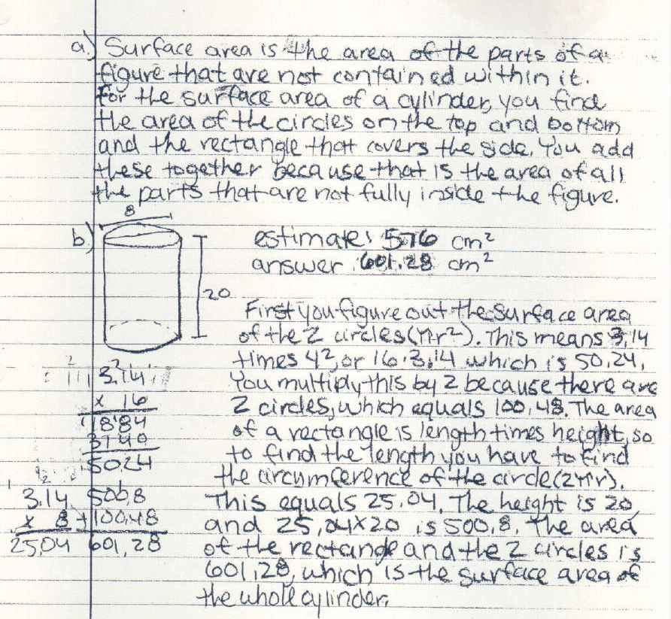
a)
1

2

b)
3

4

a)
1. The student shows a clear understanding of the meaning of surface
area.
2. The student demonstrates that he/she is able to determine the surface
area of a cylinder. (M6M4)

b)
3. Although the estimate of the surface area of the cylinder is reasonable,
there is no explanation of the process. (M6M4c)

4. Even with a slight computational error, it is evident that the student
does understand the meaning of addition and multiplication as related
to positive rational numbers and is able to use these concepts to solve
problems. (M6N1)
Continued…
SIXTH GRADE MATHEMATICS
GEORGIA STUDENT WORK SAMPLE:
Cylinder Task (Student A – page 2 of 2)
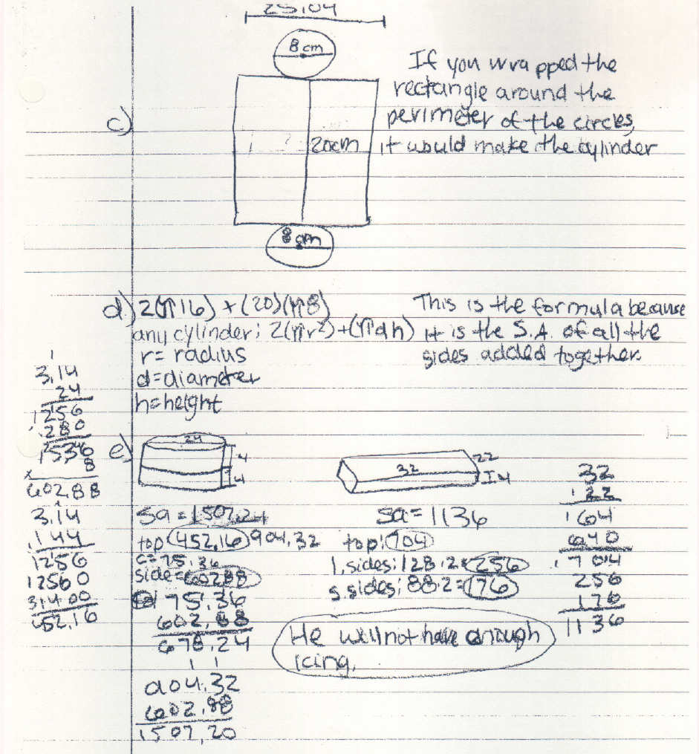

c)
5

d)
6

c)
5. It is apparent that the student is able to construct a net for the cylinder.
(M6M4a)

d)
6. The work shown indicates understanding of the development of the
formula for surfa area of a cylinder. (M6M4)

e)
7. The computational error mentioned in comment 4 is corrected here.

8. All work is accurate and indicates mastery of the standard M6M4 and
element M6M4d.

SIXTH GRADE MATHEMATICS
GEORGIA STUDENT WORK SAMPLE:
Cylinder Task (Student B – page 1 of 1)

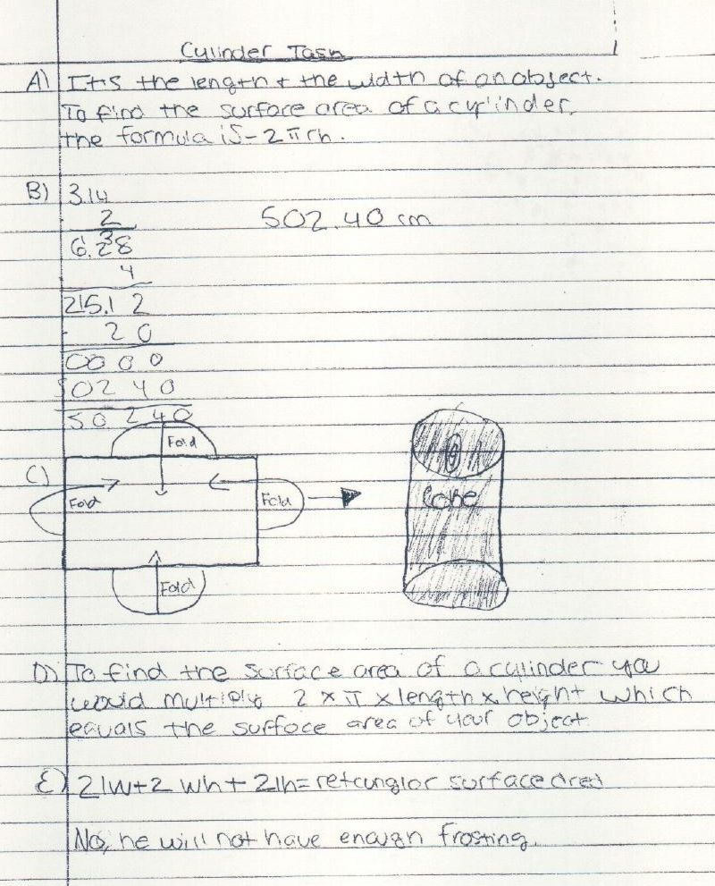

SIXTH GRADE MATHEMATICS
GEORGIA STUDENT WORK SAMPLE:
Cylinder Task (Student C – page 1 of 3)

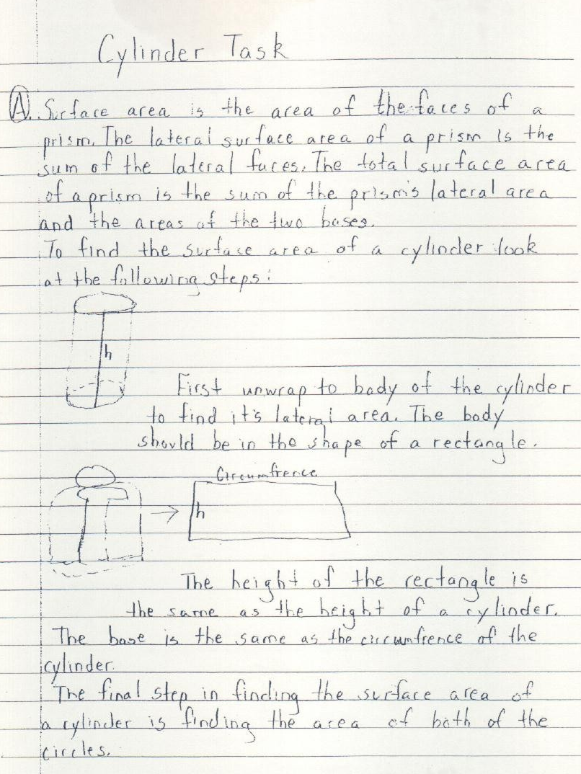

SIXTH GRADE MATHEMATICS
GEORGIA STUDENT WORK SAMPLE:
Cylinder Task (Student C – page 2 of 3)

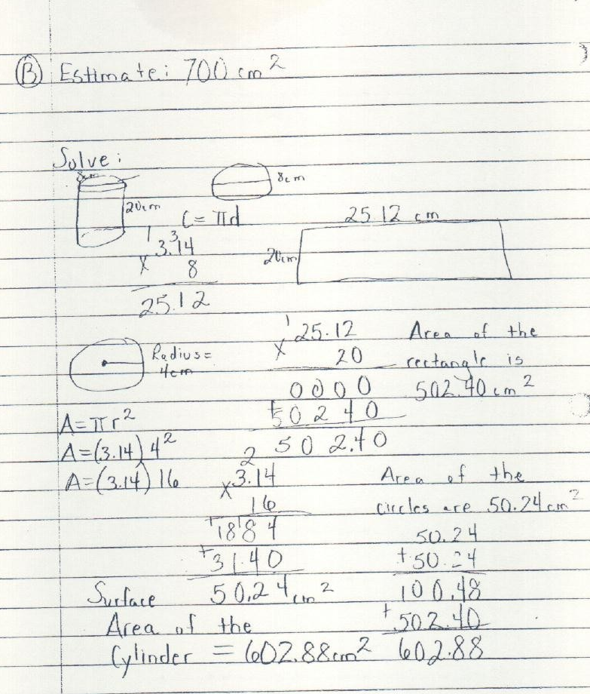

SIXTH GRADE MATHEMATICS
GEORGIA STUDENT WORK SAMPLE:
Cylinder Task (Student C – page 3 of 3)

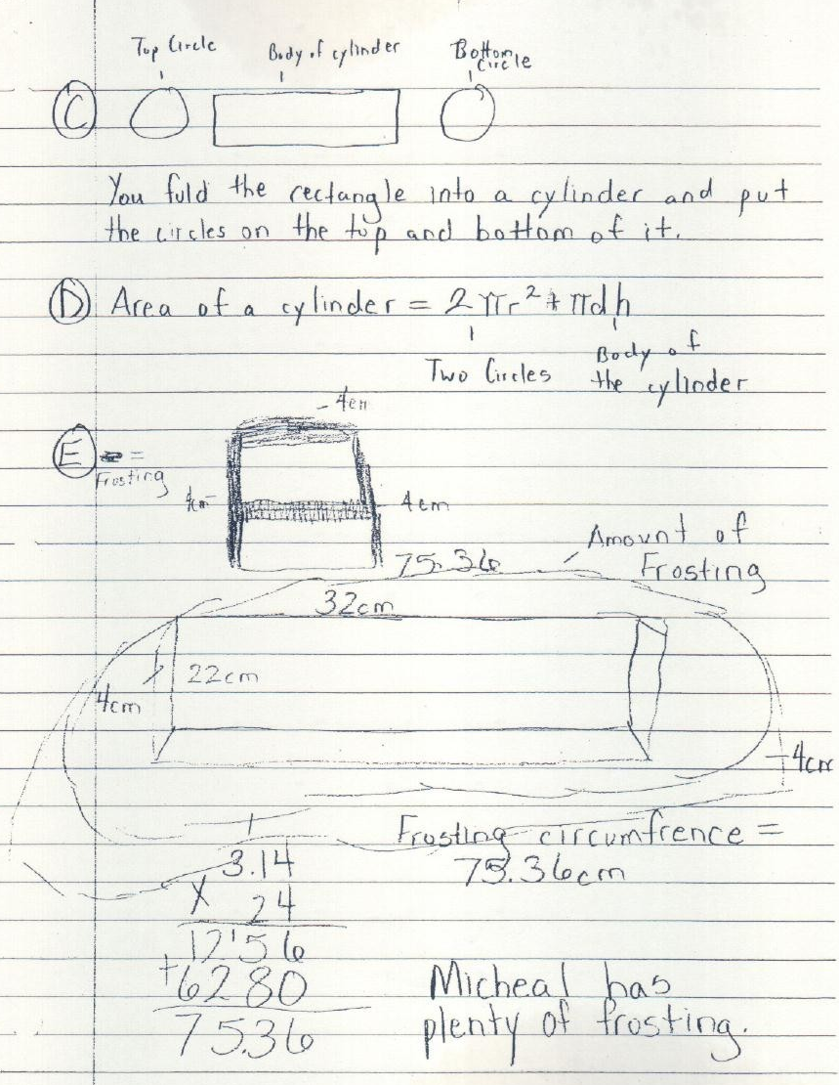

Algeblocks physically represent variables and constants in a logical system that students
can see and understand. The x², y², x, y, xy and 1 integrate algebra with two-
dimensional geometry. The x³, y³, xy² and x²y pieces allow students to pair
algebraic concepts with three-dimensional relationships in geometry. The
Algeblocks program comes with three workmats: the Basic Mat for integers,
addition, and subtraction; the Sentences Mat for equations and inequalities; and
the Quadrant mat for products, multiplication, and factoring.

Common Uses of Algeblocks

To engage students in investigating and modeling:
- Integers and operations. (M7N1)
- Expressions and operations. (M7A1), (M8A1)
- Geometry connections: area and perimeter. (M6M2)
- Patterns.(M6A2)

***********************************************************************

Centimeter Cubes are non-interlocking, brightly colored, 1cm³ plastic cubes weighing 1 gram each. They come in 10 colors. Centimeter Cubes are a versatile manipulative used to explore concepts in statistics, numerical reasoning, geometry, and algebra.

Common Uses of Centimeter Cubes:

To engage students in:
- Estimating probability and comparing experimental results to the theoretical probability. (M6D2)
- Measuring the surface area and volume of solids and building arrays to find factors for a given volume. (M6N1), (M6M3), (M6M4)
- Calculating the percentage of a color present in a sample and expressing a percentage in fractional and decimal forms. (M6D1)
- Modeling the addition and subtraction of inters using two colors, perhaps on an Algeblocks® Basic Mat. (M7N1)
- Visualizing number patterns to generalize a rule. (M5A1)
- Visualizing combinations and permutations. (MM1D1)
- Investigating systems of equations. (M8A5)

Power Solids are a set of hollow, three-dimensional shapes molded in durable plastic with removable bases.

Folding Geometric Shapes enable students to explore two-dimensional relationships among the solids.

Common Uses of Power Solids and Folding Geometric Shapes

To engage students in:
- Identifying geometric solids; analyzing their important characteristics; investigating patterns and relationships among size, shape, and volume of three-dimensional shapes; and investigating surface area and volume formulas. (M6M3), (M6M4)
- Exploring the surface area of a sphere. (MM2G4)
- Exploring the volume of a sphere. (MM2G4)

************************************************************************

Angle Rulers are multipurpose, flexible, clear plastic devices for:
- Measuring linear distances up to 12 inches or 30 centimeters
- Constructing and measuring angles for 0º to 360º.
- Drawing 2-, 3-, 4-, 5-, and 6-inch circles.

One side of the Angle Ruler is marked in inches, the other in centimeters. When opened to a full 180º, the Angle Ruler can be used as a 12-inch or 30-centimeter ruler for measuring linear distances.

Holes are strategically placed in the ruler and commonly used for two purposes:
- To mark inch marks along a linear distance (to 12 inches).
- To hold one pencil at the rivet point and another in one of the holes to easily draw circles.

Angle Rulers are made of clear plastic, so they can also be used on the overhead for demonstration purposes. This educational tool is similar to one used by physical therapists to measure joint rotation and flexibility.

Common Uses of the Angle Ruler

To engage students in:
- Estimating and measuring lengths up to 12 inches or 30 centimeters. (M3M2), (M6M2)
- Measuring angles from 0º to 360º. (M4M2), (M5N5), (M6G1)
- Verifying the measures of Pattern Block angles. (M5N5), (M6G1)
- Constructing Circles (M5N5), (M7G1)

GRAB BAG

 | Students will compare experimental results to theoretical probabilities.
 | Grouping: Whole class, then partner teams
Materials: Overhead projector, a blank transparency, and
an overhead pen.
For each pair of students: small opaque bags
containing 36 Centimeter Cubes: 6 yellow, 18
red, 4 green, and 8 blue.
Graphing calculators will also be used during
this activity.

 | Warm-Up
Warm Up  Before class, place 36 Centimeter Cubes in each of the student bags. (Paper lunch bags work well.) Put the frequency table below on the overhead projector: | Show students one bag containing the given set of Centimeter Cubes.  - Explain that there are 36 Centimeter Cubes in four different colors in the bag.  - Invite students to draw, then return one block to the bag for 12 trials.  - Have a student tally the results on the overhead using a frequency table.  - After each trial, ask students questions based on what they have seen so far. What do we know about the blocks in this bag? What color is most likely to be drawn? What color is least likely?  - After 10 trials, have students estimate the probability of picking each color in the bag based on the experimentally results.  - Dump the blocks onto the overhead and have students calculate the theoretical probabilities based on the number of each color out of the total.  - Have students compare the estimated probabilities to what should have happened. Ask the class: Were the results reasonable? If not, why?
  Block | Tally | Fraction
  Yellow
  Red
  Green
  Blue
 | Continued…
GRAB BAG
Continued…
 | Explore
Explore  The estimated probability is the number of times an outcome actually occurred out of the total number of trials.  The theoretical probability is the number of times an outcome should have occurred out of the total possible outcomes.  Theoretical probabilities:  P_{yellow} = 6/36 = 1/6  P_{red} = 18/36 = ½  P_{green} = 4/36 = 1/9  P_{blue} = 8/36 = 2/9 | Have pairs of students repeat the Warm-Up experiment of 50 trials. The should then:  - Create a table to organize tallies and probabilities (as fractions), and  - Compare their estimated probability results after 50 trials to the 10-trial figures.
 | Reflect and Connect
Reflect and Connect  1. It would be likely for students to find that as the number of trials increases, the estimated probability obtained in the experiment approaches the theoretical probability. After 1000 trials, the estimated probability would be about the same as the theoretical probability.  2. P_{red} = 18 our to 36 possible = ½ or 50%.  3. Experimental results are considered estimates because they may not be the same in another | Ask the students the following questions:  - Which sample size gave results that were closer to the theoretical probability: 10 trials or 50 trials? Why is sample size important?  - How did you calculate the theoretical probability of pulling a red cube from the bag in this experiment? Explain.  - Why do you think probabilities obtained from experimental results are called estimated probabilities?  - What would happen to the estimated probabilities if all pairs combined their results? Predict the outcome.  - Use the graphing calculator to determine the probability after even larger numbers of experiments.  - Design a new probability experiment with the Centimeter Cubes. Be sure to record your results for each part of the experiment. Run 50 trials on
GRAB BAG
Continued…
experiment and may or may not be close to the results that should happen based on the theoretical probability.  4. Combining class results should move the estimated probability closer to the theoretical probability.  5. The graphing calculators will verify that the more trials in an experiment, the closer the experimental probability is to the theoretical probability of an experiment.  5. Results will vary. | your calculator and compare your results, (the estimated probabilities), to the theoretical probabilities. What do you notice? Run 500 trials on your calculator and compare your results, (the estimated probabilities), to the theoretical probabilities. What do you notice? Continue using your calculator until you reach as close as possible to the theoretical probability. How many “trials” did it take?
 | Communicate
Communicate  It may be helpful to put an optional prompt on the overhead for students who have difficulty getting started:  “The main difference between estimated and theoretical probability is…”  Listing several common vocabulary terms under the prompt is often helpful. A structured paragraph outline may also be given. | Have students write a paragraph comparing estimated probability with theoretical probability. They should use examples from their Centimeter Cubes experiments or from real life to support their conclusions. They may choose to organize similarities and differences in a Venn diagram.
 | Teacher’s Reflections
When can I use this activity?
Notes from trying this activity…
Ideas for next time…
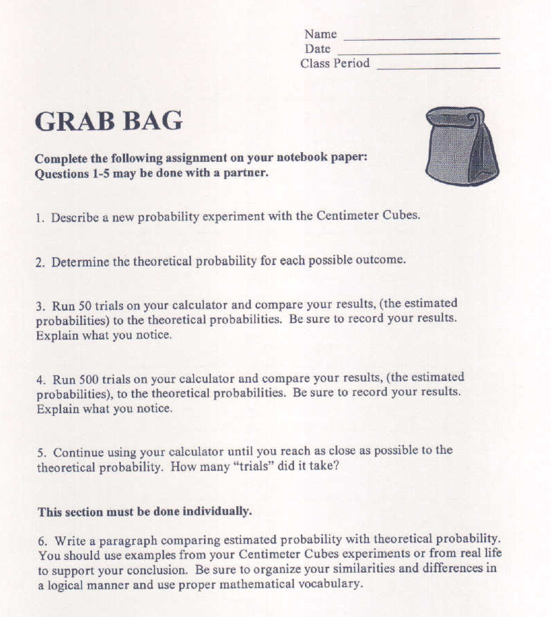

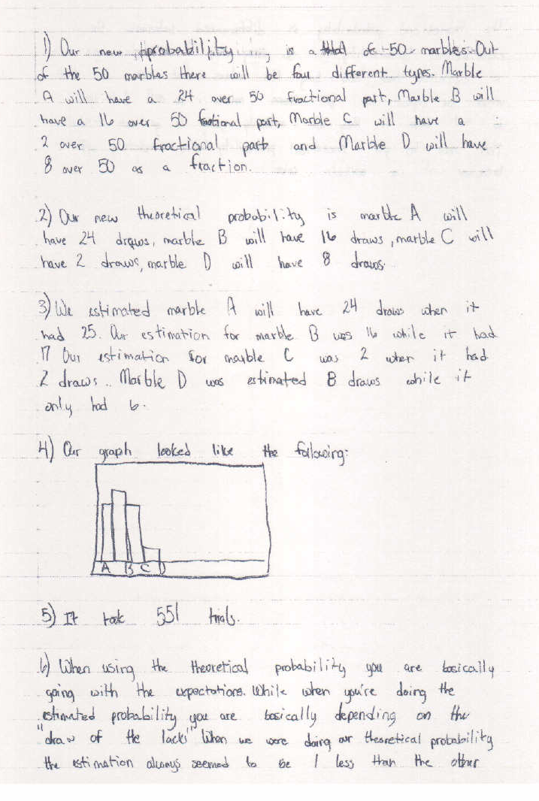
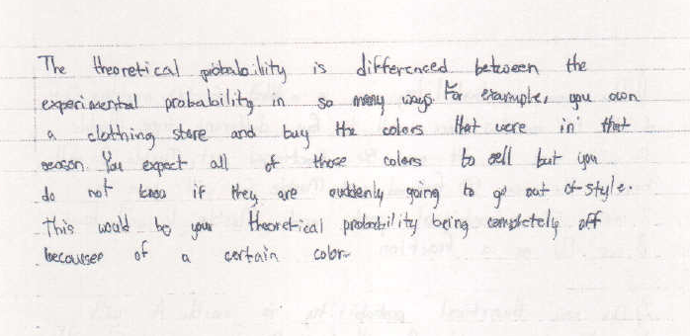

Probability Simulation Instructions
for “GRAB BAG”

1. To begin:

Turn on the calculator by pressing the button.

Probability Simulation is an Application. Therefore, the button will get you into the “Applications” section of the calculator.



Select “Prob Sim” by scrolling down or using to shift into
alphabet mode and select the “P” that is above the button. This will bring up all of the applications that begin with the letter “P”.

Press when the curser is highlighting the colon that is to the left of “Prob Sim” .

This should give you a screen that looks like the one below.

Using the key again will give you the simulation choices.

We will be using the “Pick Marbles” simulation today.
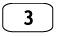
Scrolling down to “3. Pick Marbles” or pressing the button will give you a screen that looks like the one below.

Continued…
Probability Simulation Instructions
for “GRAB BAG” continued…

2. To set up the experiment:

At this point, the calculator does not know enough about our experiment. Therefore, we need to give it information before we can begin.

To set-up the experiment, we must press the button that is under the word “SET” on the above screen. This button looks like and should give you a new screen.

We want to keep one trial, so use to move the curser to the “Types” category.

This experiment has 4 instead of 5 colors. Thus, we need to arrow over so that
the curser is now over the 4. The button will save the change.

We will keep the “Graph” as “Freq”, so scroll down to the “StoTbl”.
For this experiment, we would like to store all of our data, so use the arrow to
highlight the “All” and hit the button to save the change.

Continued…
Probability Simulation Instructions
for “GRAB BAG” continued…

The calculator still does not know how many marbles (or centimeter cubes) we have in the bag, so we need to go to advanced set-up. To do this, we need to use the key that is

under “ADV” which looks like and will give a new screen.

Type over the “10” to change the number of color A to match your experiment, then using the button, do the same to change the numbers of the other colors.


To tell the calculator that the information is “OK”, click twice because it is under the “OK”. This should get you back to the experiment’s screen.

Now you are ready to do the experiment.

Continued…
Probability Simulation Instructions
for “GRAB BAG” continued…

3. To do the experiment:
Under the word “PICK” use the button to pick a marble/cm cube. The calculator will pick a color at random. Below is what the graph would look like if your calculator picked color D.

Note that in the sixth grade, we work with replacement. Therefore, the experiment is set to use replacement.
To pick one at a time, continue to use the button under “+1” or . To do ten
picks, use the button under “+10” or . To do fifty picks, use the button under

“+50” or .

Each time you “pick”, the graph will change to reflect the experiment. Every calculator will have different results. An example of what a graph might look like after doing several experiments is shown below.

Continued…

Probability Simulation Instructions
for “GRAB BAG” continued…

4. To see how many of each color has been picked:

To view the frequency of each color, use the or key on your calculator.

Each time that you press this key, the bar on the graph representing that color will become shaded and the number of times that color has been picked will be displayed.
An example of what you might find is pictured below.

This shows that color A was selected 8 times.

Know that you may not exit the “Prob Sim” to use the calculator for other tasks without erasing your data.

5. To view a history of the experiment:
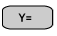
To see what was picked each time during the experiment, use the “ESC” button or .
Then use “TABL” or to have a display of every pick that the calculator randomly

made during the experiment.

At this point, you do not need to use the “ESC” button again to switch from the two screens. Simply use the “GRPH” button to return to the bar graph that was previously shown and the “TABL” button to return to the above display. Continued…
Probability Simulation Instructions
for “GRAB BAG” continued…

6. To exit Probability Simulation:

When you are absolutely sure that you are finished with this experiment and are ready to use the calculator for other purposes or turn off the calculator, then follow the following steps.
Use “ESC” or to begin the process of exiting the Application.

The calculator wants to be certain that you are ready to erase your data. Use “YES” or .

Now move over all the way to the right to “QUIT” or .

At this time, return to “YES” or .

You should be out of the program.

If you wish to turn off the calculator, use then .
Maximum/Minimum Measurements

 | Students will build rectangular prisms with Centimeter Cubes to find the maximum and minimum surface areas for a given volume.
 | Grouping: Pairs
Materials: For each pair of students: about 100
Centimeter Cubes.

 | Warm-Up
Warm Up  Students will build the following prisms: | - Challenge students to use the Centimeter Cubes to build all possible rectangular prisms using 12 cubes.  - Have students record their work by sketching each prism in a math log, labeling the surface area.  - Discuss which prisms have the greatest and least surface areas for a volume of 12 cm³.
  Dimensions | Surface Area
  2 x 2 x 3 | 32
  4 x 3 x 1 | 38
  6 x 2 x 1 | 40
  12 x 1 x 1 | 50
 | Explore
Explore  Note: Only integer dimensions are explored in this lesson. | - Invite students to use Centimeter Cubes to investigate the possible rectangular prisms with volumes of 16, 24, and 36 cubes. Record the dimensions and surface area of each in a table. Circle the maximum and minimum surface areas for each volume.  - Ask students to look at the sketches for all three volumes and compare the prisms having the greatest surface areas with those that have the smallest surface areas. They should describe any patterns they see.
  Volume | Dimensions | Surface Area
  16 | 1 x 1 x 16 | 66
  16 | 1 x 2 x 8 | 52
  16 | 1 x 4 x 4 | 48
  16 | 2 x 2 x 4 | 40
  24 | 1 x 1 x 24 | 98
  24 | 1 x 2 x 12 | 76
  24 | 1 x 3 x 8 | 70
  24 | 1 x 4 x 6 | 68
  24 | 2 x 2 x 6 | 56
  24 | 3 x 2 x 4 | 52
  36 | 1 x 1 x 36 | 146
  36 | 1 x 2 x 18 | 112
  36 | 1 x 3 x 12 | 102
  36 | 1 x 4 x 9 | 98
  36 | 2 x 2 x 9 | 80
  36 | 2 x 3 x 6 | 72
  36 | 3 x 3 x 4 | 66
 | Continued…
Maximum/Minimum Measurements

Explore (continued…)
Prisms with the greatest surface areas are stretched out so that the blocks are in a single row, with two of the dimensions being 1 unit.
Prisms with the smallest surface areas have a shape that is as close to a cube as possible.

 | Reflect and Connect
Reflect and Connect  1. Students may have made an organized list of all possible factors equaling the given volume.  2. The cubes are arranged in different configurations which have different numbers of exposed faces. More compact designs have fewer exposed faces; longer designs have more exposed faces.  3. The maximum volume would be obtained from the design closest to a cube in shape.  Sample student responses: | Ask students the following questions:  1. What strategy did you use to make sure that you had built all possible prisms with a given volume?  2. How can figures with the same volume have different surface areas? Explain.  3. Can you think of a method for finding the maximum volume for a given surface area? Try your plan by finding the maximum volume for a surface area of up to 24 square units. (Use only whole number dimensions.)
  Surface Area | Dimensions | Volume
  22 | 5 x 1 x 1 | 5
  22 | 3 x 2 x 1 | 6
  24 | 2 x 2 x 2 | 8
 | Continued…
Maximum/Minimum Measurements
Continued…
 | Communicate
Communicate  The box having the least surface area would be a cube with length, width, and height dimensions of about 17cm each. This would cost the least to make. Students can find dimensions quickly if they realize that he box should be a cube:  17³ = 4913.  This will be easier if the students have already discovered that the dimensions of the prisms are factors of the volume. | Ask students to write a proposal to a cereal company for a box that uses the least amount of material for a volume of 4913 cubic centimeters. Tell students that each dimension should be a whole number. They should describe the benefits and drawbacks of their designs.
 | Teacher’s Reflections
When can I use this activity?

Notes from trying this activity…

Ideas for next time…

Fraction Puzzles

This activity may be found on pages 50 – 53 in the Pattern Blocks the Super Source booklet by ETA/Cuisenaire® that accompanied the manipulatives that were shipped to schools.

Overview

Children solve Pattern Block puzzles that require them to build shapes in which certain blocks comprise specific fractional parts of the whole shape.
In this activity, students have the opportunity to:
- Discover fractional equivalents
- Explore relationships among the areas of different shapes
- Use rations and proportions to solve problems

Materials: Pattern Blocks, about 12 green, blue, and red
blocks per pair
Pattern Block triangle paper
Crayons
Scissors
Overhead Pattern Blocks

Introducing

- Build this Pattern Block shape using four green triangles.
- Ask children what fractional part each small triangle is.
- Substitute a blue block for two of the green blocks in the large triangle. Have children confirm that the blue block – since it is equivalent to two of the green triangles – is two-fourths, or one-half, of the triangle.

On Their Own

Can you solve these Pattern Block fraction puzzles?

- Working with a partner, use pattern Blocks to solve each of these fraction puzzles in at least two different ways:
Puzzle 1: Build a triangle that is one-third green and two-thirds red.
Puzzle 2: Build a triangle that is two-thirds red, one-ninth green, and two-ninths
blue.
Puzzle 3: Build a parallelogram that is three-fourths blue and one-fourth green.
Puzzle 4: Build a parallelogram that is two-thirds blue and one-third green.
- Record and color each of your solutions on triangle paper and cut them out. Label the back of each solution with the puzzle number.
Continued…
Fraction Puzzles
Continued…
The Bigger Picture

Thinking and Sharing

Divide the chalkboard or display board into four sections, labeling them Puzzle 1, Puzzle 2, and so on. Have each pair post its solutions beneath the appropriate headings. Use prompts such as these to promote class discussion:
- What discoveries did you make as you solved the puzzles?
- What strategies did you use to find solutions?
- How many possible solutions do you think there are to each of the puzzles?
- How are the solutions for each puzzle the same? How are they different?
- How can you convince us that a particular solution is correct?

Extending the Activity

- Have children work with their partners to create their own fraction puzzles with triangles or parallelograms. Tell them to trace and color two possible solutions for each puzzle, and write the puzzle itself on the other side of the paper. Encourage children to share puzzles, perhaps in a “class puzzle book” or “class puzzle box” to be used at an independent math center.
- Have children create puzzles in which a square or a hexagon represents the whole.

Where’s the Mathematics?

In searching for solutions to the puzzles, children recognize that the relationships that exist among the areas of the Pattern Blocks play an important role. For example, in building shapes that are red and green, students need to use the fact that a red trapezoid is equivalent to three green triangles. Furthermore, they need to see that when a red trapezoid and a green triangle are adjoined to make a shape, the green triangle represents one-fourth of the area of the new shape (not one-third, as some students may incorrectly reason).
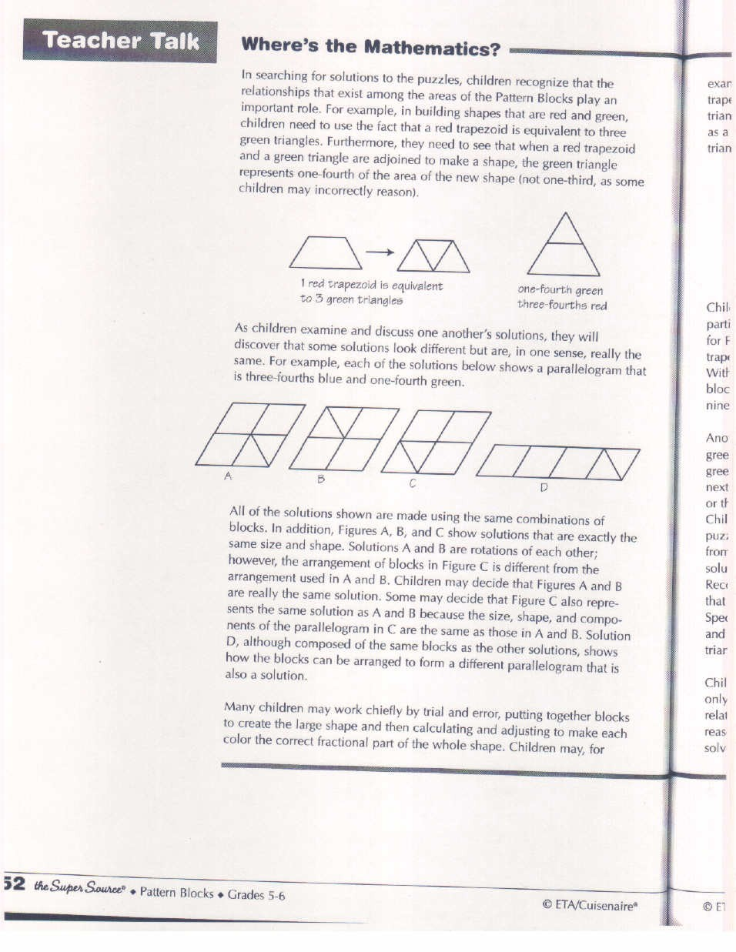

Continued…
Fraction Puzzles
Continued…

As children examine and discuss one another’s solutions, they will discover that some solutions look different but are, in one sense, really the same. For example, each of the solutions below shows a parallelogram that is three-fourths ble and one-fourth green.

All of the solutions shown are made using the same combinations of blocks. In addition, Figures A, B, and C show solutions that are esactly the same size and shape. Solutions A and be are rotations of each other; however, the arrangement of blocks in Figure C is different from the arraangement used in A and B. Students may decide that Figures A and B are really the same solution. Some may decide that Figure C also representst the same solution as A and B because the size, shape, and componenets of the parallelogram in C are the same as those in A and B. Solution D, although composed of the saem blocks as the other solutions, shows how the blocks can be arranged to form a different parallelogram that is also a solution.

Many students may work chiefly by trial and error, putting together blocks to create the large shape and then calculationg and adjusting to make each color the correct fractional part of the whole shape. Children may, for example, if they have solved Puzzle 1 using three triangles and two trapezoids, sub stitute a third trapezoid for the triangles to show that the triangles make up one-third of the shape. Other children, using the triangle as a basic unit, might explain that the entire shae is equivalent to nine triangles; three triangles being thre-ninth, or one-third of the whoel shape.

Continued…

Fraction Puzzles
Continued…

Children may discover that the ratio of blocks used for all solutions to a particular puzzle must be the same. For example, the solution shown above for Puzzle 1 shows that there must be three green triangles for every two red trapezoids in order for the triangle to be one-third green and two-thirds red. With this in mind, children may try to build triangles using combinations of blocks having this same ratio – six green triangles and four red trapezoids, nine green triangles and six red trapezoids, and so on.

Another helpful discovery that children may make concerns the number of green blocks needed to make triangles that are progressively bigger. One green block is, of course, the smallest possible Pattern Block triangle. The next Pattern Block triangle that is possible to buikd requires 4 green triangles or their equivalent; the one after that requires 9; then 16, 25, 36, and so on. Children may recognize these numbers as perfect squares. Since the triangle puzzles refer to fractional parts that are thirds and ninths, triangles made from the equivalent of, for example, 16 green triangels will not produce solutions since 16 cannot be divided evenly into thirds and ninths. Recognition of this may help children to see that the next largest triangle that will work will be one that is equivalent in size to 36 green triangles. Specifically, for Puzzle 1, this triangle would consist of 12 green triangles and 8 red trapezoids, and solutions for Puzzle 2 sould consist of 4 green triangles, 8 red trapezoids, and 4 blue parallelograms.

Children may realize that the number of soluitions to these puzzles is limited onlyby the number of blocks they have. Their understanding of the relationships involved may help them to see how to use proportional reasoning to generalize about additional solutions to these puzzles and to solve other problems involving fractional parts.

Pattern Block Shapes
