

Training for Georgia
Performance Standards

Days 3 and 4: Planning Instruction

Facilitator’s Guide
Grade 7 Mathematics

Acknowledgements
This training program was developed by the Georgia Department of Education as part of a series of professional development opportunities to help teachers increase student achievement through the use of the Georgia Performance Standards.

For more information on this or other GPS training, contact Marcia Mayo at
(404) 463-1933 or mmayo@doe.k12.ga.us.

Use of This Guide
The module materials, including a Content Facilitator’s Guide, Participant’s Guide, PowerPoint Presentation, and supplementary materials, are available to designated trainers throughout the state of Georgia who have successfully completed a Train-the-Trainer course offered through the Georgia Department of Education.

Table of Contents
Acknowledgements 2
Use of This Guide 2
Table of Contents 3

Overview 4
Goal and Objectives 4
Module Sequence 5
Module Materials and Preparation 6

Introduction 7
Quote Activity 9
Review of Stages One and Two 10
Teaching for Breadth and Depth 11
Overview of the Training 12

Concept Mapping 13
Looking at Student Work 14
Creating Content Maps 15

Curriculum Mapping 17
True or False? Activity 19
Basic Principles for Curriculum Mapping 19
Creating a Curriculum Map 20
Analyzing and Reviewing Maps 21

Describing the Standards-Based Classroom 22
"Math Lab Raided" Activity 23
Math Lab Lesson 23
What Should We See in a Lesson 24
Review of Assessment 25

Designing an Instructional Unit 27
Michael Activity 28
Selecting Appropriate Tasks for a Unit 29
Creating Units 30
Evaluating Units 31

Action Plan for Redelivery 32

Overview

Module Goal | Demonstrate a deep understanding of the new Georgia Performance Standards and the standards-based education approach, through thoughtful determination of learning goals for specific units of instruction, development of a balanced assessment plan that includes formative and summative assessments, and the design of instruction that will provide students with the knowledge, skills, and understandings necessary to achieve the learning goals. This goal shall be measured by student performance on progress monitoring and on standardized criterion-referenced tests.  Note that the goal will not be reached by any single day of training. It will take preparation and follow up to master this goal.
Objectives | By the end of day four of training, participants will be able to:  - Explain concept mapping and why it is important.  - Explain different aspects of curriculum mapping.  - Describe what a standards-based mathematics classroom looks like and how to choose appropriate instructional strategies.  - Evaluate a unit plan, focusing on the instructional plan detailed on the unit calendar, and develop a balanced plan for instruction, one that includes strategies appropriate to achievement targets and content.

Module Sequence | This is a two-day course, with approximately 11 hours of instructional time.  Prior Preparation—Participants  - Identify desired results for several standards to create Stage 1.  - Write assessments to match the unit of study to create Stage 2. Collect student work that reflects several levels of performance for the assessments written.  Introduction  - Quote Activity  - Review of Stages One and Two  - Teaching for Breadth and Depth  - Overview of the Training  Concept Mapping  - Looking at Student Work  - Creating Content Maps  Curriculum Mapping  - True or False? Activity  - Basic Principles of Curriculum Mapping  - Creating a Curriculum Map  - Analyzing and Reviewing Maps  Describing the Standards-Based Classroom  - “Math Lab Raided” Activity  - Math Lab Lesson  - What Should We See in a Lesson  - Review of Assessment  Designing an Instructional Unit  - Michael Activity  - Selecting Appropriate Tasks for a Unit  - Creating Units  - Evaluating Units  Action Plan for Redelivery
Module Materials | Content Facilitator’s Kit contents:  - Content Facilitator’s Guide (one for each leader)  - Complete set of slides (PowerPoint)  - Participant’s Guide (one per participant and one per leader)
Other materials needed:

- Name tags
- Chart paper
- A number of colored markers for chart paper
- Sticky notes
- Masking tape to post chart paper
- Scissors
- Highlighter markers, one per participants
- Standards/Elements cards
- Power Solids
- Small pitchers of water and little tubs
- Copies of the Coordinate Plane
- Pencils
- CellophaneTape
- Construction Paper
- Angle Rulers

Equipment:

- Overhead projector or computer and LCD projector

Preparation | Each participant should bring the following resource materials to  Days 3 and 4:  - Wiggins, Grant, and Jay McTighe. Understanding by Design Professional Development Workbook. Association for Supervision and Curriculum Development. 2004. Pages 214 – 225.  - Notebooks from Days 1 and 2 of Training  - Student Work Samples with permission forms  - Materials to Develop Unit  - If possible, lap top computer

Introduction
Overview | In the introduction, the participants review key points from stages one and two in the standards-based education process. Then, the group discusses the overview of Days 3 and 4.
Objectives | - Explain why instruction is stage three in the standards-based education process.  - Describe the importance of Assessment in the unit design process.
Activities | - Quote Activity  - Review of Stages One and Two  - Teaching for Breadth and Depth  - Overview of the Training
Materials | - Overhead projector or computer and LCD projector  - Transparencies or PowerPoint presentation  - Participant's Guide  - Parking Lot flipchart (create before class)  - Pages 214 – 225 in the UbD Professional Development Workbook

Slide:  GPS Planning Instruction | Introduction  Participants will be working in grade level groups to write curriculum maps and design units.  Show slide.  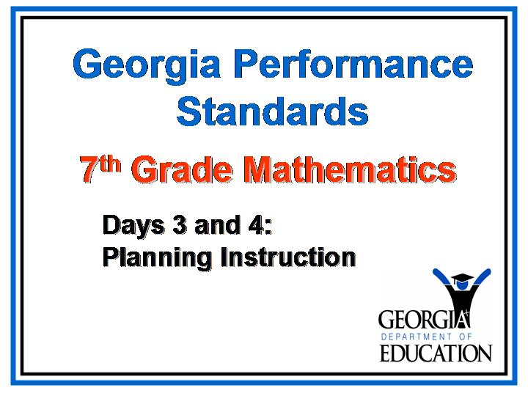  Welcome participants to Days 3 and 4 of GPS training.
Slide:  New GPS Portal | Show slide.  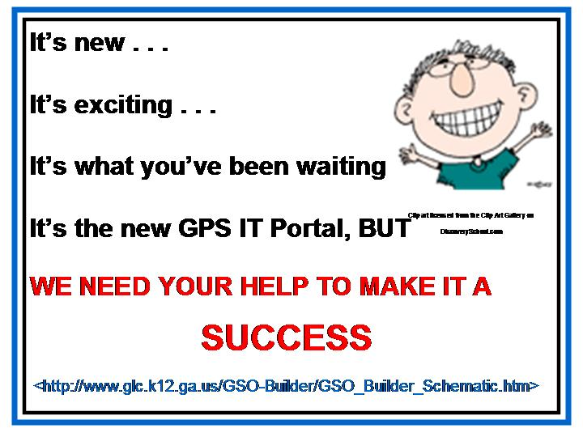

The Georgia Department of Education is pleased to announce the development of a new web portal. This new portal allows teachers to build and share units of instruction designed using GPS and the standards-based education model. To see the template design for this portal, visit

http://www.glc.k12.ga.us/GSO-Builder/GSO_Builder_Schematic.htm

 | [Trainer’s Note: All the information on slide 3 will appear automatically EXCEPT for the URL for the website. Click to make that appear at appropriate time.]
 | This web portal can only succeed if teachers build and share instructional units. If you have a unit you would like to submit OR if you would like to be considered for one of the reviewer positions, please contact Karen Muska in Instructional Technology and Media at the DOE. You can reach her via email at <kmuska@doe.k12.ga.us>.
Slide:  Menken Quote | Show slide.  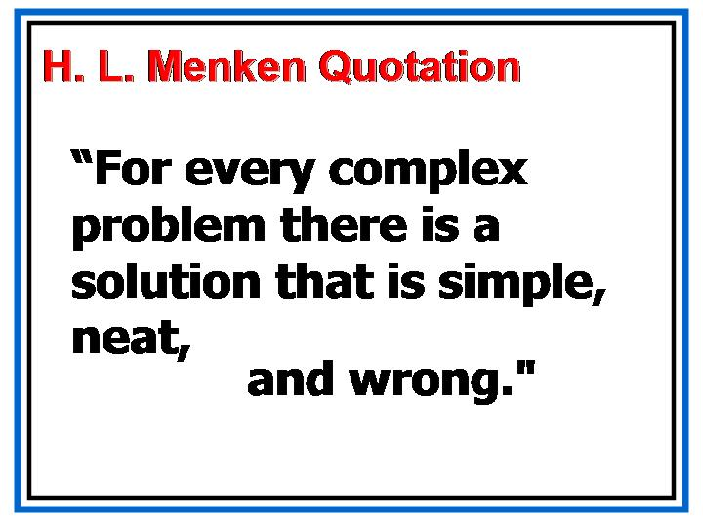
This statement by writer and philosopher H. L. Menken was referenced the other day on an early morning radio program, but it seems à propos as we begin.

Keeping this quotation in mind, take a minute or two in your table groups to reflect on the GPS training—from where we started in the fall to where we are today. How does Menken’s aphorism relate to the implementation of the Georgia Performance Standards?

 | Before we begin today, let’s take a second and pat ourselves on the back. We’ve come a long way since Day 1 of GPS training. With each subsequent day of training, we’ve moved closer to our goal of implementing the Georgia Performance Standards in order to improve student achievement; and with each day of training we’ve all become less anxious and more confident about what we’re doing. These feelings of increased confidence will continue in these final two days of training for this academic year, but we shouldn’t become discouraged if we still have difficult moments.

Reflections on Redelivery

Ask participants about Redelivery. Be aware that some participants combined Days 1 and 2 during professional development time, and others have not yet redelivered.
- Have each group brainstorm a list of successes, questions and concerns OR compile a whole group list.
- Consider the ones to address and work on during this session.

 | - To begin today, we will briefly review the first two stages of the standards-based education process.

Slide:  Standards Based Education Model | Review of Stages One and Two  Show slide:  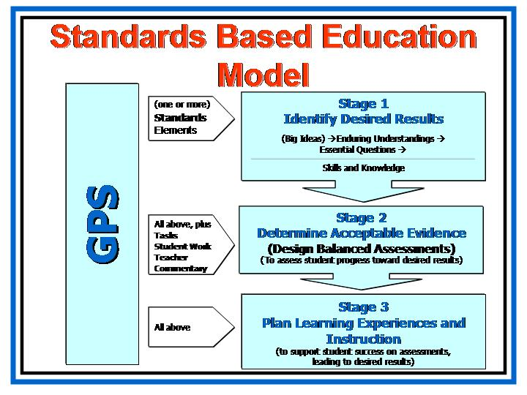
PG—p. 6 | Review of Stages One and Two  Refer participants to GPS and the Standards-Based Education Process, on page 6 in their Participant's Guides. Say: In our previous workshops, we worked extensively on understanding and applying Stages 1 and 2. In this workshop, we’re going to focus on Stage 3.
We’re going to discuss instruction shortly, but first, I’d like you to recall key points from Stages 1 and 2.

Some ideas to be reviewed for Stage 1 include:
- The Big Ideas/Established Goals are in the standards themselves.
- Enduring understandings are formed by grouping or relating core concepts and processes specified in the standards, either explicitly or implicitly; but these understandings specify the kinds of conceptual learning that students will retain beyond the unit and the course.
- By using a variety of modalities to answer essential questions via different tasks, activities, and/or assessments, students will provide evidence of learning.
- The knowledge and skill statements specify what students need to know and be able to do in order to provide evidence of learning, so this helps teachers design appropriate assessments in Stage 2.
- The core concepts and processes are consistent because they are specified in the standards, so our desired results should be similar, if not identical in terms of the big ideas and established goals that we determine; however, because these core concepts and processes may be combined differently in different units, the standards we choose for a unit may look different.

PG—p. 7 | Some ideas to be reviewed for Stage 2 include:  - We need to determine the assessments that will provide the best and most complete evidence of the desired learning goals from Stage 1 before we can plan the tasks and activities that will provide students with the best and most effective opportunities to learn.  - What learning goals have we determined for this unit? What are our achievement targets? Will this assessment generate evidence of learning appropriate to this achievement target? Is this the best assessment format for this achievement target? Will this assessment plan allow multiple opportunities for students to provide evidence of learning? Will students be able to use different modalities to provide evidence of learning?  - A list of assessment formats should be predetermined to use as a preparation guide throughout the course.  - We should work collaboratively with other teachers to evaluate our assessment plans.  - Classroom assessment for learning allows us to use assessment to guide instruction and to obtain a complete and ongoing record of student growth so that we can intervene whenever necessary in order to provide students with more practice, remediation, extension, or alternate means of understanding.  Look at the chart in your Participant’s Guide that discusses Teaching for Breadth and Depth.  How do these ideas reflect what we believe about standards-based education?  We also need to recall that:  - The Georgia Performance Standards provide year-long learning goals.  - Units of study typically involve multiple standards and elements.  - Units of study often take weeks to complete.

Slide:  Overview | Show slide.  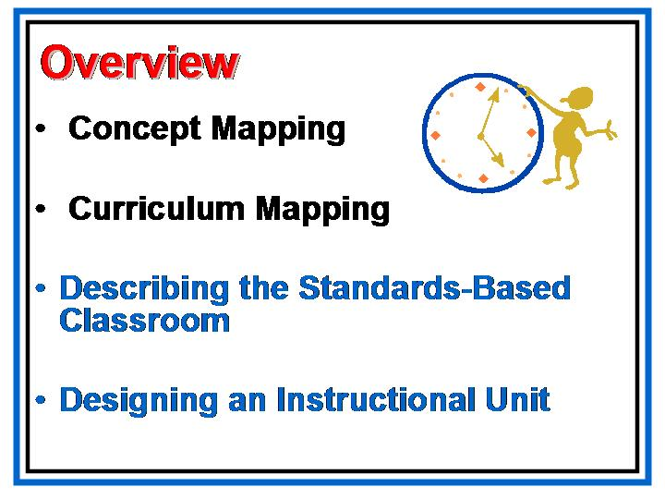  We will start by examining student work and using it to begin a discussion on Concept Mapping. Next, we will develop a concept map for our selected unit standards.  From there we will move to designing Curriculum Maps which will integrate all of the standards and elements into a year long plan for instruction.  Furthermore, we will spend some time discussing what a standards-based classroom looks like so that we will be ready to design our unit to reflect best practices.  The final part of this module, Designing an Instructional Unit, forms the heart of this workshop, and will take the majority of our time. In it, we will focus on how to select and design a balance of instructional activities, in much the same way as we looked at balanced assessment. In this section, you will work on applying what you learn in order to design a unit of instruction.

Concept Mapping

Overview | In this section, participants will examine the student work they brought and consider the curriculum implications the tasks and their results bring to the table. They will then practice developing concept maps based on selected standards and elements which support the observations made from examining the student work.
Objectives | - Explain concept mapping and why it is important.
Activities | - Looking at Student Work  - Creating Content Maps
Materials | - Overhead projector, computer and LCD projector  - PowerPoint presentation  - Participant's Guide  - Samples of student work  - Chart Paper  - Markers

Slide:  Essential Question 1 | Concept Mapping  Show slide.  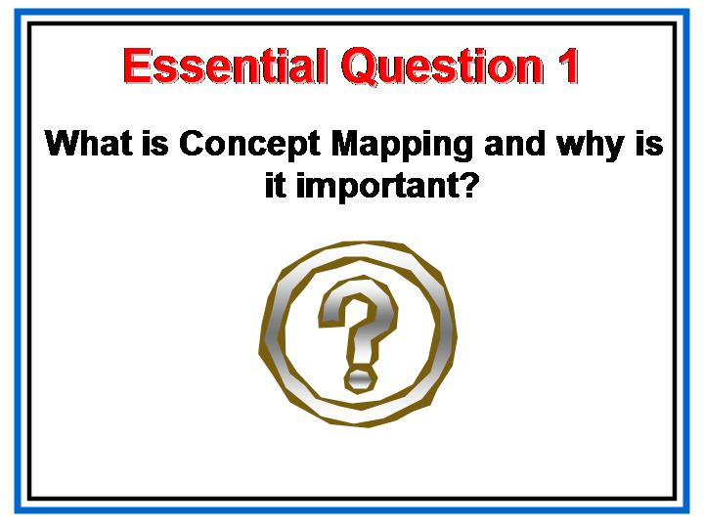
 | To answer this question, let’s start by looking at the student work you brought to share today.
 | Poll the group to see who brought student work to share and determine where you need to provide samples you have collected. Be sure each group has at least one piece of work to examine.

Slide:  Looking at Student Work | Show slide.  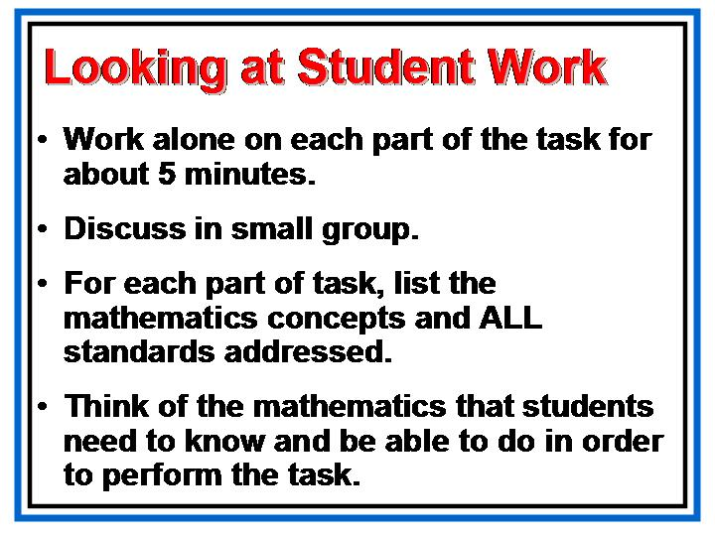
 | Use the steps on this slide to guide your small group work. Be prepared to report your findings to the large group. Be especially conscientious in making your list of skills and knowledge as we will use those in our next activity.

Slide:  Skills and Knowledge | Show slide.  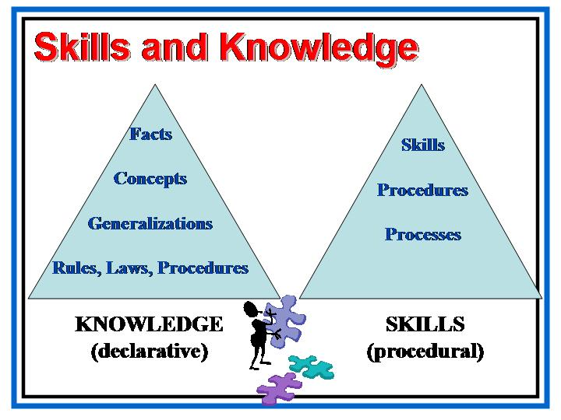  Show this slide while the participants are working in groups to identify the skills and knowledge needed to perform the task they are examining.
Slide:  Create a Map | Show slide.  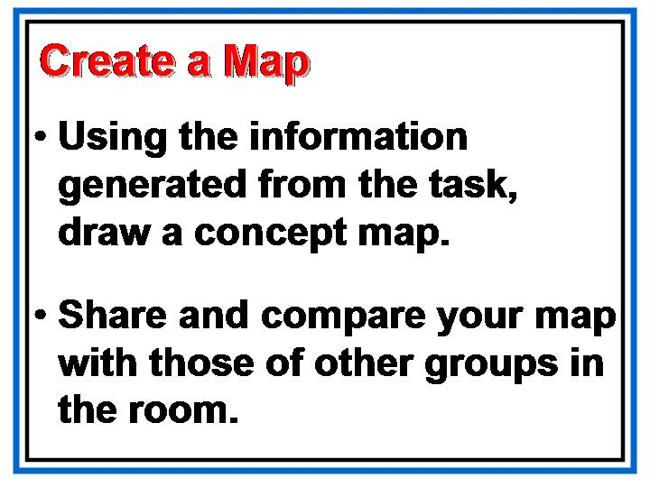  Using chart paper and markers make a concept map to post on the wall. Use any format you choose. There is a sample in the Participant’s Guide on page 8.

Slide:  Examining Our Concept Maps | Show slide.  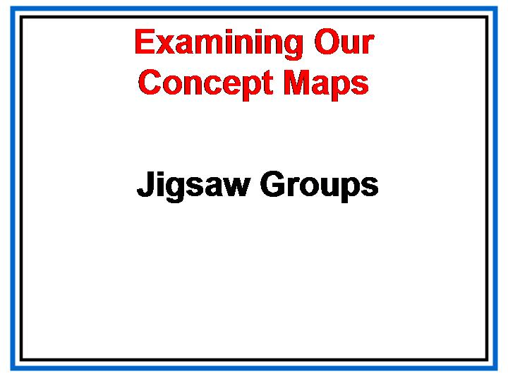  Walk around the room and look at the concept maps created by your colleagues. Be prepared to discuss format as well as content.  Discuss these ideas in the large group, clarifying questions and concerns. Ask, what useful information can we gain from designing and examining concept maps?
Slide:  Concept Development | Show slide.  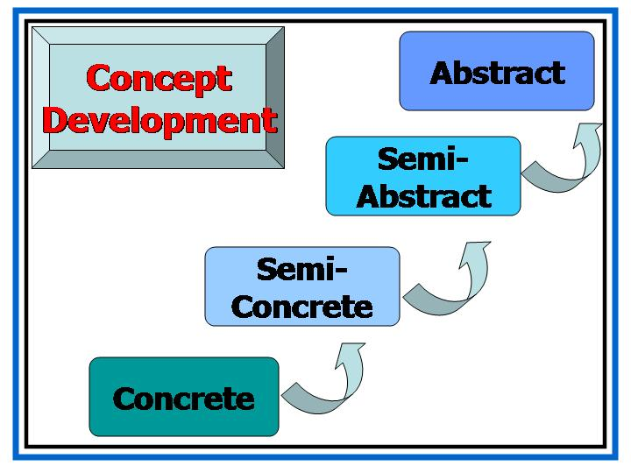  What components of concept development did you observe in the maps posted?  How might you edit the concept maps based on this review of cognitive development?

Curriculum Mapping
Overview | In this section, participants begin to think about the formats and processes that they would like to use to map out their instructional units throughout the school year.
Objective | - Explain different aspects of curriculum mapping.
Activities | - True of False? Activity  - Basic Principles of Curriculum Mapping  - Creating a Curriculum Map  - Analyzing and Reviewing Maps
Materials | - Overhead projector, computer and LCD projector  - PowerPoint presentation  - Participant's Guide  - Standards/Elements Cards  - Sample Curriculum Map from Sixth Grade Framework  - Chart Paper  - Markers  Trainer’s Note: The Heidi Hayes Jacobs book, Mapping the Big Picture, contains 17 sample curriculum maps in the appendix. You should choose either one of these samples or a sample from other resources that you have, to show the participants. Because different types of maps might appeal differently to teachers in various subjects and at various grade levels, we are not prescribing a specific set of samples for you to use, but the Hayes Jacobs book is a great starting point. Also, you should provide a variety of maps to show the many ways that they can be used.

Slide:  Essential Question 2 | Curriculum Mapping  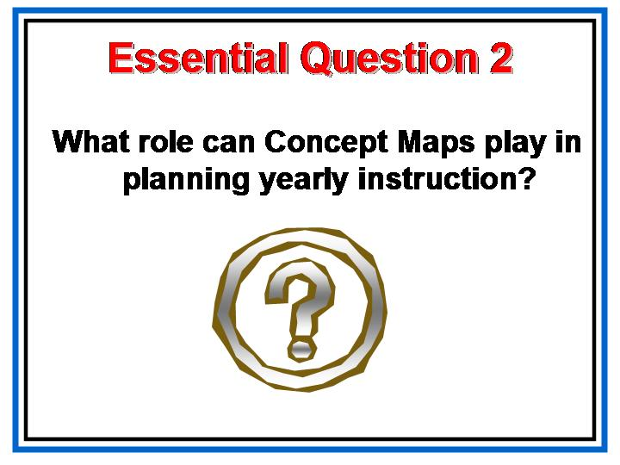  Show slide.  We are ready to think about Curriculum Mapping, which is really no more than putting together, in a thoughtful way, a series of concept maps. It is important to consider how we group standards to create units and concept mapping helps us with this process.
Teachers often work in isolation, or in what we have come to refer to as "private practice,” to plan the scope and sequence of their instructional units. Mapping, by contrast, is a collegial or collaborative approach.
- In 1993 a group of 23 heart surgeons agreed to observe each other regularly in the operating room and to share their know-how, insights, and approaches. In the two years after their nine-month-long project, the death rate among their patients fell by an astonishing 25 percent. The study shows that merely by emphasizing teamwork and communication instead of functioning like solitary craftsmen, all the doctors brought about major changes in their individual and institutional practices.

- Teachers, like heart surgeons, have traditionally worked in isolation. A powerful lesson can be learned from this study. Many educators now emphatically believe that if our goal is to lower the “death rate” of young minds and see them thrive, we can do it better together than by working alone. (www.essentialschools.org)

Slide:  True or False? | 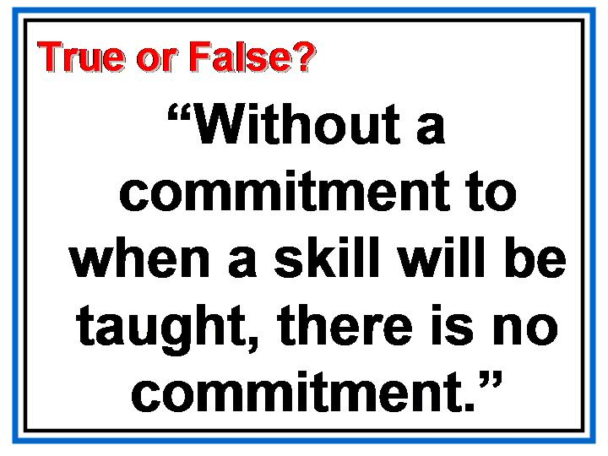  Show slide.
Ask participants to raise their hand if this statement is true…..or false.
Discuss their thinking and the implications of it being true.

In Heidi Jacobs Hayes’ book, Mapping the Big Picture, page 8, she explains,
- “It is critical that each teacher completes a calendar-based map. No one can complete a map for anyone else; otherwise, the data are false. The only professional person who knows what is taught in the classroom is the teacher. Coordinators cannot fill out maps; principals cannot; department chairs cannot fill them out for everyone for the simple reason that they are not in each classroom.”

Slide:  What Mapping Provides | Show slide.  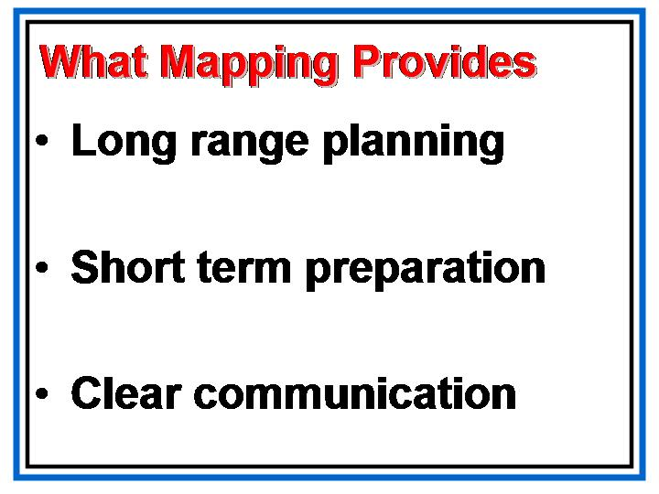  Maps work just like itineraries or road maps to show teachers where they are in a particular scope and sequence, what their students have been learning, and where their students need to be by the end of the unit, year, or grade level. They simply show where students have been and where they are going. Teachers need each other's maps to see the bigger, K-12 curriculum perspective.  Individual teachers use maps to get a picture of what students experience from grade to grade. Though teachers work in the same building, they may have sketchy knowledge about what goes on in other classrooms. If gaps exist among teachers within buildings, there are chasms among buildings in a district. When this is true, transient students experience a happenstance curriculum.  There may be gaps between a standard and what is actually taught. These curriculum gaps negatively impact student learning. Maps may indicate missing pieces in vertical and horizontal articulation.  Maps may also reveal repetitions. Too often teachers assume that they are introducing a concept, or even a book, for the first time, and students are subjected to repetitious instruction.  Maps provide a calendar-based timeline for teachers. This is most helpful for new teachers not experienced in planning for an entire course.  The map should be viewed as a "living" document that plays an integral part in teacher planning each day.
Slide:  Instructional Planning | Show slide.  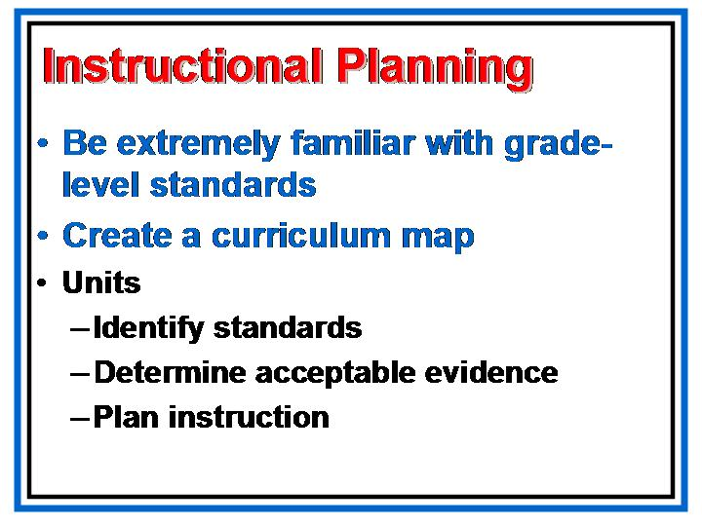
 | This is where instructional planning starts, with the curriculum map. A clear knowledge of the standards and their elements is a pre-requisite for beginning this important work.

Slide:  Time to Map | Show slide.  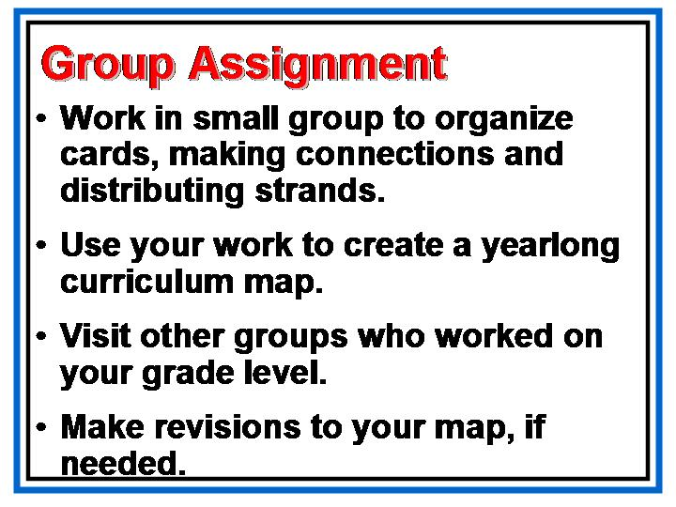
PG—p. 9  PG—p. 10 – 13  PG—p. 14  PG—p. 15 | Review the list of considerations in the Participant’s Guide on page 9. These are guidelines to help as you look at the curriculum from a year-long perspective.  Participants may find it helpful to arrange the “cards” in groups to help facilitate thinking and planning.  Suggest the use of the template on page 14. They may, however, use any format that works for them.  Give them adequate time to work in their groups to develop a useful Curriculum Map.  Refer to the Curriculum Map from the sixth grade framework on page 15 of the Participant’s Guide only if people are struggling with this task.

Slide:  Developing Analyzing and Reviewing Maps | Show slide.  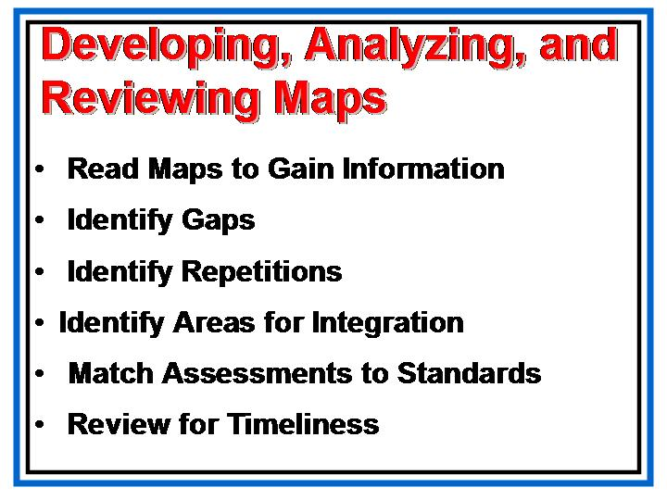
 | After a sufficient amount of time, call the group back together to discuss how we can analyze our maps. Use the slide to give direction to this process.

Slide:  Analyzing Our Curriculum Maps | Show slide.  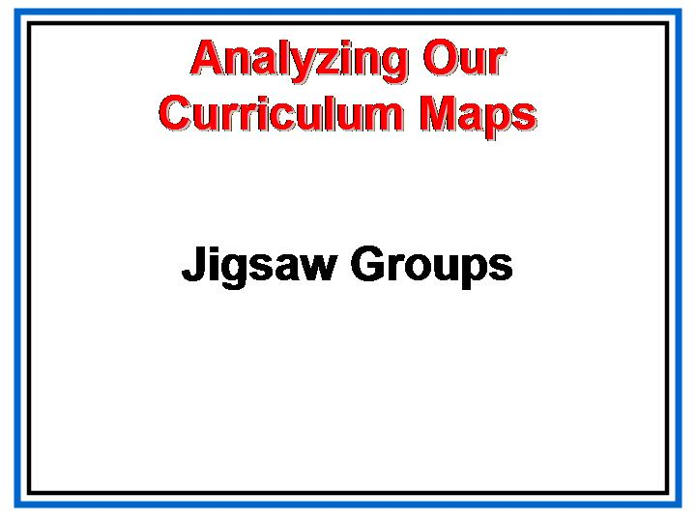  Instead of posting these for everyone to evaluate, have each group pair up with another group to swap maps. Instruct them to use the protocol to evaluate and provide feedback to their partner group.

Describing the Standards-Based Classroom
Overview | In this section, participants will explore the characteristics of a standards-based classroom. A suggestion for lesson structure will be provided and discussed.
Objective | - Describe what a standards-based mathematics classroom looks like and how to choose appropriate instructional strategies.
Activities | - “Math Lab Raided” Activity  - Math Lab Lesson  - What Should We See in a Lesson  - Review of Assessment
Materials | - Overhead projector, computer and LCD projector  - PowerPoint presentation  - Participant's Guide  - Chart Paper  - Markers  - Power Solids  - Small pitchers of water and little tubs  - Copies of the Coordinate Plane  - Pencils  - Tape  - Construction Paper  - Scissors  - Angle Rulers

Slide:  Essential Question 3 | Describing the Standards-Based Classroom  Show slide.  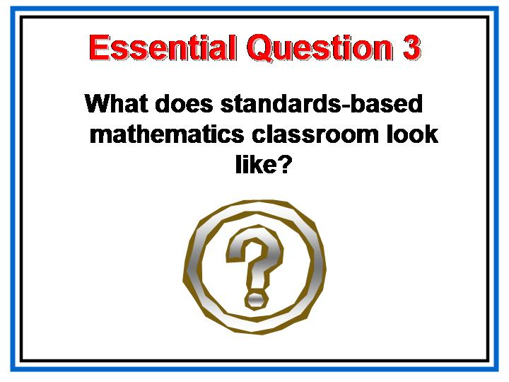

PG—p. 16 | Read the “altered article” on page 16 of the Participant’s Guide.  What evidence was reported that let you know what type of math lab the police had discovered?  Allow a few minutes for discussion in the large group.
 | Let’s take a few minutes and have our own math lab lesson today.

Slide:  Math Lab Lesson | Show slide.  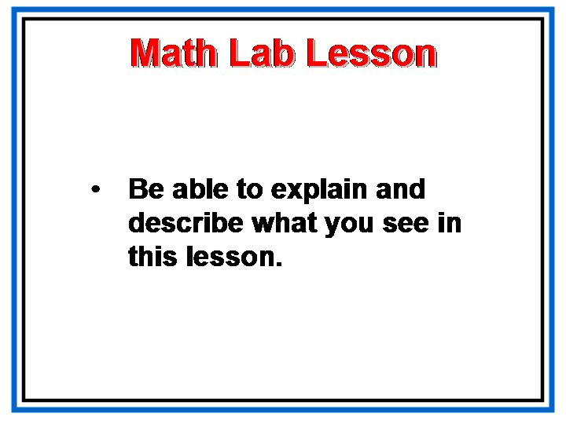

PG-p. 17 | Using the Power Solids and water, discover the cross-sections of various solids. Use chart paper to record the results generated by the group. Include a sketch of the results and describe them. After allowing time to complete the activity, give them time to share with the large group.  Time permitting, progress to constructing two-dimensional shapes. Tape them to pencils to conduct an experiment with the purpose of discovering how movement through space can create three dimensional figures. Include a sketch of the results and describe them. After allowing time to complete the activity, give them time to share with the large group.

Slide:  What did you see in this lesson? | Show slide.  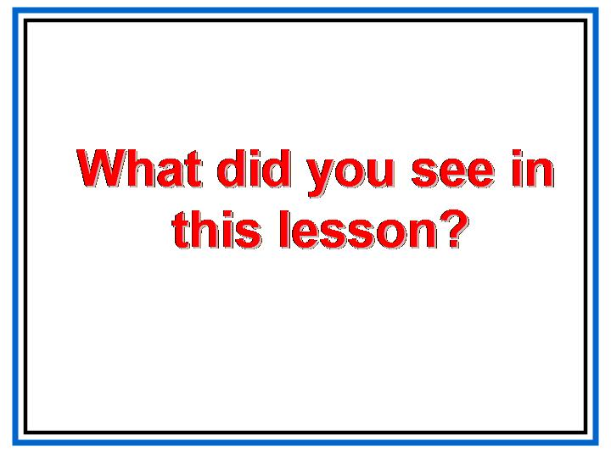
 | Brainstorm a list of things participants noticed about the lesson.
 | Providing effective teacher commentary and developing our students’ skills in self-assessing and self-adjusting enhance student learning and, as a result, improve student achievement. As one of the four parts of the Georgia Performance Standards, teacher commentary must be a part of our implementation plans. Begin with what is doable, then practice and work collaboratively to develop consistency in your commentary.

Slide:  What should we see? | Show slide.  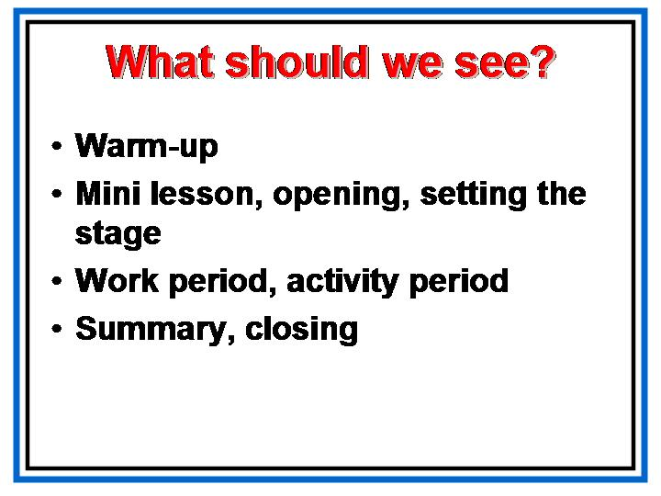
PG—p. 19 | How does our list compare with the slide and the description in the participant’s guide of a standards-based classroom.

Slide:  The Standards | Show slide.  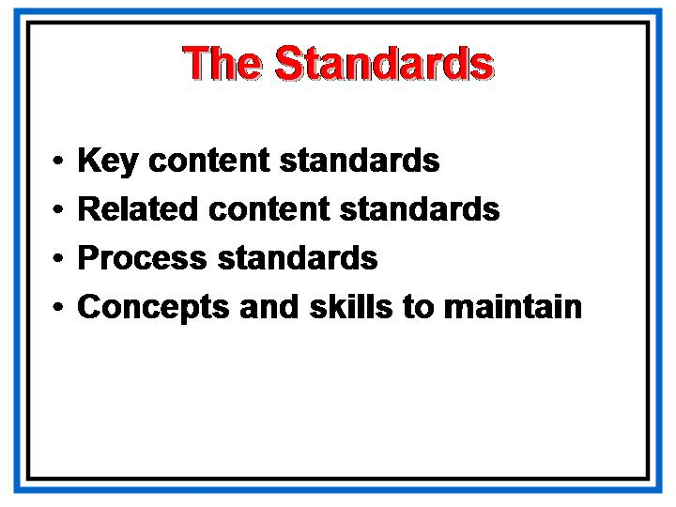  Which standards were addressed in this lesson?  What strategies were used to assess student learning?
Slide:  Assessment | Show slide.  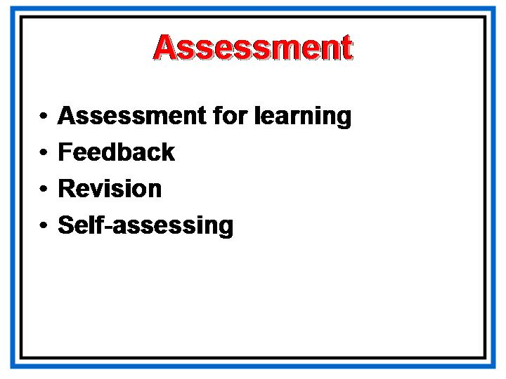
PG—p. 20 | Let’s take a few minutes to review basic fundamental concepts about assessment.
Slide:  Types of Classroom Assessment | 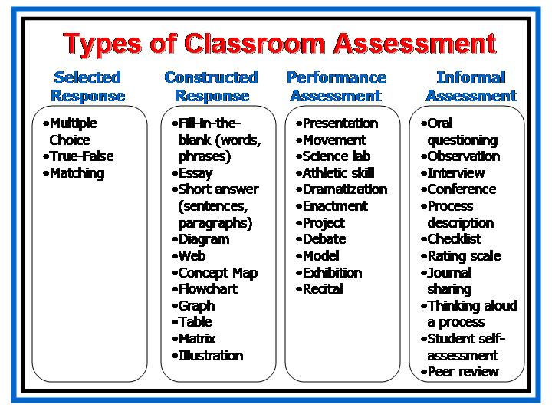  Show slide.  Remember, we want to see a balanced assessment program within our classrooms. Lessons and units should use a variety of techniques to adequately assess the students.
Slide:  Characteristics of Exemplary Assessment (1) | 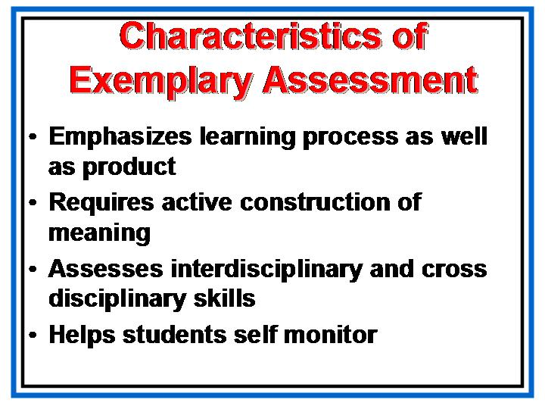  Show slide.  Furthermore, other ideas are important when planning assessment.  Review the topics on these two slides.
Slide:  Characteristics of Exemplary Assessment (2) | 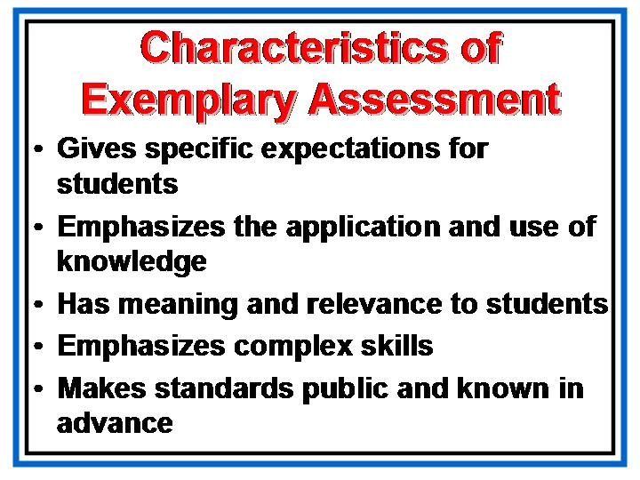  Show slide.
Slide:  Student Work Sample | Show slide.  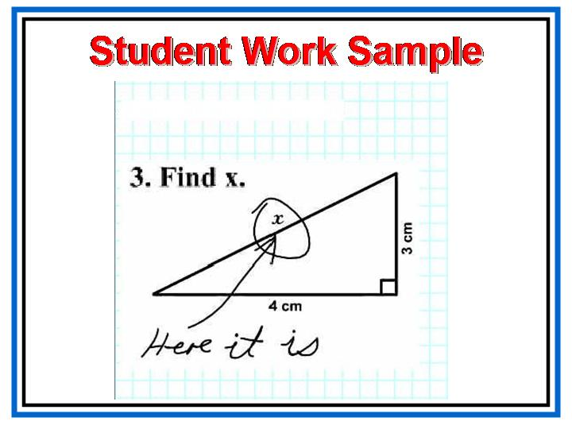  What can we tell about this student’s achievement based on this sample of their work on a model assessment?

Designing an Instructional Unit
Overview | In this section, participants focus on applying what they’ve learned in the first section. They evaluate an instructional plan and complete unit planning templates, including calendar templates for an instructional plan.
Objective | - Evaluate a unit plan, focusing on the instructional plan detailed on the unit calendar, and develop a balanced plan for instruction, one that includes strategies appropriate to achievement targets and content.
Activities | - Michael Activity  - Selecting Appropriate Tasks for a Unit  - Evaluating Units
Materials | - Chart paper  - Markers  - Transparencies or PowerPoint presentation  - Highlighter markers  - Paper for folded “tent” to label table topic for units  - Extra copies of page 28 in the participant’s guide

Slide:  Essential Question 4 | Designing an Instructional Unit  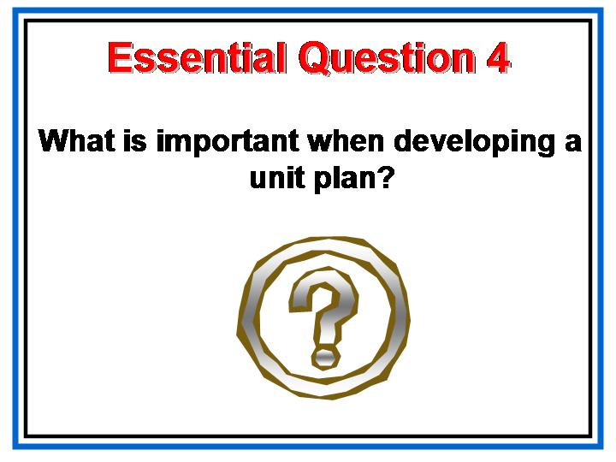  Show slide.  Read Michael out loud to the large group. Ask them to think about the essential question as they learn about Michael’s experiences in school.  Discuss what the teachers should have considered in their instructional plans for the class, including students like Michael.
Slide:  What is important? | 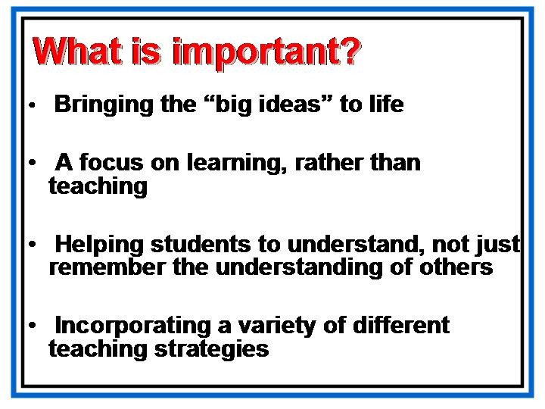  Show slide.  As we begin planning our instructional unit we need to consider the key ideas that will drive our work.  Go over each bullet on the slide carefully.
Slide:  Instructional Planning | 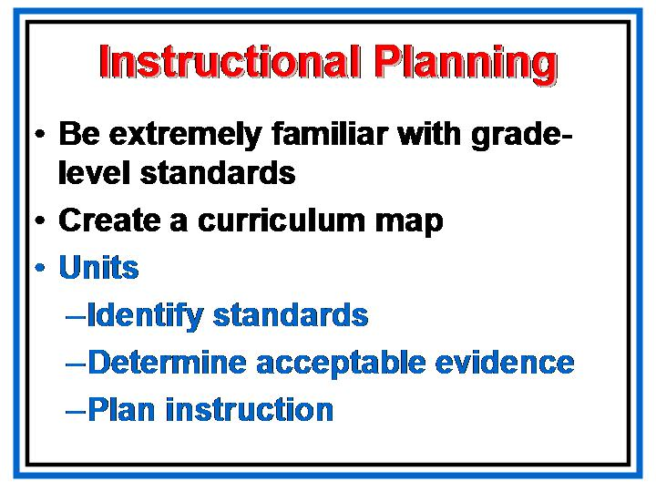  Show slide.  We’ve already discussed the importance of being familiar with standards and elements and we’ve created our own curriculum maps.  Now we’ll look to the stages of unit development.
Slide:  Criteria for Good Tasks  PG—p. 21 | Show slide.  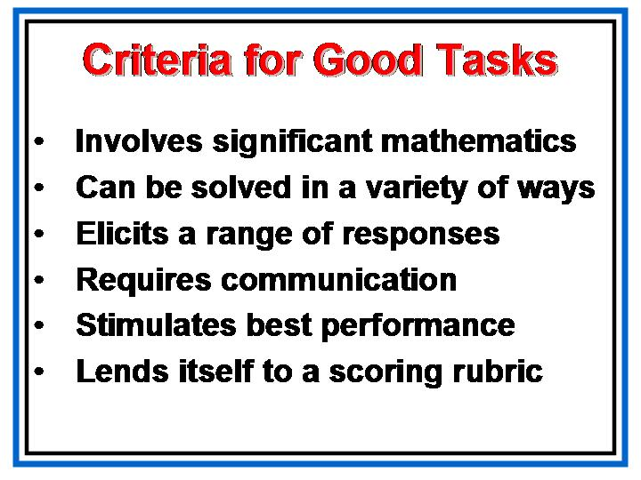  It all starts with assessment and good tasks are the heart of assessment. Let’s review the criteria for good tasks. The tasks we write will be the anchors for our units.  Discuss each bullet on the slide in depth.  Direct them to a copy of the standard rubric on page 21 of the participant’s guide. This can be used to help them as they write their units.
Slide:  Pick a Unit  PG—p. 22 - 31 | Show slide.  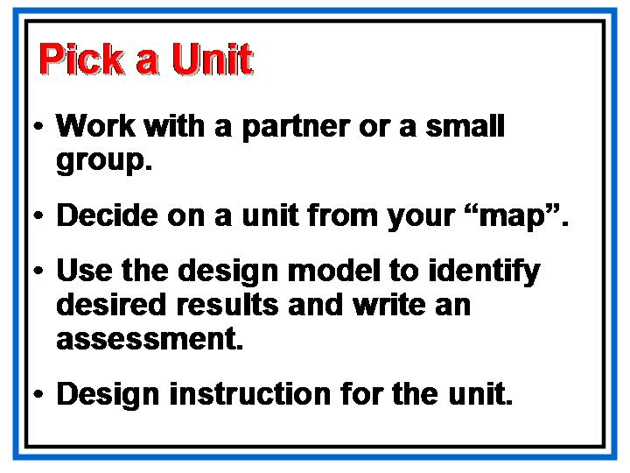
Have extra copies of PG-p. 28 available. | - There are different versions of unit design templates. The UbD workbook has template samples of 1, 2, and 6 page formats.  - Because of consistency in the training sessions, each content group is using pages 22 – 31 of the participant’s guide. This is not a required template. This is a thorough template that sets the tone of the training session. It is also the one we are using for all the frameworks.  - If your school or system has developed a unit template, please use that one, but look for any additions or modifications that might add to the quality of the design.  - There are extra copies of page 28 from the participant’s guide that you can use for additional tasks.
Slide:  Making Instructional Decisions  PG—p. 32 – 35  and p. 38-44 | 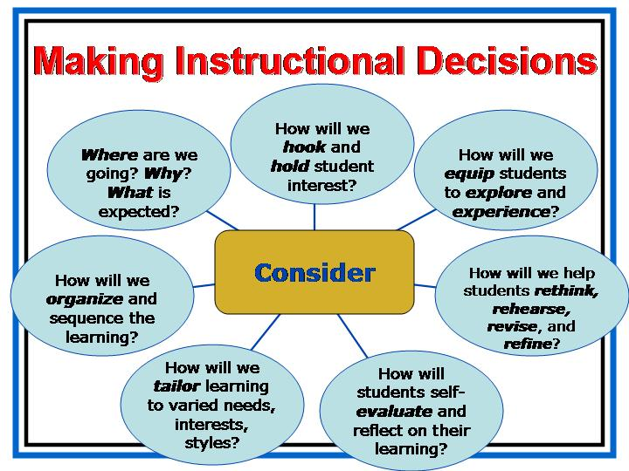  Show slide.  There are a number of additional resources in the participant’s guide to help you as you make instructional decisions and consider the types of experiences students will need in order to apply the standards.
Slide:  Multiple Representations | 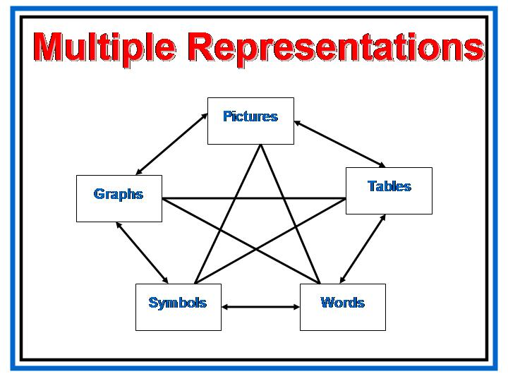  Show slide.  Remember how important these multiple representations are for students’ concept development. You will want to be sure to consider a balance of these throughout your unit.  Give participants adequate time to develop their units. Assist with resources and answering questions as needed.  As groups finish, gather their units electronically and print them off for each group. This will help make the sharing time more meaningful.
Slide:  Sharing Our Units | Show slide.  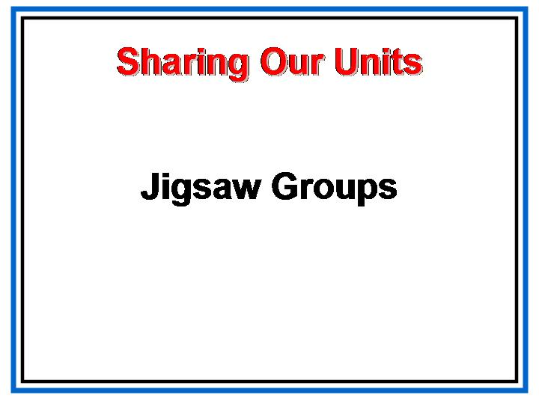  Have the participants visit each other and share their units.
Slide:  I would like to teach and assess for understanding but…(1) | Make suggestions for redelivery and discuss next steps.  Action Plan for Redelivery  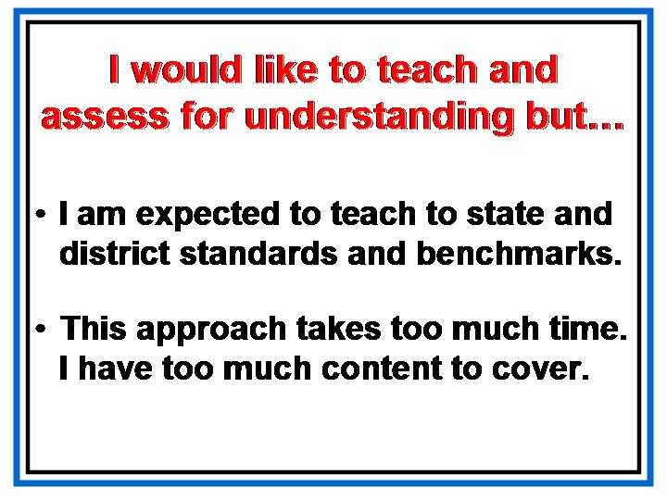  Show slide.  Have participants self-assess using these two slides together.  Discuss
Slide:  I would like to teach and assess for understanding but…(2) | Show slide.  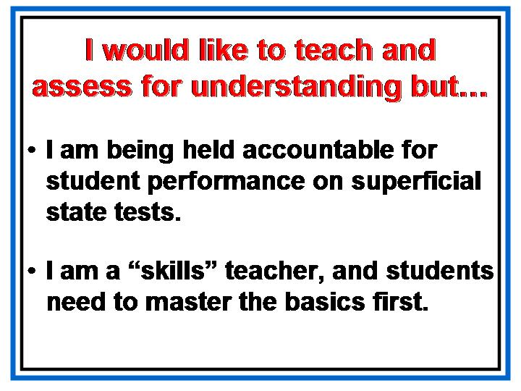
Slide:  I would like to design curriculum using a template, but…(1) | 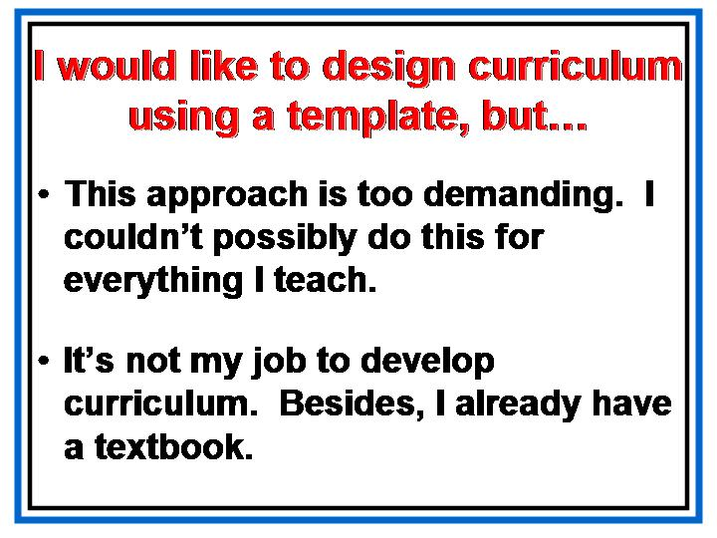  Show slide.  Have participants continue to self-assess using these next two slides together.
Slide:  I would like to design curriculum using a template, but…(2) | 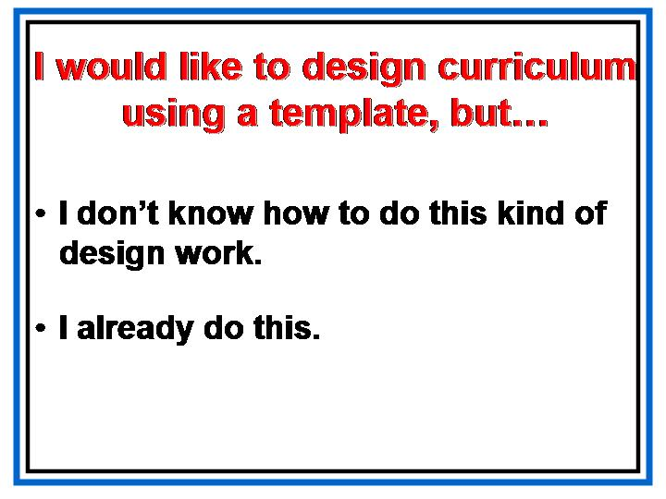  Show slide.
Slide:  Discussion of Redelivery Action Plan  PG—p. 45 - 49 | 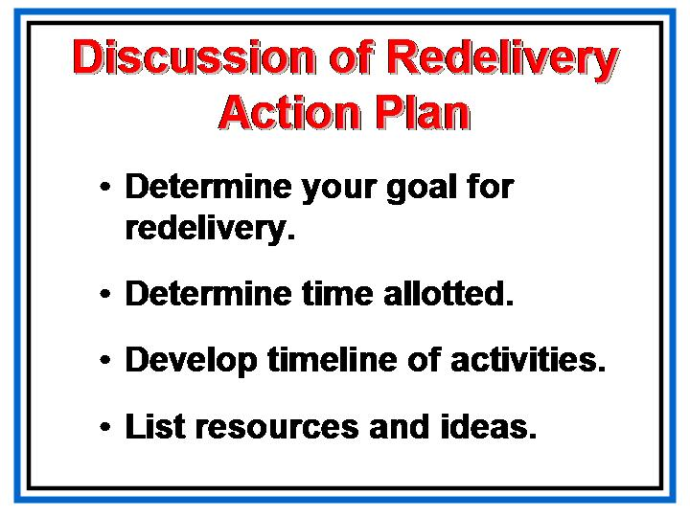  Show slide.  Point out additional resources in the back of the participant’s guide.
Slide:  Wrapping Up  Additional Student Work Consent Forms are on  PG-p.36 | 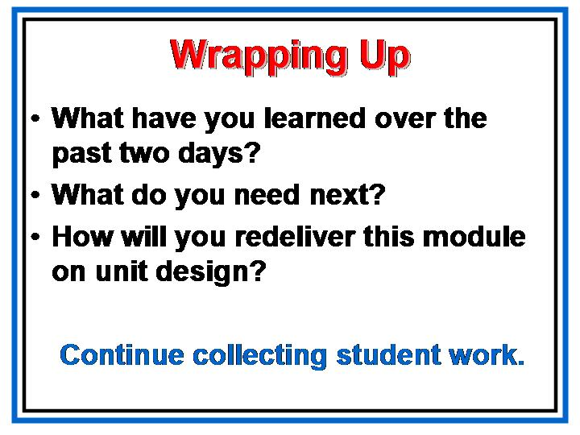  Show slide.  Discuss the questions on this slide in large group, making notes for further planning.  As always, let me know how I can help.
Slide:  Contact |   Show slide.

