

Training for Georgia Performance Standards
Day 2: Learning to Assess
and Assessing to Learn

Content Facilitator’s Guide
Mathematics Grade 7

Acknowledgements
This training program was developed by the Georgia Department of Education as part of a series of professional development opportunities to help teachers increase student achievement through the use of the Georgia Performance Standards.

For more information on this or other GPS training, contact Gerald Boyd at (404) 656-0476, gboyd@doe.k12.ga.us or Marcia Mayo at (404) 463-1933, mmayo@doe.k12.ga.us.

Use of This Guide
The module materials, including a Content Facilitator’s Guide, Participant’s Guide, PowerPoint Presentation, and supplementary materials, are available to designated trainers throughout the state of Georgia who have successfully completed a Train-the-Trainer course offered through the Georgia Department of Education.

Materials (guides, presentations, etc.) will be available electronically on http://www.georgiastandards.org under the training tab after all trainings of Day Two have occurred. Consult the trainer for availability.

Table of Contents
Acknowledgements 2
Use of This Guide 2
Table of Contents 3
Overview 4
Module Rationale 4
Module Description 4
Module Goal 4
Day Two Objectives 5
Module Sequence 6
Module Materials for Day Two of Training 6
Agenda 7

Introduction 9
What should we assess? 15
Why should we assess? 22
How should we assess? 25
Putting It All Together 38

Overview
Module Rationale | This training extends and builds upon Day One of training.  The first purpose of Day One of training was to introduce participants to the applicable standards.  The second purpose of Day One of training was to introduce the Standards-Based Education approach and to assist teachers in using this approach to develop assessments and instruction in support of the new curriculum standards. During Day One of the training, the emphasis was on the model itself—what it is, why it is important, and how it can be used so that the new GPS have a profound impact at the classroom level.  The third purpose of Day One of the training was to help participants gain proficiency in identifying desired results of standards.  The purpose of Day Two of the training is to teach Stage 2 of the Standards-Based Education Process.
Module Description | This module includes an instructor-led one-day session composed of several large and small group demonstrations, practice activities, and follow-up. The activities require the participants to jump into meaningful discussions and the follow up serves as a bridge to Day Three of training.
Module Goal | Demonstrate a deep understanding of the new Georgia Performance Standards and the Standards-Based Education approach, through thoughtful curriculum planning, development of formative and summative assessments, and the design of instruction matched to the standards and research-based best practices. This shall be measured by student performance on progress monitoring and standardized criterion-referenced tests.  Note that the goal will not be reached by any single day of training. It will take preparation, seven days of classroom instruction, and follow up to master this goal.
Day Two Objectives | By the end of Day Two of training, participants will be able to:  - Explain why assessment is Stage 2 in the Standards-Based Education process.  - Identify the purpose of assessment in the classroom.  - Differentiate among different types of assessment and assessment formats.  - Given specific standards and a purpose for assessment, determine which assessment methods would be most appropriate at various times to increase student learning.  - Given an assessment plan for a unit, identify whether it meets best practice standards for assessment.  - Create a balanced assessment plan for a unit, including examples of performance tasks, rubrics, and constructed response items.
Module Sequence | Introduction  - First Grade Takes a Test  - Overview of the Module  - Today’s Assessment  What should we assess?  - Task: The “eyes” have it!  - Criteria for Good Tasks  - Assessment and the Unit Design Process  - Conceptual Understanding  Why should we assess?  - Task: Emergency 911! Bay City  - Accountability  How should we assess?  - Packing Parachutes  - Activity: What about Sam?  - Assessing for Learning vs. Grading  - Multiple Representations  - Types of Assessment  - Matching Assessments with Standards  - Analyzing Student Work  - Rubrics  Putting It All Together  - Designing an Assessment: Small Group Work  - Self-Assessment  - Field Assignment
Module Materials for Day Two of Training | Content Facilitator’s Kit contents:  - Content Facilitator’s Guide (one for each leader)  - Complete set of slide transparencies (PowerPoint)  - Participant’s Guide (one per participant and one per leader)
Other materials needed:
- Flipchart paper
- Markers
- Stop Watches
- Scissors
- Rulers
- Pencils/Pens
- Painters tape to post charts
- Handouts:
- Rubric for Today’s Assessment
- Task: The “eyes” have it!
- Task: Emergency 911! Bay City
- Activity: What about Sam?
- Student Work: Emergency 911! Bay City
- Sample Rubrics

Equipment:
- Overhead projector or computer and LCD projector

Agenda
Introduction
- First Grade Takes a Test
- Overview of the Module
- Today’s Assessment

What should we assess?
- The “eyes” have it!
- Criteria for Good Tasks
- Assessment and the Unit Design Process

Why should we assess?
- Emergency 911! Bay City
- Accountability
- Testing

How should we assess?
- What about Sam?
- Multiple Representations
- Assessing for Learning vs. Grading
- Types of Assessment
- Matching Assessments with Standards
- Analyzing Student Work
- Rubrics

Putting It All Together
- Designing an Assessment: Small Group Work
- Self-Assessment
- Field Assignment

Introduction
Overview | During the introduction, participants will discuss what they know about assessment. After a brief presentation of the day’s agenda and objectives, participants will be presented with their assessment for the day. A rubric will be distributed outlining clear expectations.
Objectives | - Describe how and why assessment is Stage 2 in the Standards-Based Education process.  - Identify the purposes of assessment in the classroom.
Activities | - First Grade Takes a Test  - Overview of the Module  - Today’s Assessment
Materials | - Overhead projector or computer and LCD projector  - Transparencies or PowerPoint presentation  - Participant's Guide  - First Grade Takes a Test  - Rubric for Today’s Assessment  - Chart Paper
Slide | First Grade Takes a Test  Show slide, First Grade Takes a Test.  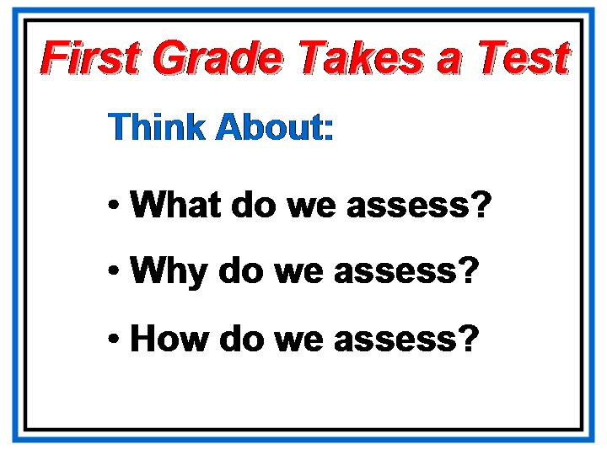  To start our focus today on assessment I want to read you a short book called First Grade Takes a Test. Please listen and consider the questions on the slide. You might find examples of what, why and how we assess in the pages of the story.  Discuss the observations they can make about the way we sometimes view assessment in our schools.
Slide | Overview of the Module  Show slide, Table Discussion.  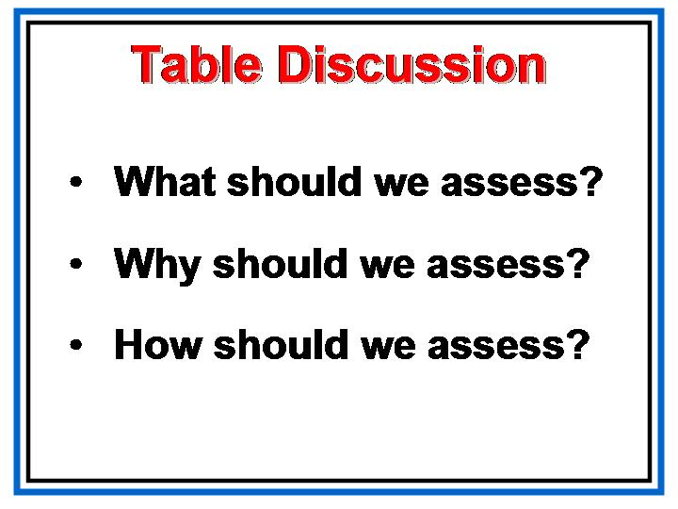  Allow groups time to discuss the questions on the slide. Discuss in large group and explain that this is what we are going to discuss today.  Place the comments on chart paper to use as reference throughout the day.
PG, p. 4 | The agenda for today is located in your Participant’s Guide on  page 4.  In the Introduction to Assessment section we will discuss our goals and objectives for today.  First we will look at what it is we should be assessing.  Then we will discuss why we should assess.  Finally, we will discover how we should assess.  In the last section we will put it all together to develop an assessment that will drive the instruction of a unit we will continue to build in Days 3 and 4 of our training.
Do we have anyone that has not attended Day 1?
If so, welcome them to the group.
This is a good time to have everyone introduce themselves and say a little something about themselves.

Before we go further, lets reflections on the redelivery process from Day 1.

Ask participants about the redelivery of Day 1.

On Chart Paper have each group brainstorm a list of successes, questions, and concerns.

Have a group reporter tell rest of the groups the main points of the list.

Highlight the ones to address and work on during this session.

Slide | Today’s Assessment  Show slide, Stephen Covey Quote.  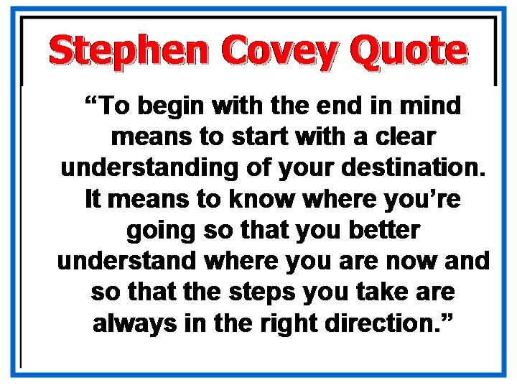

Slide | Consider the quote.  What does that mean to us as educators?  What does that mean to us today as we plan our day?  Because we should “begin with the end in mind”, we need to start today’s training by looking at the end result of our work today.  Show slide, Today’s Assessment.  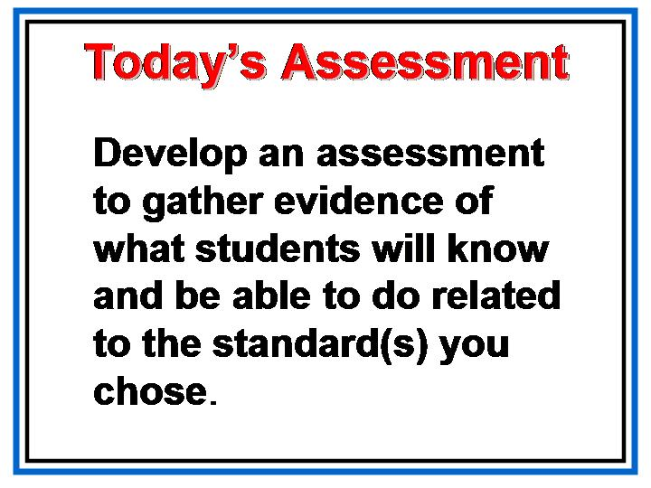  This is our assessment, our end product, for today’s work.
Slide  Emphasize this← | Show slide, Performance Tasks & Assessments  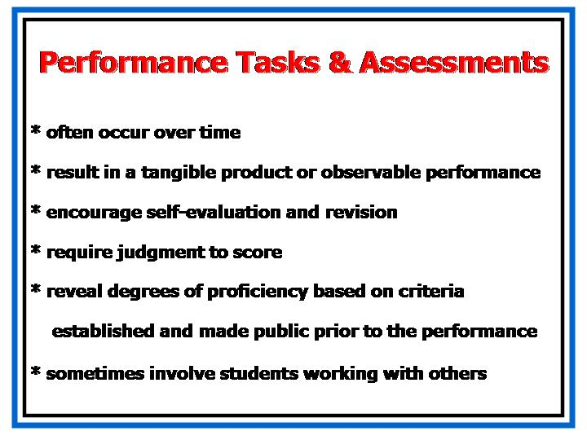  Marzano, Pickering, and McTighe (1993) offer the following characteristics of performance assessment:  - Performance assessments often occur over time.  - Performance assessments result in a tangible product or observable performance.  - Performance assessments encourage self-evaluation and revision.  - Performance assessments require judgment to score.  - Performance assessments reveal degrees of proficiency based on criteria established and made public prior to the performance.  Performance tasks sometimes involve students working with others
Slide | Show slide, According to Grant Wiggins….  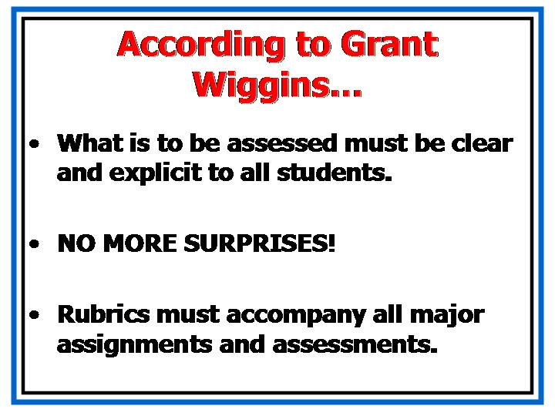  So that there are no surprises, let’s look at a rubric outlining the expectations of  today’s assessment.
Slide | Show slide, A rubric is a set of rules that.  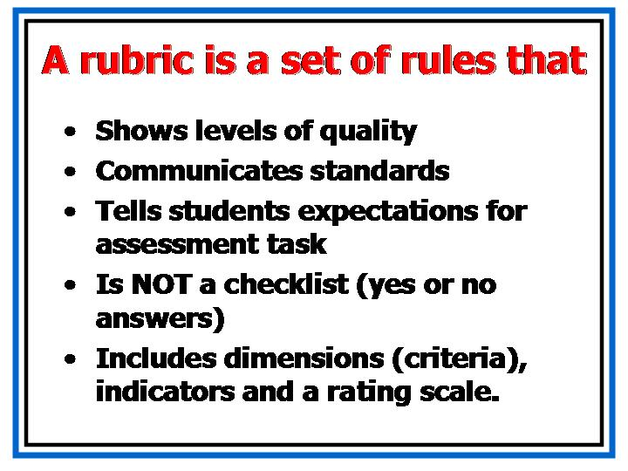  Use this slide to discuss what a rubric is and is not.
Slide | Show slide, Rubric.  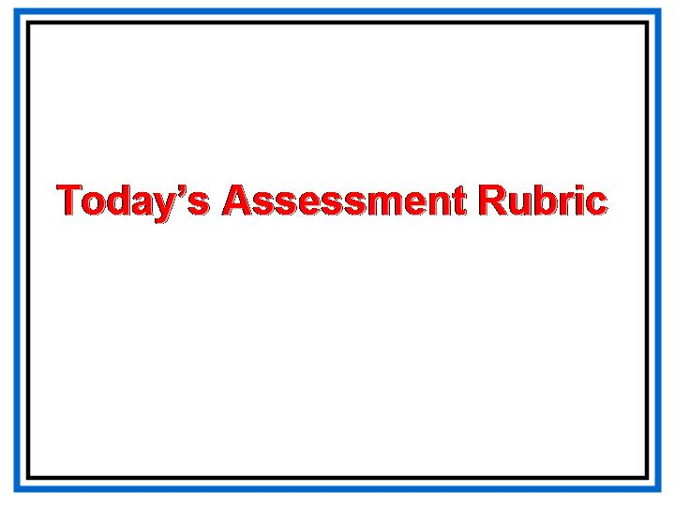  Discuss the rubric. Explain how we will know if WE have been successful in our work today.

What should we assess?
Overview |  | In this section participants will identify what is important to assess. Criteria for good tasks with be examined and they will review how assessment fits in with the standards-based education model for designing instruction.
Objective |  | - Explain why assessment is Stage 2 in the Standards-Based Education process.  - Given an assessment plan for a unit, identify whether it meets best practice standards for assessment.
Activities |  | - Task: The “eyes” have it!  - Criteria for Good Tasks  - Assessment and the Unit Design Process
Materials |  | - Overhead projector or computer and LCD projector  - Transparencies or PowerPoint presentation  - Participant's Guide
 | Slide | Task 1  Show slide, What should we assess?  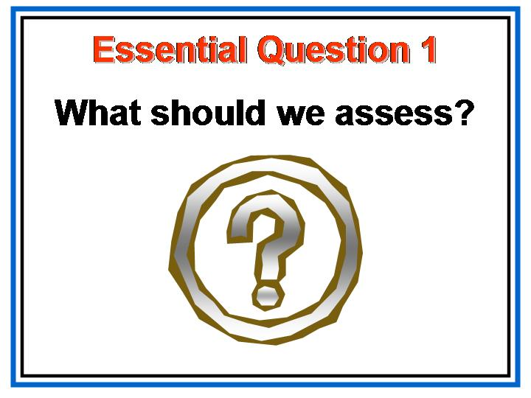  First, let’s discuss WHAT we should assess. Let’s consider a performance task.
 | Slide | Show slide, The “eyes” have it!  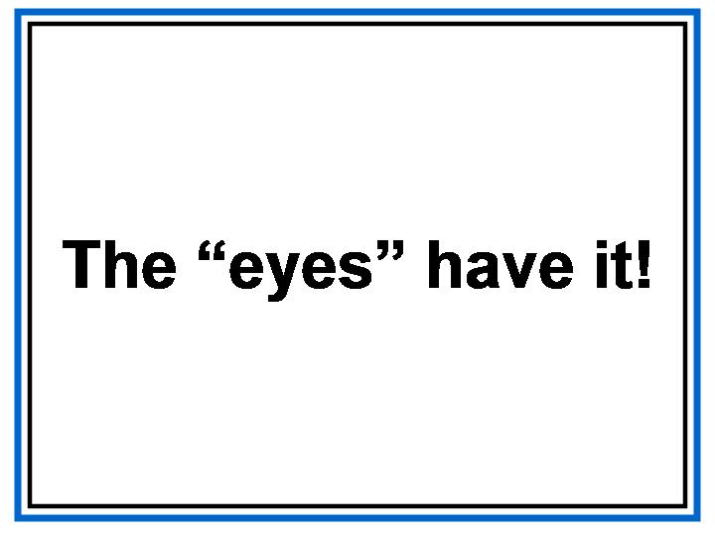  Give them time to complete the task.
 | Slide  Slide  Slide | Show slide, The “eyes” have it! (Questions).  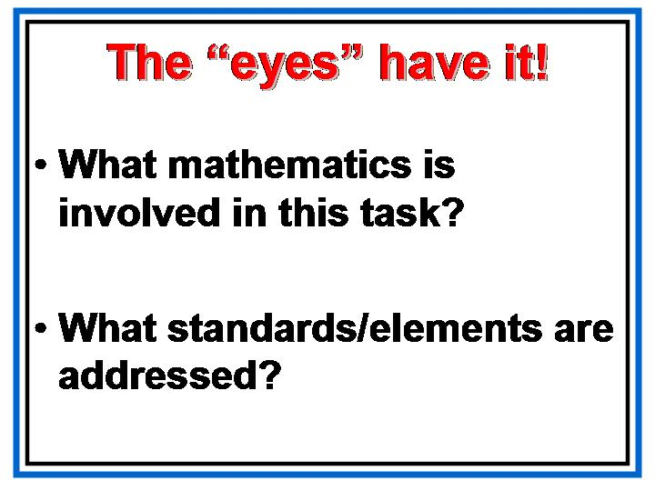  Discuss the questions on the slide. Hand out the student work and discuss.  Show slide, Is This a Good Task?  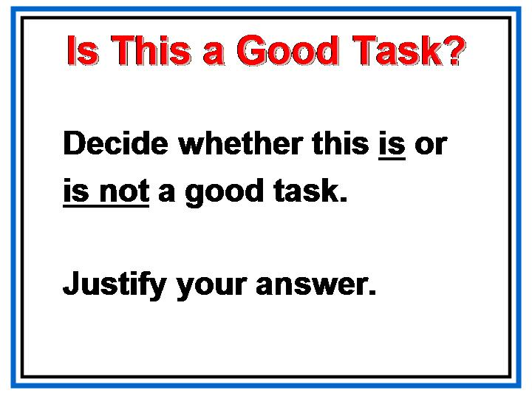  Discuss.  Show slide, What should we assess?  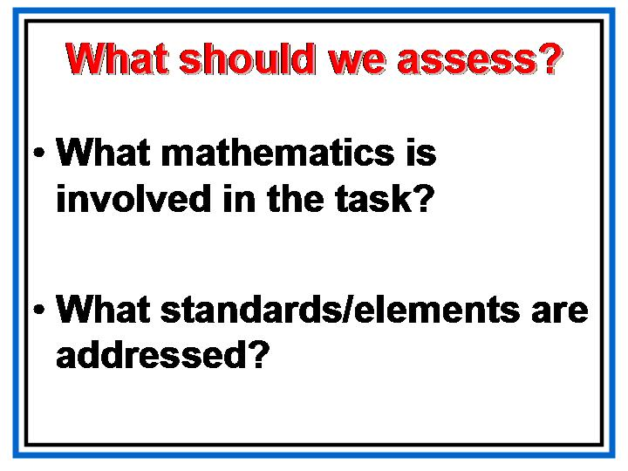  Discuss.
 |  | Criteria for Good Tasks
 | Slide | Show slide, Criteria for Good Tasks.  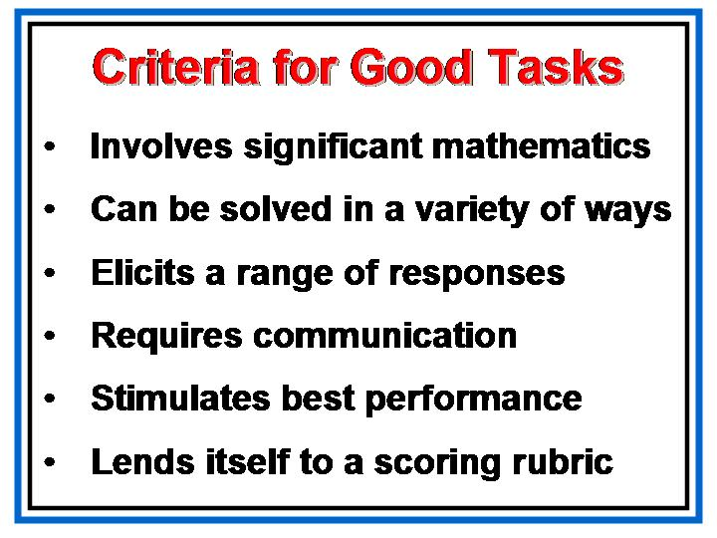  Discuss the criteria on the slide.
 | Slide  PG, p. 6  Slide | Assessment and the Unit Design Process  Show slide, Standards Based Education Model, and refer participants to their Participant Guide.  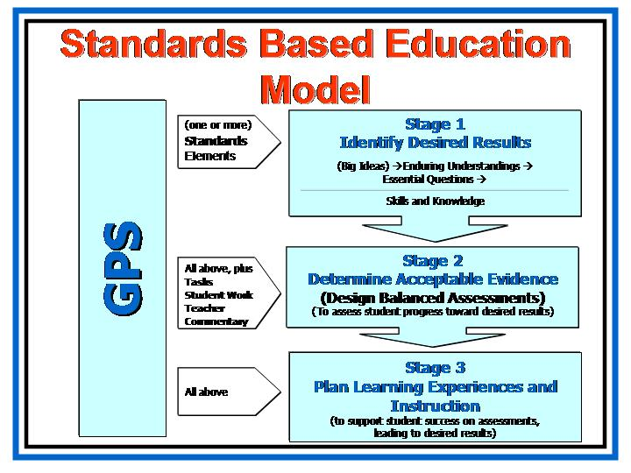  During Day 1 of training, we gained familiarity with the Georgia Performance Standards: the parts of a standard, the different strands, and relevant terminology.  We practiced the process of identifying the desired results to determine exactly what the standards say—what we want our students to know, be able to do, and understand. We identified the Big Ideas embedded in the standards, and we grouped Big Ideas together to formulate Enduring Understandings, the broad statements or generalizations that span a number of standards, strands, and/or disciplines, and that specify what our students should understand at the end of a unit, at the end of a course, or twenty-five years from now.  Finally, we developed Essential Questions that directly relate to the Big Ideas and the Enduring Understandings and, consequently, directly relate to the standards. We developed broad, overarching questions as well as more specific and topical questions. We began to examine the different types of knowledge - both Declarative Knowledge (facts, rules, concepts) and Procedural Knowledge (skills, procedures, and processes) that must be acquired for students to achieve deep understanding.  Today, we will connect the work on Stage 1 of the Standards-Based Education process with Stage 2: designing appropriate, balanced assessment plans that allow students to demonstrate the depth of their understanding of the concepts, skills, and processes inherent in the Georgia Performance Standards.  Planning assessments this early in the SBE process may be difficult for many of us to grasp because we have traditionally planned our learning experiences and instruction before considering assessment.  But it is only after we have determined what we want students to know, understand, and be able to do (Stage 1) and what constitutes acceptable evidence of the knowledge, skills, or understanding (Stage 2) that we make decisions about the specific instructional activities, tasks, and/or lessons that we will employ to help our students achieve these desired results (Stage 3).  Show slide, Looking for Big Ideas..  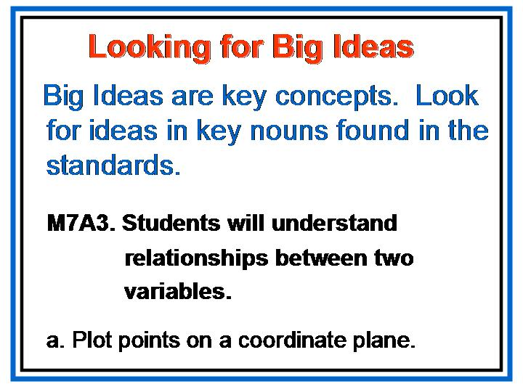  Remember the work we started on Day 1. Here is a reminder of the standard I used as an example as we began to identify desired results.
 | Slide | Show slide, From Understandings to Questions.  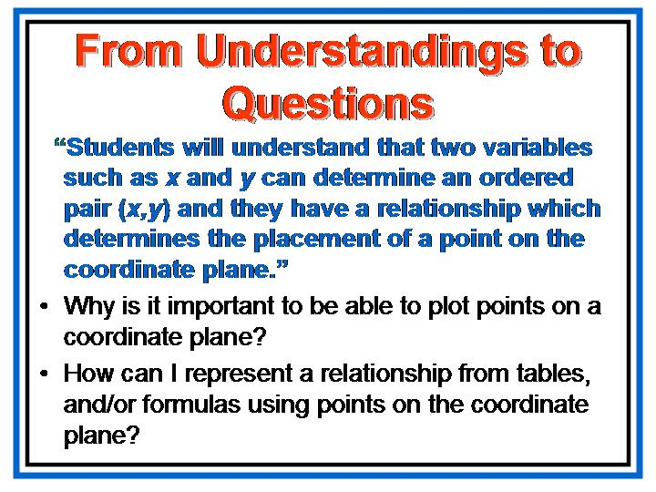  In working through stage 1, we not only talked about the Big Ideas, but also the Enduring Understandings and Essential Questions.
 | Slide  PG, p. 7 | Show slide, Skills and Knowledge (chart).  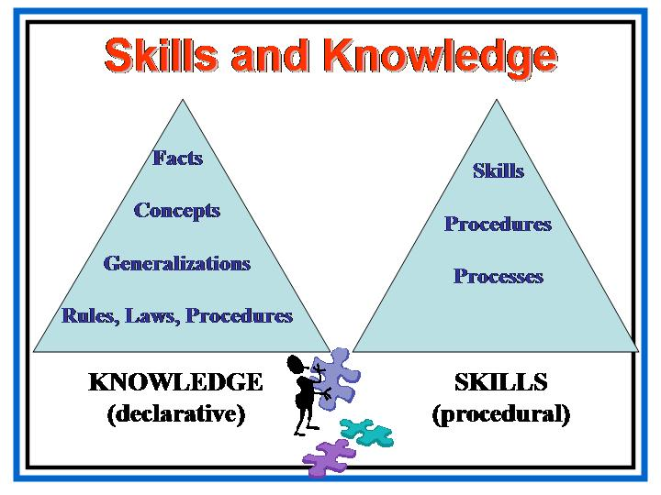  Then we looked at the skills and knowledge needed to answer the essential questions. This slide is a review of the learning we shared.
 | Slide 16 | Show slide, Skills and Knowledge (example).  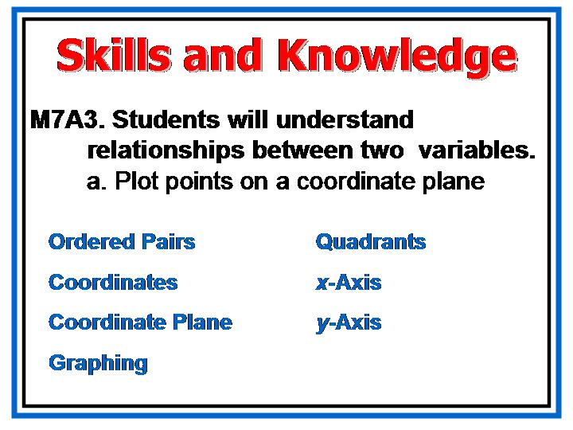  Here is a list of the skills and knowledge needed to answer the essential questions I wrote. This is what I will use to complete our assessment today. Please pull out the chart you started on Day 1. Review it with your group. This is WHAT we should assess.
 | Slide | Show slide, Concept Development.  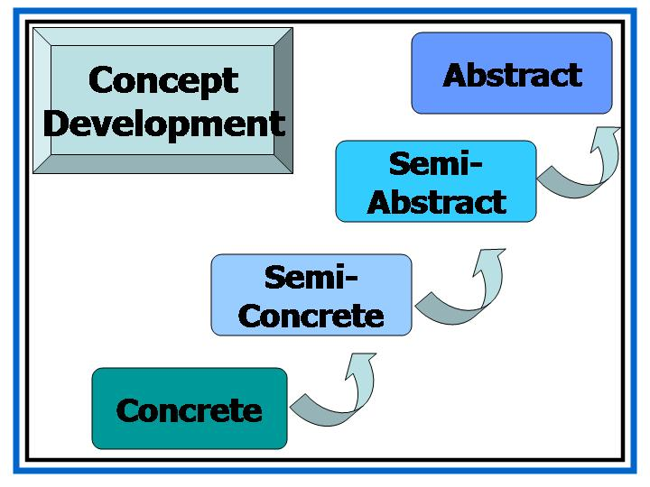  On Day 1, we discussed the process that students experience in developing the ability to move from the concrete to the abstract. Why do we need to consider this as we discuss WHAT we should assess?  Refer to the ideas on chart paper for “WHAT should we assess?” and edit as needed.

Why should we assess?
Overview | This section will provide a rational for assessments, especially performance tasks. Participants will also get information about the Georgia Testing Program.
Objective | - Identify the purposes of assessment in the classroom.  - Understand how and when to use performance assessments  - Given an assessment plan for a unit, identify whether it meets best practice standards for assessment.
Activities | - Task: Emergency 911! Bay City  - Accountability
Materials | - Overhead projector or computer and LCD projector  - Transparencies or PowerPoint presentation  - Participant's Guide  - Graph Paper  - Rulers  - Pencils/Pens

Slide | Show slide, Why should we assess?  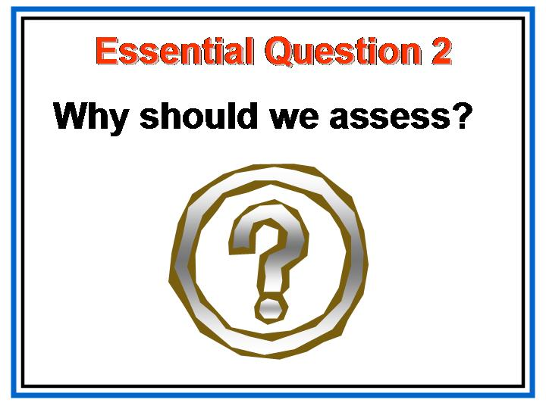  Next we will discuss why we should assess. Again, let’s look at a task to begin our discussion.
Slide | Show slide, Emergency 911! Bay City.  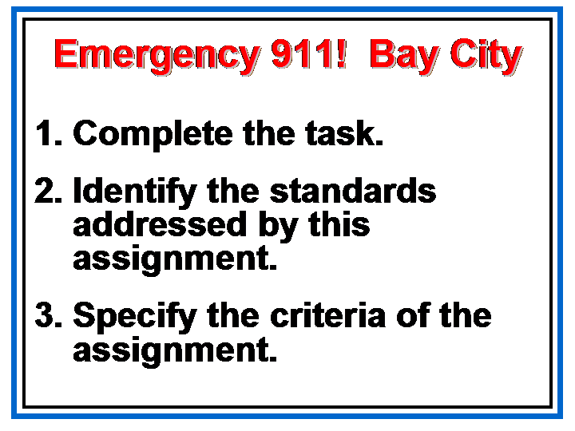  Give them time to work the problem. Share the results.
Slide | Show slide, Why should we assess?.  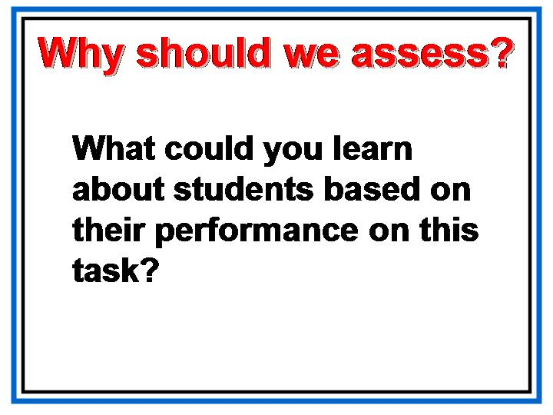  After each group has shared, ask the question on the slide.  Does this activity give us any ideas about WHY we should assess?
 | Accountability
Slide | Show slide, Accountability.  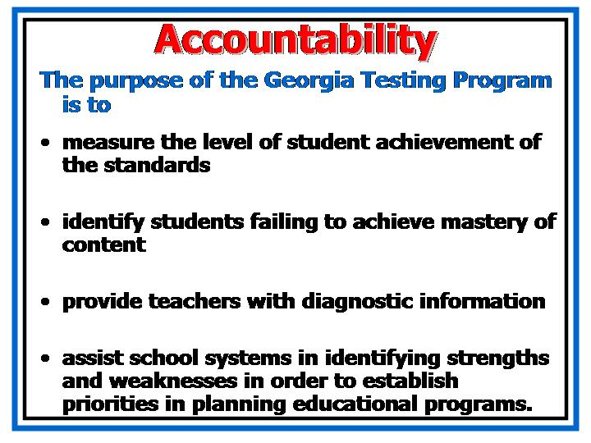  Another reason we assess is because we are held accountable for our students’ achievement.  Discuss the purposes of the Georgia Testing Program. Answer questions participants have about the CRCT, etc.
Slide  PG, p. 32 | Show slide, Testing.  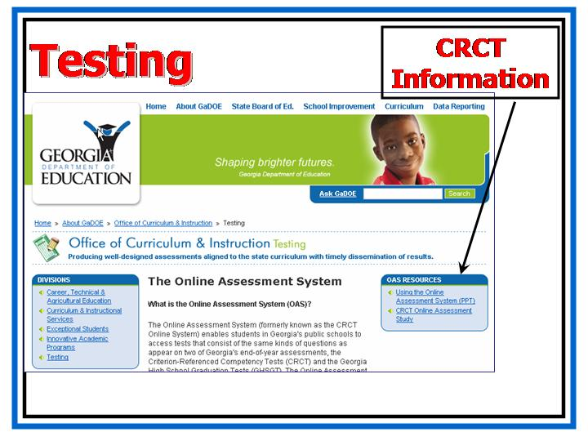  Update the participants on the resources available online for the CRCT.  To access this website, go to http://public.doe.k12.ga.us/index.aspx  The fifth tab at the top of the page is “Curriculum”. Click on the tab and look at the last section of “Divisions”. This is labeled as “Testing”. When you click on “Testing”, you will see below “About Testing” choices concerning the CRCT. Clicking on the first choice,  Criterion-Referenced Competency Tests (CRCT) will take you to the CRCT site.  Refer to the ideas on chart paper for “WHY” and edit as needed.

How should we assess?

Overview | In this section, participants will learn about different types of assessment and how to match the various forms of evaluation to the appropriate learning activities. They will analyze student work and develop rubrics for helping them understand how students think about mathematics.
Objective | - Differentiate among different types of assessment and assessment formats.  - Given specific standards and a purpose for assessment, determine which assessment methods would be most appropriate at various times to increase student learning.  - Given an assessment plan for a unit, identify whether it meets best practice standards for assessment.
Activities | - Parachute Discussion  - Activity: What about Sam?  - Assessing for Learning vs. Grading  - Multiple Representations  - Types of Assessment  - Matching Assessments with Standards  - Analyzing Student Work  - Rubrics
Materials | - Overhead projector or computer and LCD projector  - Transparencies or PowerPoint presentation  - Participant's Guide  - Scissors  - Student Work: Emergency 911! Bay City  - Sample Rubrics

Slide | Show slide, How should we assess?  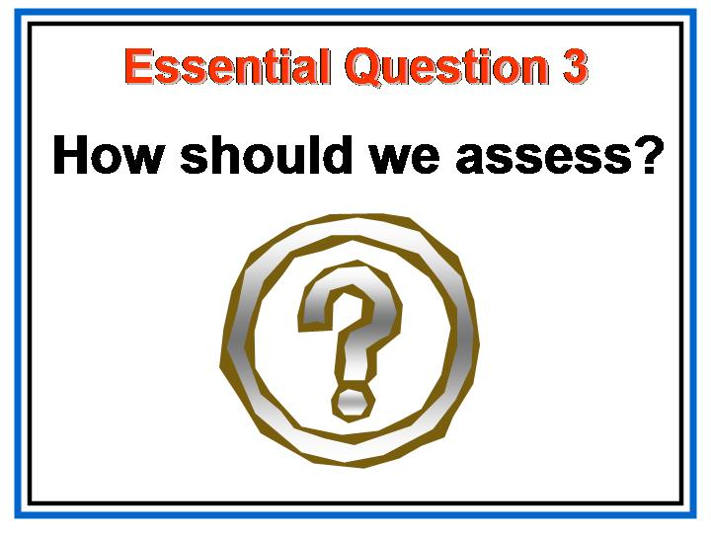  The bulk of our time will be spent exploring HOW we should assess. This is the “nuts and bolts” of what we need to do to design our assessments.
Slide | Show slide, Assessment vs. Grading.  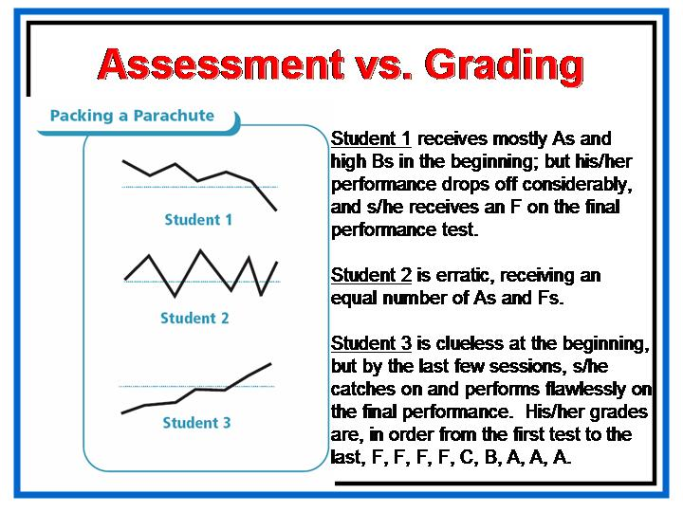  What grade do you think that student 1 should receive? Why?  What grade do you think that student 2 should receive?  Why?  What grade do you think that student 3 should received?  Why?  Now for a little more information concerning these grades…  These students were in a class called “Packing Parachutes”. Student 1 started out strong. Why do you think his scores look this way?  Student 2 was very inconsistent with packing his parachutes. One would be perfect and the next one a total mess. Why do you think his scores were the way that they are?  Student 3 started off not even knowing what a parachute is. What do you think his scores reflect and why?  What does this tell us about the way that most teachers grade?
Slide | Now let’s look at an actual student’s mathematics grades.  Show slide, What about Sam?  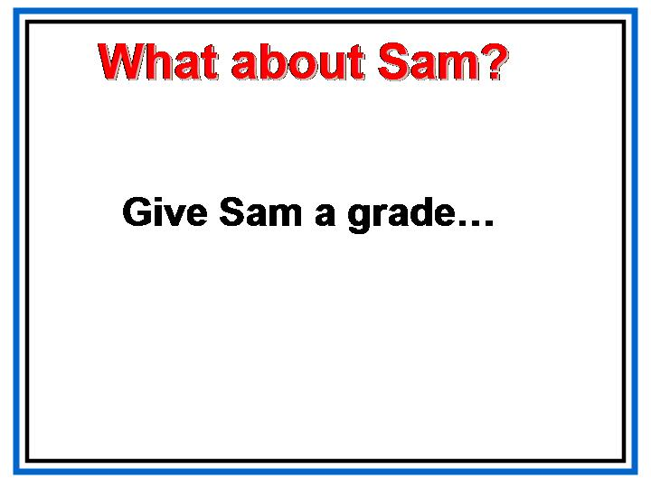
Slide | Show slide, How should we assess?  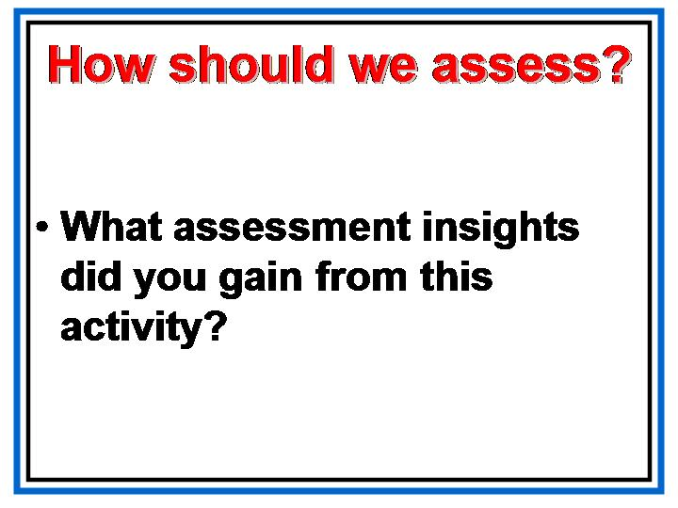  Give participants time to discuss.  You may want to refer to the chart paper labeled “HOW?”
Slide | Assessing for Learning vs. Grading  Show slide, Assessing for Learning vs. Grading.  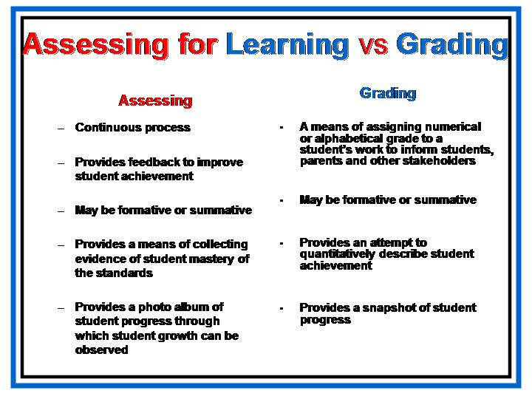  Discuss the differences in the two purposes for assessment.
Slide | Multiple Representations  Show slide, Multiple Representations.  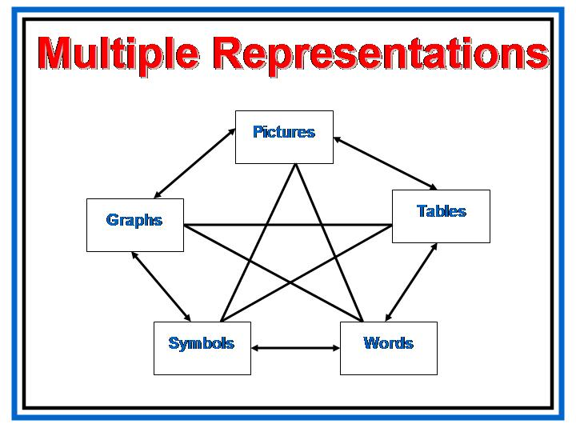  How does this connect with “How we assess”?
 | Types of Assessment
Slide  PG, p. 8  PG, p. 9, 10  UBD workbook Page 142 | Many of us already use a variety of assessment methods in our classrooms. We will now look at some frameworks for considering different methods of assessing students using the new Georgia Performance Standards.  Show slide, Types of Classroom Assessment.  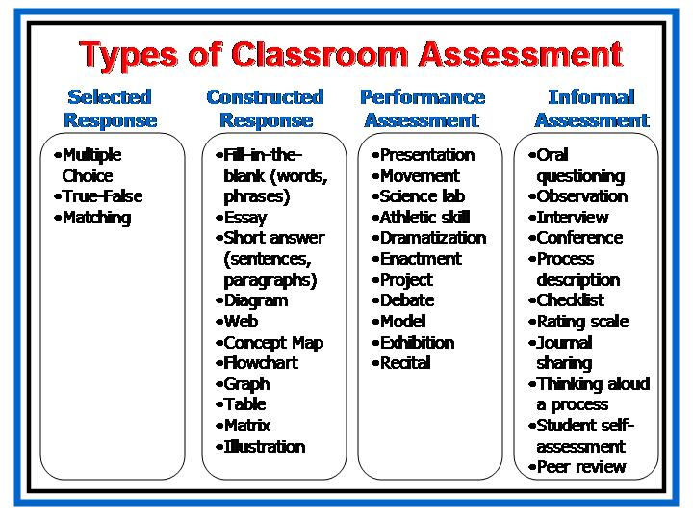  While you may choose to employ any of these formats, rather than adopting any single format for training, we have adapted the various assessment frameworks for purposes of discussion today. We will arrange our classroom assessments into these four categories: Selected Response, Constructed Response, Performance Assessment, and Informal & Self-Assessment.  In the Participant’s Guide you will find descriptions of these four assessment formats.  Check out pages 135 – 210 in your UBD Workbook for more information concerning these.  Spend a few minutes allowing the participants to look through these pages.  It would be good to especially point out pages 142, 161, 170, and 172. Many other pages are also excellent resources to aid in forming assessment decisions.

Authors describe and categorize assessment formats in a number of different ways. For example, UBD describes a continuum of assessments.

Review information on slide.

Performance assessments and informal & self-assessments are not meant to totally replace selected or constructed response assessments.

Each type of assessment has its own advantages and disadvantages, strengths and uses. It’s especially important to note here that assessments for learning occur throughout the teaching/learning process, from the first day a unit is introduced until the day the unit of instruction is completed. Each unit, therefore, will have a number of different assessments that allow the classroom teacher to measure a student’s progress toward his/her acquisition of the requisite knowledge, skills, and understanding.

Emphasize this← | Whatever format or framework we use in thinking about assessment, a balanced assessment plan that incorporates multiple types of assessments is necessary if we hope to determine what students know, are able to do, and can understand in relation to particular standards.  But simply using a variety of types of assessments is not enough. We need to use the particular type of assessment that is most appropriate for measuring specific types of knowledge, skills, and understanding.
 | Matching Assessments with Standards
 | To assess effectively, we need to match the appropriate type or format of assessment to the kind of evidence that will provide the best indicators of the desired results we have predetermined for the standard. If the goal is for students to learn basic facts, then paper-and-pencil tests and quizzes may provide adequate and efficient measures. However, when the goal is deep understanding, we need to rely more on complex performances to determine whether the learning goals have been reached.
Slide 32  PG, p. 11, 12 | Show slide, Matching Assessments with Standards.  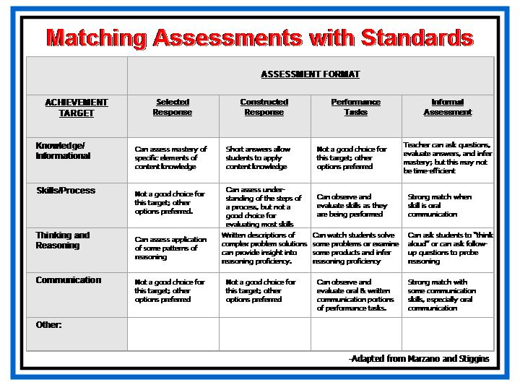  Knowledge/Informational targets refer to a student’s complete and detailed understanding of the information important to a topic—the content knowledge. What are some examples of Knowledge/Informational targets in the standards?  Allow time for participants to look over standards and contribute suggestions.
Skill/Process targets refer to a student’s success in performing a skill or process important to the topic. What are some examples of Skill/Process targets from the standards?

Allow time for participants to look over standards and contribute suggestions.

A number of types of “Thinking and Reasoning” skills are included in the standards; these are skills that fit within the Skill/Process targets but involve higher level processes. What are some examples of “Thinking and Reasoning” targets from the standards?

Allow time for participants to look over standards and contribute suggestions.

Marzano has also generated a list of “Communication” targets. Again, these fit within the classification of Skills/Processes, but directly relate to the processes of communication. What are some examples of “Communication” targets from the standards?

Allow time for participants to look over standards and contribute suggestions.

Slide  Slide  Slide | Analyzing Student Work  One of the most import HOWs of assessment is looking at student work. How we analyze the evidence they provide is critical to out success as educators. Here are some helpful suggestions as we learn to do this in a meaningful way.  Show slide, Analyzing Student Work: Emergency 911! Bay City.  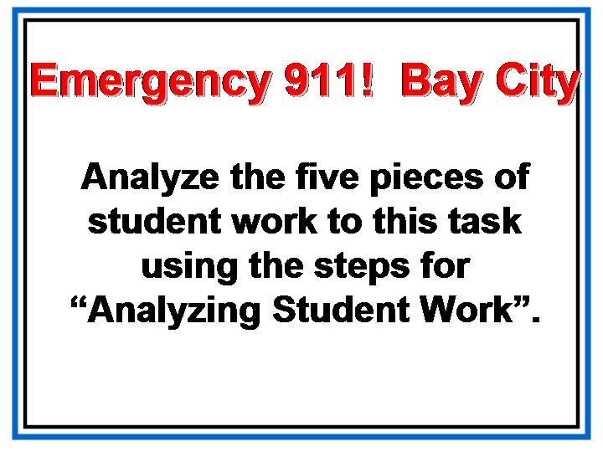  Show slide, Analyzing Student Work (1-3): Emergency 911! Bay City.  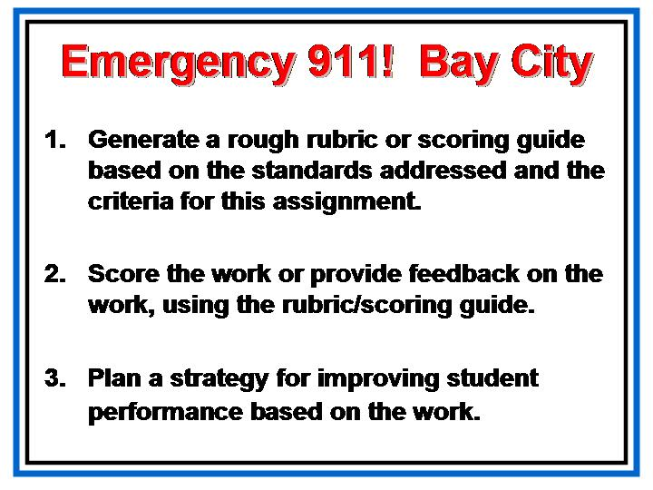  Discuss the steps of analyzing student work shown on the two slides. Explain to the participants that they will use these steps for the following task.
Then hand out the student work packet for them to analyze.

Hand out the sample rubrics at this time as optional tools in their analysis.

Slide 36 | Rubrics  Show slide, Rubrics.  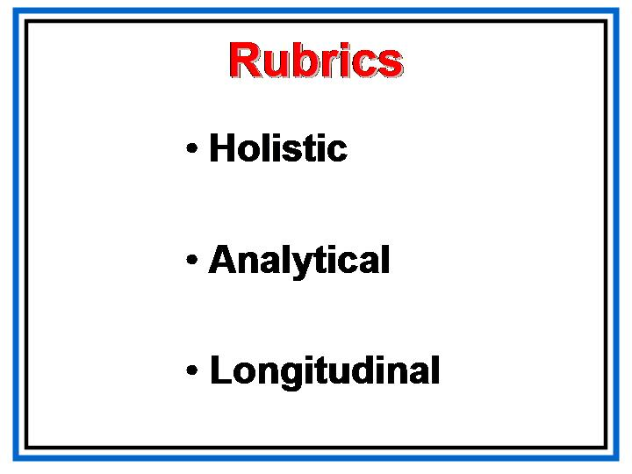  Explain the types of sample rubrics distributed during the analysis of the last task.  Now we are going to look at rubrics in depth.
Slide | Why are rubrics important?  Show slide, Advantages of Using a Rubric.  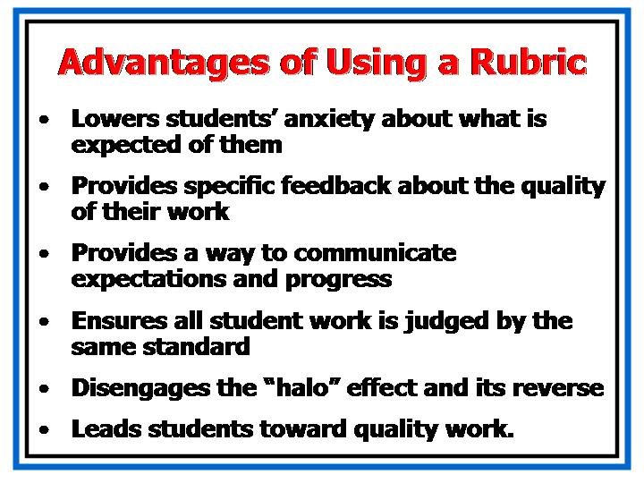  Discuss the advantages of using a rubric.
Slide  PG, p. 13 | Show slide, Basic Rubric Template.  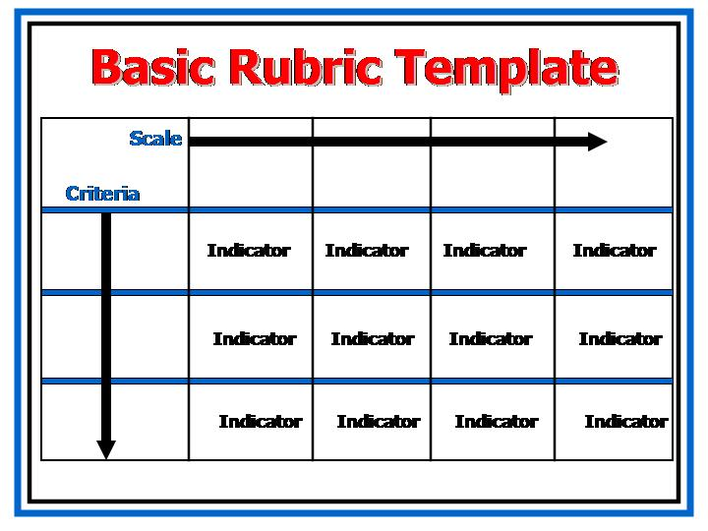  Refer participants to the copy in their participants guide.
Slide | Show slide, Ugly Rubrics.  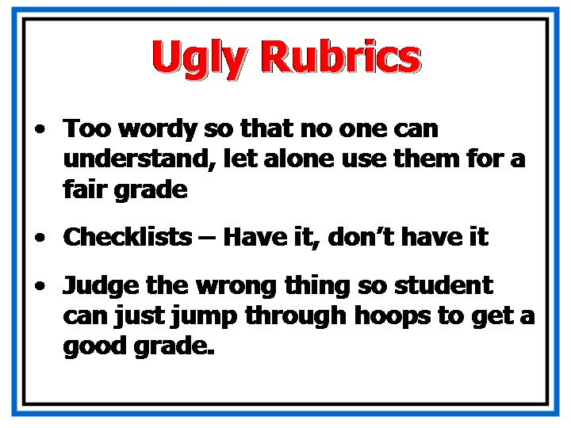  Here are some pitfalls to avoid when writing rubrics.
Slide  PG, p. 14 - 17 | Show slide, Good Rubrics.  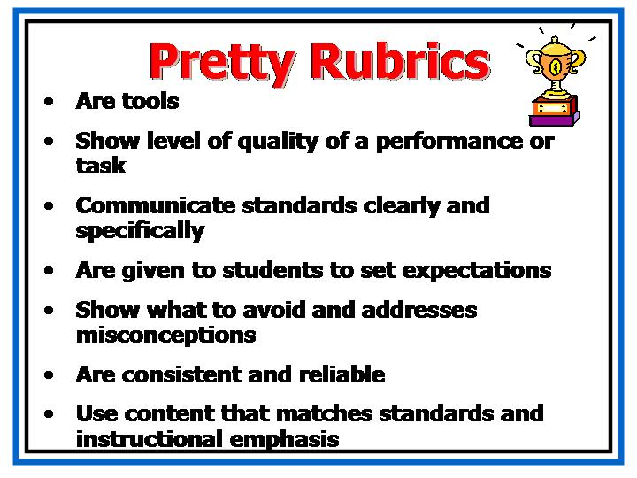  Use this slide to give direction for rubric writing. Refer participants to the reference pages in their participants guide for Designing Rubrics.

Putting It All Together
Overview | In this section, participants will design an assessment to match the standard(s) and/or element(s) they identified the desired results for on Day One. They will also take a self-assessment about their assessment practices and set a goal for themselves or their faculty.
Objective | - Create a balanced assessment plan for a unit, including examples of performance tasks, rubrics, and constructed response items.
Activities | - Designing an Assessment: Small Group Work  - Self-Assessment  - Field Assignment
Materials | - Overhead projector or computer and LCD projector  - Transparencies or PowerPoint presentation  - Participant's Guide  - Chart Paper  - Markers  - Tape

 | Designing an Assessment: Small Group Work
Slide | Show slide, Small Group Assignment: What has to happen?  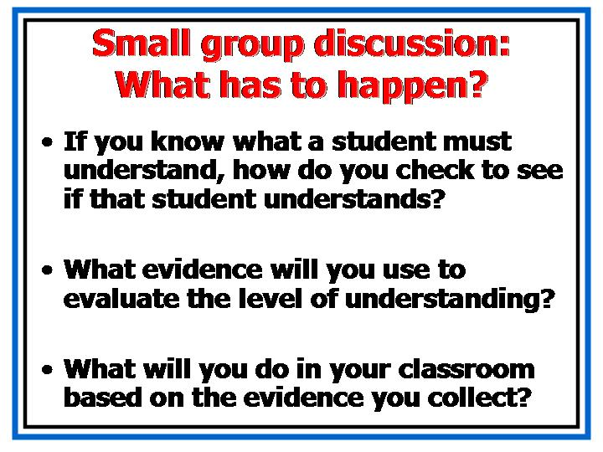  Here are the things you will need to consider as you begin planning your assessment.
Slide | Show slide, Today’s Assignment.  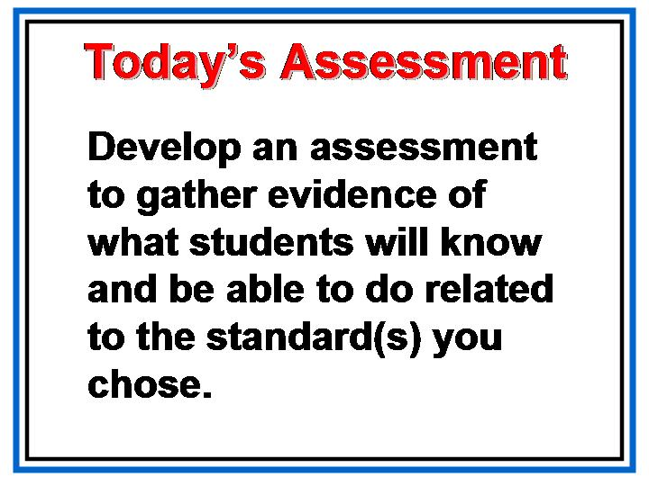  Remember what we discussed at the beginning of our day. Now it is time to put all our learning to work.
Slide  PG, p. 19, 20 | Show slide, Work in small groups.  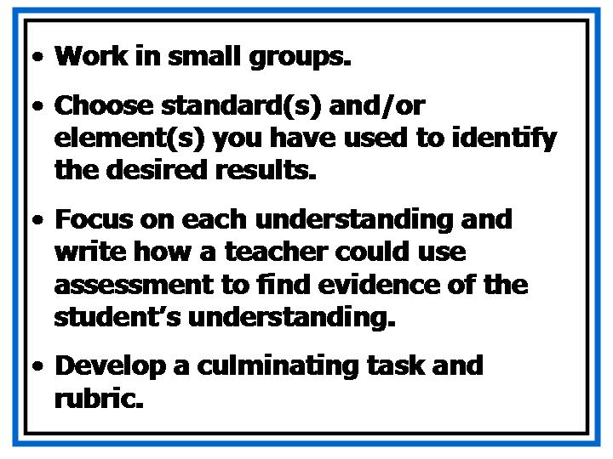  Present them with the assignment and give them time to work in groups.  Direct the participants to the templates in their guide.  Hand out the chart paper for them to record their work.  Instruct them to post their work when completed.  When everyone is finished, have them walk around and view each others’ work.  Discuss.
Slide  PG, p. 21, 22 | Self-Assessment  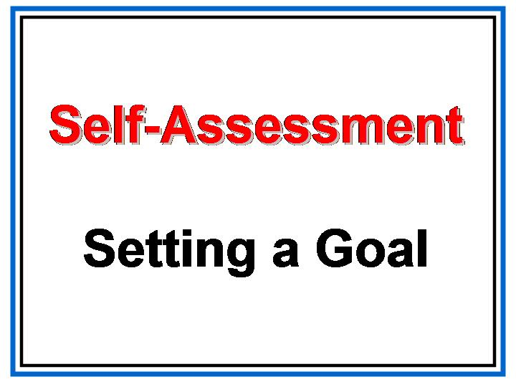  Show slide, Self-Assessment.  Direct participants to the self-assessment in their guide.  Give them time to complete the questionnaire and tally their results.  Discuss the questions at the end.  Encourage them to write a goal and to share it with a partner.  This is a good time to go back to any issues that have not been addressed during the day.
Slide 51  PG, p. 24 - 26 | Field Assignment  Show slide, Field Assignment.  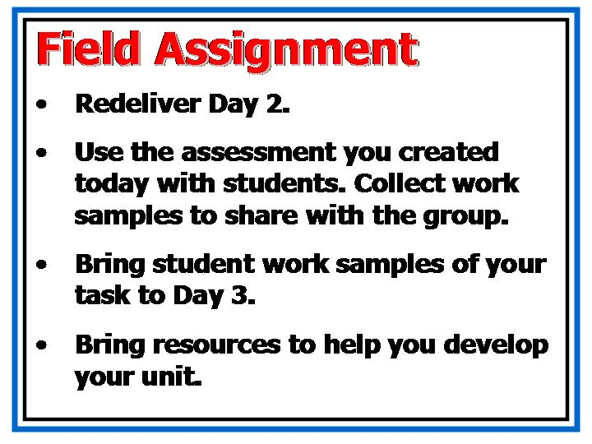
Slide | Review of Training Dates  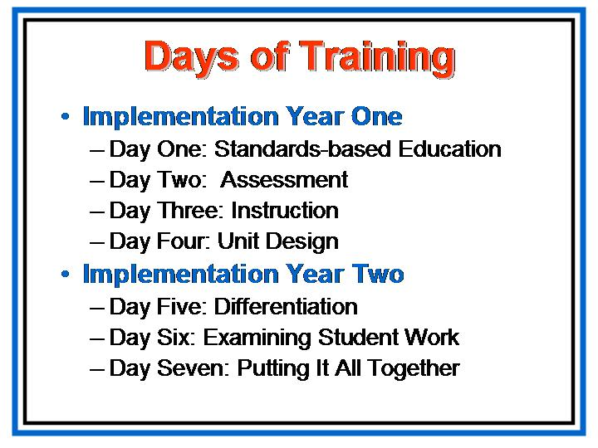  Next time, we will see each other for two days in a row!  It will take us two days to work on lesson plans and unit designs. This will be MUCH easier if you are able to bring plenty of resources.
Slide |   As always, please feel free to contact me at anytime.

